Waves and Optics Worksheet
1. Which of the following waves require a medium and which can propagate in a vacuum?
Sound wave Vacuum Medium
X-Ray Vacuum Medium
Light wave Vacuum Medium
Shock wave of an explosion Vacuum Medium

2. Label the following wave diagram with the appropriate parts:
Crest, trough, amplitude, wavelength
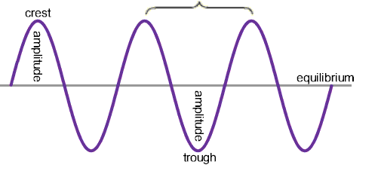
3. Suppose you record a song and play it back on your phone. If the amplitude of the sound wave is very large, the song will be very:_____________________ ?
4. Draw two waves. The first wave has a very high frequency. The second wave has a very low frequency. Which one has the highest energy?

5. Order the following types of radiation from the electromagnetic spectrum from largest wave length to smallest wavelength: Gamma Ray, Infrared, Microwave, Radio, Ultraviolet, Visible, X-ray
___________________ < ___________________ < ___________________ < ___________________ <
___________________ < ___________________< ___________________

6. For each type of radiation, give a technological application or give an interesting fact.
___________________:________________________________________________________________
___________________:________________________________________________________________
___________________:________________________________________________________________
___________________:________________________________________________________________
___________________:________________________________________________________________
___________________:________________________________________________________________
___________________:________________________________________________________________

7. On the following diagram, label the following:
Incident ray, reflected ray, angle of reflection, angle of incidence, normal.
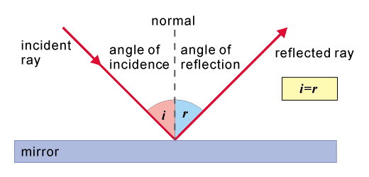
8. The angle of incidence is always [greater, smaller or equal] to the angle of reflection
9. Explain how refraction works (i.e. your straw looks broken in a glass of water)
____________________________________________________________________________________
____________________________________________________________________________________
____________________________________________________________________________________
____________________________________________________________________________________

10. Explain the difference between a converging and diverging lens:
____________________________________________________________________________________
____________________________________________________________________________________
____________________________________________________________________________________
____________________________________________________________________________________

11. Sound waves are longitudinal waves, as opposed to transverse waves like the EM spectrum. Explain the difference between longitudinal and transverse waves:
____________________________________________________________________________________
____________________________________________________________________________________
____________________________________________________________________________________
____________________________________________________________________________________

12. The speed of sound is the greatest in [space, air, water]?

