Types of Soil
***Read in the Textbook Eureka pages 307-310 and then answer the following questions and fill in the blanks to complete your notes on Types of Soil***

Land and Soil are two different things.....
Soil is the surface layer of matter that, enables plants to grow
and is created from the mixture of components of the lithosphere, hydrosphere, and
atmosphere. Soil is a vital element because it fulfills the needs of plants.

What would happen without soil in our Earth?
No Life, it is essential to human survival (no harvest or animal farming)

Explain the two formation processes of soil (1. The alteration of the bedrock and 2. The influx of organic material from living things) while defining bedrock, acid, and humus.
1. The Alternation of the bedrock – Bedrock is Intact rock (lying under the soil)
- Water can infiltrate fissures in the bedrock. When it does, freezing temperatures can cause water to expand, exerting pressure on the fissure walls casing them to break.
- Acid (substance with pH<7) in the water will also disintegrate bedrock.
2. The influx of Organic Material from Living Things -
- Debris from plants (leaves, fruit, bark, dead roots etc.) and animals (feathers, hair, excrement, carcasses etc.) decompose forming humus (decomposed organic matter).
- Micro-organism are added as well.
Soil Profile
The deeper you dig in the soil, the bigger the elements you find.
There are different layers of composition and structure called the soil’s Horizons.
The soil profile is generally formed from three horizons A, B, and C. Using your textbook and the diagram below explain the main points of each horizon below:
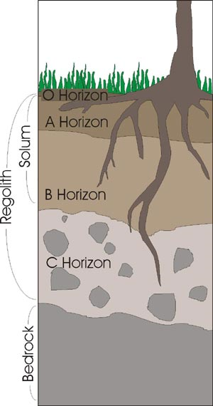
A
- Found at the surface
- Plant and animal matter is converted to humus
- Thickness of horizon A & the speed of decomposition affects the amount of humus
- It can be low in minerals, when rain carries them to horizon B
B
- Many Minerals
- Rocks are less fragmented than horizon A
C (Subsoil)
- Provides raw materials for upper layers
- Contains degraded bedrock & various minerals

What is leaching? A process by which a substance is dissolved and then carried off by water
Soil Texture and Structure
The texture of soil depends on the size of particles composing it and these sizes vary from gravel to microscopic bits of clay. Soil is usually a mix of 3 particle types: Sand, Silt, & Clay.
What are the most fertile soils and what are they made up of? Why are they the most fertile?
- Argilloarenaceous Silts – Made of clay & sand – They contain enough fine particles to retain water and allow minerals to adhere (stick).
Label the following from smallest to biggest particles and include the size of the particles.
Biggest Medium Smallest
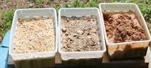

Silt

Clay

Sand

Explain the following sentence using the term soil porosity: The structure of the soil is an indication of how the elements are arranged. (deposited loosely or tightly packed)
- Soil porosity determines the % of free space in a given volume of soil
- Porosity is directly related to soil structure
- It determines how much water and air circulates in the soil
- It determines the development of animal & plant life
- Large pores allow gases and water to circulate
- Small pores retain a portion of the water
Soil Inhabitants
The soil houses an unbelievable quantity and variety of living organisms. Use Figure 22 to explain how these organisms can determine the properties of the soil where they are found. (hint: use drawings and words to explain this concept)
- Earthworms – aerate the soil when they dig and secret mucus that hold soil particles together
- Bacteria – transform atmospheric nitrogen allowing plants to assimilate it
- Plants Roots – extract water and minerals dissolved in soil, and hold soil in place, reducing the effects of erosion

