Types of Soil
***Read in the Textbook Eureka pages 307-310 and then answer the following questions and fill in the blanks to complete your notes on Types of Soil***

Land and Soil are two different things.....
Soil is ______________________________________________________________________
and is created from the mixture of components of the ____________, ______________, and
_____________. Soil is a vital element because ___________________________________.

What would happen without soil in our Earth?

Explain the two formation processes of soil (1. The alteration of the bedrock and 2. The influx of organic material from living things) while defining bedrock, acid, and humus.
1. The Alternation of the bedrock -

2. The influx of Organic Material from Living Things -

Soil Profile
The deeper you dig in the soil, ______________________________________________________.
There are different layers of composition and structure called the soil’s __________________.
The soil profile is generally formed from three horizons A, B, and C. Using your textbook and the diagram below explain the main points of each horizon below:
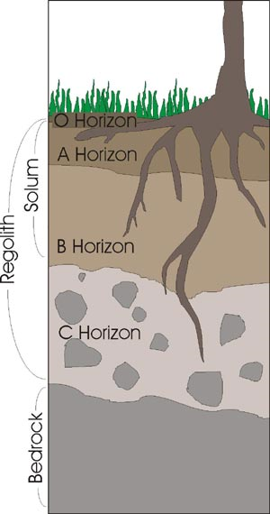

What is leaching?

Soil Texture and Structure
The texture of soil depends on the size of particles composing it and these sizes vary from gravel to microscopic bits of clay. Soil is usually a mix of 3 particle types: __________, _________, & _________.
What are the most fertile soils and what are they made up of? Why are they the most fertile?
Label the following from smallest to biggest particles and include the size of the particles.

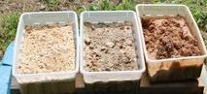

Silt

Clay

Sand

Explain the following sentence using the term soil porosity: The structure of the soil is an indication of how the elements are arranged.

Soil Inhabitants
The soil houses an unbelievable quantity and variety of living organisms. Use Figure 22 to explain how these organisms can determine the properties of the soil where they are found. (hint: use drawings and words to explain this concept)

