**Trigonometry- Enriched notes**

To find unknown sides use: **SOHCAHTOA**

S = sin C= cos T= tan

**O= opposite**- always located opposite of the angle given

**H= hypotenuse**- always the longest side of the triangle

**A= adjacent**- side which is not the O or the H.

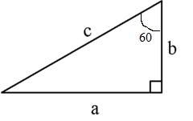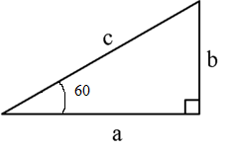

**SOH**

Sin Sin

**CAH**

Cos Cos

**TOA**

Tan Tan

**Steps to determine which to use:**

1- Place hyp, adj and opp on the triangle

2- Determine if use cos, sin or tan

3- Solve for unknown

|  |  |
| --- | --- |
|  |  |
|  |  |
|  |  |

|  |  |
| --- | --- |
|  |  |
|  |  |
|  |  |