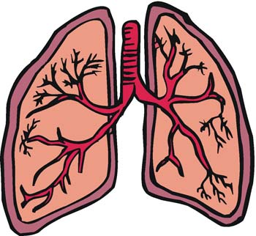
The Respiratory System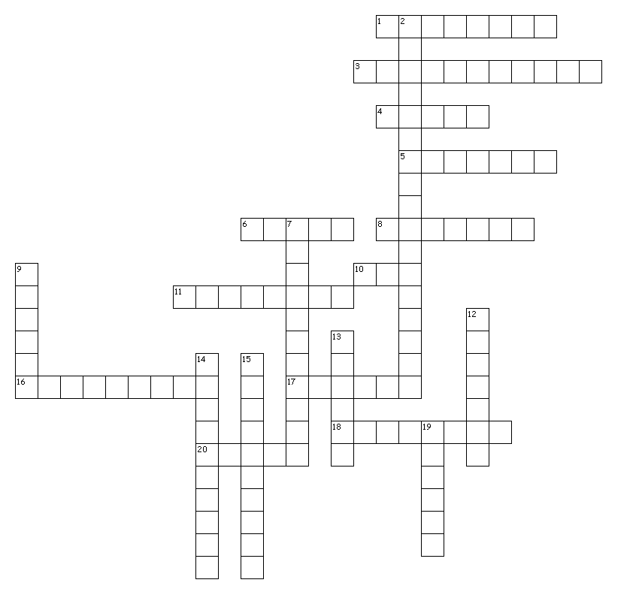

Across
1. Force exerted on a surface
3. Air pressure in lungs decreases and air enters lungs
4. Lines the trachea and bronchial tubes
5. Thin permeable sacs where gas exchange occurs
6. Form of respiratory defense
8. Made of cartilage rings
10. A fluid which is compressible
11. Maximum volume of air we can inhale
16. Process of gas exchange from alveoli to capillaries
17. Number of cycles in one minute
18. Process through which air exits lungs
20. Contain bronchi and alveoli

Down
2. consists of respiratory tract and lungs
7. Tiny blood vessels
9. A fluid which is incompressible
12. handles air between nasal cavity and trachea
13. 21% of air composition inhaled
14. Process of air intake
15. Effects the larynx
19. Contains voice box

