Term 1 Exam Review

  - Fill in the blanks below about the states of matter:
All substances are made of __particles_______ which cannot be ____seen______ by the naked eye because they are _too small___________.

  - Name the three states of matter:__solid___ ___liquid__ ___gas______

  - Fill in the following table summarizing the 6 changes of state

Start Phase | End Phase | Change of State
Gas (G) | Liquid | Condensation (6)
L | G | Evaporation (1)
L | S | Freezing (2)
S | L | Melting (3)
G | S | Deposition (4)
S | G | Sublimation (5)
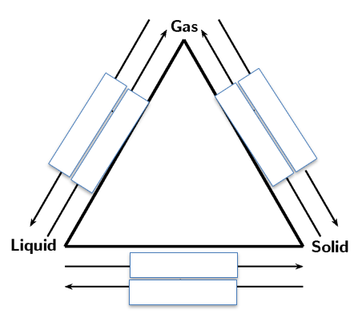
  - Fill in the diagram below

6.
4.
5.
1.

2.
3.

  - Complete the following table
 | Solid | Liquid | Gas
Shape  (definite or not?) | Definite | Not definite | Not definite
Volume  (definite or not?) | Definite | Definite | Not definite
Forces/bonds  (strong or weak?) | Strong | Medium | Weak
Movement | Small vibrations (can’t really move) | Medium vibrations (can flow) | Lots of movement  (spreads wide)
Drawing  (Particle model) | See your notes | See your notes | See your notes

- Give the definition for the following terms:
    - Mass: how much matter is in something

    - Volume: how much space it takes up

    - Density: amount of mass in a given volume

    - Temperature: agitation level of the particles

    - Solubility: ability to dissolve a solute (powder) into a solvent (water)

- Fill in the table below for Mass, Volume and Density

 | Regular Solid | Irregular  Solid | Liquid | Equipment | Unit
Method to determine  Mass | Weigh on scale/balance | Weigh on scale/balance | Place in graduated cylinder(gc.) on scale, add water to gc., subtract numbers | Scale (balance)  and gc. | g
Method to determine  Volume | Ruler  LxWxH | Water displacement | Place in graduated in cylinder | Balance  And gc. | Cm3 or mL
Method to determine  Density | Mass  Volume | Mass  Volume | Mass  Volume | None (need to calculate) | g/mL or  g/cm3

- Define characteristic (CP) and non-characteristic properties (NCP).
CP definition:
Unique or individual feature ____________________________________________________________________
NCP definition: _____not unique or special ________________________________________________________________________________________________________

- List examples of characteristic properties (CP) and non-characteristic properties (NCP).
CP: _______density, melting point, freezing point, boiling point ___________________________________________________________

NCP:
______mass, volume, shape, colour, hieght, temperature, malleable _____________________________________________________________

- Jade wants to measure the volume of a piece of quartz from her mineral collection. She pours 20 mL of water in a graduated cylinder. She gently slides in her piece of quartz. The figure below shows the results obtained. What is the volume of quartz? Show your work. (Don’t forget units!)

27-20 = 7mL = volume
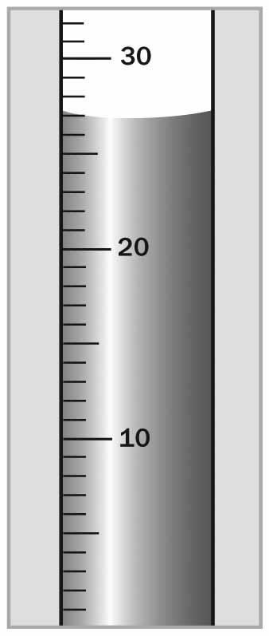

- Solve the density of the marble with a weight of 14 g and 28mL. Show your calculations below. (Don’t forget units!)

D=m/v
= 14g/28mL
D= 0.5g/mL

- How does the volume of an object affect the density if the mass stays the same?
A larger volume creates a smaller density.
Ex: 1/5 = 0.2 but 1/10 = 0.1 so it is a small answer.

The Earth’s Internal Structure

We can divide the Earth’s internal structure into three distinct layers:
- __core________
- __mantle_______
- __crust______

The Earth’s Internal Layers

Crust | The Earth’s crust is ___solid_________. Its thickness varies:
Mantle | Upper Mantle | - Can be up to 670 km thick.  - Is a __semi liquid__________. Composed of partially melted rock.  - Causes _continental drifts__ (plate tectonics) due to _moving layers of earth under the crust_  - Convection:_inner heat of the earth___
 | Lower Mantle | - This layer is ___solid____ despite its high temperature because the _pressure______ is very high.  - It is composed mainly of _silica_, __oxygen_, _iron__, __magnesium___.
Core | Outer Core | - The outer core is _liquid____  - This layer gives is responsible for the Earth’s magnetic field
 | Inner Core | Despite its VERY ____high temperatures___, the inner part of the core is _solid__ because of the enormous _pressure___ holding the core’s particles together.

Relief & Soil
    - What factors affect relief?

Winds, water, and glaciers that combine to.... alter the landscape
Erosion that works on rocks and the Earth’s relief by... rounding summits of mountains and digging & filling valleys

    - The Earth’s relief is constantly changing because of underground forces.
True or False (circle the correct answer)

3. How can humans contribute to the transformation of relief? (give 3 examples)
-walking on the ground (ex: hiking trails)
- They construct roads and airports
- dig mines
- Build cities and towns
- Build farms

4. What are the 3 components that make up soil?
- silt
-sand
- clay

