**Static Electricity Notes**

Def: __________________________________________________________________________

______________________________________________________________________________

* Generally substances are found in a neutral state (same # of + and -). When **electrons** move from one substance to another the materials become charged.

**Rules:**

1. There is a ______ and a _____ charge.

2. Only _______________ can move.

3. If a substance has more _______________ it is _____________charged, if it has more ________________ it is _______________charged.

4. To become neutral again a substance will lose or gain ____________________.

5. Alike charges_________, opposites _____________.

6. ________________ (rubbing causes the electrons to be passed on.

7. *_________________ passes on the charge.

8. A _________________ substance can attract a ___________________ substance because the protons will align with the electrons.

**Examples**

[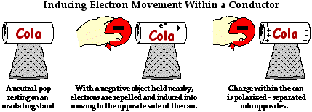](http://www.google.ca/url?sa=i&rct=j&q=&esrc=s&frm=1&source=images&cd=&cad=rja&uact=8&ved=0ahUKEwjekae9vLnJAhUH8z4KHZwrBIEQjRwIBw&url=http://www.physicsclassroom.com/class/estatics/Lesson-1/Polarization&psig=AFQjCNG1wf0SA2UjeNPQ5oEVnx-S8krn8w&ust=1449018417227461)

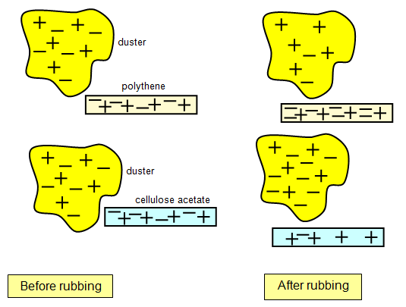

**Electrostatic series**

* Gives a hierarchy of substances and their ability to lose and gain electrons.
* An object above another object will gain electrons from the ones below it.

**Example**

Plastic

Gold

Wood

Cotton

Paper

Glass

Rub: plastic and wood rub: gold and paper

1- What happens if plastic and paper come close?

2- Gold and plastic?

3- Wood and paper?

\***Must memorize**: _______________ will always __________ electrons and be

______________charged. _______________ will always _________ electrons and become ________________ charged.

**Past exam questions**

1. We are given four spheres, A, B C and D. Sphere A is positively charged and the charges on spheres B, C and D are unknown. The following diagram shows what happens to these spheres if we suspend them two by two close to each other.



Given the diagram above, what are the charges on spheres C and D?

A) Sphere C is positively charged and sphere D is negatively charged.

B) Sphere C is positively charged and sphere D is positively charged.

C) Sphere C is negatively charged and sphere D is negatively charged.

D) Sphere C is negatively charged and sphere D is positively charged.

1. Four charged spheres A, B, C and D are suspended from wires.

The following diagrams show what happens when these spheres are suspended in pairs close to each other.



Spheres A and D are suspended close to each other, as are spheres B and C.

Which of the following pairs of diagrams correctly shows what will happen to these spheres?

|  |  |
| --- | --- |
| A) | C) |
| B) | D) |

1. Three conducting spheres M, N and P are used for an experiment in static electricity. The following observations are made :

|  |  |
| --- | --- |
|  | Sphere M is repelled by a glass rod which was rubbed with silk.  Spheres M and N attract each other.  Spheres N and P attract each other. |

What electrical charges are there on the three spheres?

1. Positive for sphere M, negative for sphere N, negative for sphere P
2. Negative for sphere M, positive for sphere N, positive for sphere P
3. Positive for sphere M, negative for sphere N, positive for sphere P
4. Negative for sphere M, positive for sphere N, neutral for sphere P
5. When we rub a glass rod with silk, the rod becomes electrically charged. What happens during the rubbing process?
6. The glass picks up protons from the silk.
7. The glass picks up electrons from the silk.
8. The silk picks up protons from the glass.
9. The silk picks up electrons from the glass.
10. A student was given the following materials:

- a wool cloth

- a vinyl ruler

- two Styrofoam balls (A and B) suspended from ring stands



Using these materials, she performed a laboratory experiment consisting of five steps.

The table below lists the five steps and the results of the first three steps.

|  |  |
| --- | --- |
| Step | Result |
| 1. Rub the ruler with the wool cloth. | 1. The wool cloth and the ruler acquire opposite charges. |
| 2. Touch ball A with the ruler. | 2. Ball A and the ruler have the same charge. |
| 3. Touch ball B with the wool cloth. | 3. Ball B and the wool cloth have the same charge. |
| 4. Bring the ruler close to ball A, but without touching it. | 4. ? |
| 5. Bring the ruler close to ball B, but without touching it. | 5. ? |

What were the results of steps 4 and 5?

1. Result of Step 4: the ruler and ball A repelled each other.

Result of Step 5: the ruler and ball B attracted each other.

1. Result of Step 4: the ruler and ball A repelled each other.

Result of Step 5: the ruler and ball B repelled each other.

1. Result of Step 4: the ruler and ball A attracted each other.

Result of Step 5: the ruler and ball B repelled each other.

1. Result of Step 4: the ruler and ball A attracted each other.

Result of Step 5: the ruler and ball B attracted each other.

1. In the laboratory, a student was given the following substances :

1. ebonite

2. cotton

3. silk

4. glass

The student was told that when two substances from the above list are rubbed together, the one higher up in the list becomes negatively charged and the other becomes positively charged.

The student did the following :

• Rubbed the ebonite and the silk together.

• Rubbed the glass and the cotton together.

• Brought the cotton close to the ebonite.

• Brought the cotton close to the silk.

Which one of the following statements is TRUE?

1. Ebonite and cotton repel each other; silk and cotton repel each other.
2. Ebonite and cotton repel each other; silk and cotton attract each other.
3. Ebonite and cotton attract each other; silk and cotton repel each other.
4. Ebonite and cotton attract each other; silk and cotton attract each other.
5. The list below arranges different substances in increasing order of their tendency to acquire electrons. When two of these substances are rubbed together, the one situated lower on the list attracts electrons from the substance above and becomes negatively charged.

**Electrostatic Series Chart**

|  |
| --- |
| Acetate  **Weak** hold on electrons  Glass  Cotton  Ebonite  Plastic  Rubber  **Strong** hold on electrons |

In the laboratory, a student rubs a cotton cloth with each of the following materials: ebonite, plastic, acetate and glass. He then brings the different materials together:

1. Ebonite and plastic

2. Plastic and acetate

3. Acetate and glass

4. Glass and ebonite

In which of the situations do the materials repel each other?

A) 1 and 2 B) 1 and 3 C) 2 and 4 D) 3 and 4

1. After being rubbed with wool, an ebonite rod attracts small objects. Ebonite is known to hold its electrons very tightly when rubbed against other substances. Wool on the other hand, exerts very weak attraction on its electrons. The diagram below shows the distribution of electrical charges before the two objects (ebonite rod and wool) are rubbed together:

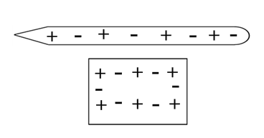

Show the distribution of electrical charges in the two substances after the two objects are rubbed together *(use + and -).*

