**Name:___________________________ SCT 204**

**Sec II Science and Technology Term 3 Exam Review**

**Characteristic/Non-characteristic properties**

1. For each of the following, state whether the properties is characteristic (C) or non-characteristic (NC)

a. mass_______ h. atomic number______

b. volume_____ j. pH____

c. density_____ k. length_____

e. temperature_____ l. distance_____

f. melting point_____ m. colour_____

g. boiling point_____

**Density**

2. Express the following information as a density:

a. An irregular object with a mass of 18 kg displaces 2.5 L of water.

b. A 250 g piece of rock has a volume of 50 cm3.

3. Metal A has a mass of 600 g and displaces 100 cm3 of water while Metal B has the same mass and

has a volume of 75 mL. Which metal has a higher density?

4. What happens to the density of air in a balloon if the volume is increased while the mass remains

constant?

**Atoms, molecules and periodic table**

5. State the name and symbol of the first 20 elements from the periodic table.

6. What is a molecule?_____________________________________________________________

7. What is the smallest particle of matter that can exist on its own? __________________

8. Match the formula with the following molecular model given

gray = oxygen white = hydrogen black = carbon

Carbon dioxide (CO2) Oxygen (O2) Water (H2O) Methane (CH4)

a.______________________ b.________________________

c.______________________ d.________________________

9. For each of the molecules above, state the number of atoms of each element.

a._______________________________________________________________

b._______________________________________________________________

c._______________________________________________________________

d._______________________________________________________________

10.

* 1. How is it determined where in the periodic table an element is placed? ________________________________________________________________
  2. Is it a characteristic property or not? If so, explain why. ________________________________________________________________

11. For each of the following state the location, mass, and charge:

a. Proton:_________________________________________________________________

b. Electron:________________________________________________________________

c. Neutron:_________________________________________________________________

12. If fabric softener is not used, sometimes socks stick together when they are removed from the

dryer. Explain why using electrons and static electricity________________________________

_____________________________________________________________________________

_____________________________________________________________________________

_____________________________________________________________________________

13. Same charges will (attract or repel) and opposite charges will (attract or repel). [circle the correct answer]

**Cells and cellular processes**

14. Match the cell organelles on the left to their appropriate roles on the right

a. Cell membrane__________________ 1) Produce energy

b. Cytoplasm___________________ 2) Holds organelles in place

c. Nucleus____________________ 3) Absorbs energy from the sun for photosynthesis

d. Endoplasmic reticulum__________ 4) Controls what comes in and goes out of the cell

e. Vacuoles ___________________ 5) Storage of nutrients and other substances

f. Mitochondria________________ 6) Thick support for plant cells

g. Cell wall__________________ 7) Directs cell’s activities

h. Chloroplast________________ 8) Cellular transport and protein production

14. Label the organelles (except chloroplast and cell wall) from question 13 on the animal cell below

[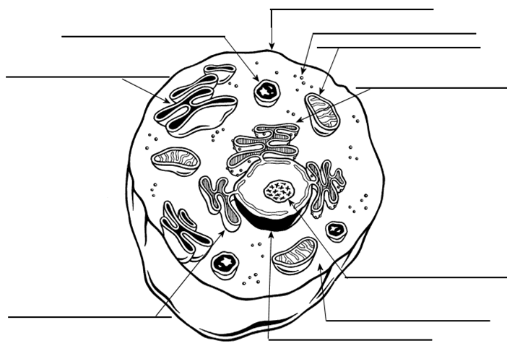](https://ayoqq.org/explore/cell-drawing-unlabeled/)

15. Label the organelles from question 13 on the plant cell below

[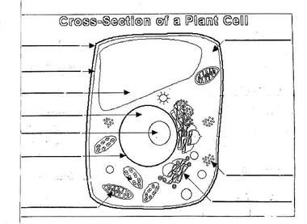](https://www.pinterest.com/pin/497225615079754551/)

16. All living things are comprised of cells. It is the bases of life. What are other characteristics of living

things? ________________________________________________________________________

______________________________________________________________________________

______________________________________________________________________________

17. Write the equation for cellular respiration_______________________________________________

18. State whether the statement describes diffusion (D) or osmosis (O)

1. Solute moves from a high concentration to a low concentration_________
2. Water moves from an area of low solute concentration to an area of high solute concentration_____

19. Label the diagram of photosynthesis

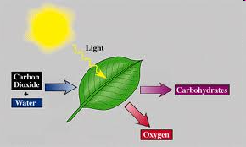

20. What is the difference between photosynthesis and cellular respiration?_____________________

_____________________________________________________________________________

_____________________________________________________________________________

21. What is the term used to describe molecules when they are evenly spread out in the space they

occupy?___________________________________________

**Reproduction**

22. Define the following:

a**.**  Asexual reproduction:

b. Sexual reproduction:

c. Embryo:

d. Fertilization:

e. Ova:

f. Fetus:

g. Spermatazoa:

h. Zygote:

23. Describe, in steps, the reproductive process of humans: _____________________________________

_____________________________________________________________________________________

_____________________________________________________________________________________

_____________________________________________________________________________________

_____________________________________________________________________________________

_____________________________________________________________________________________

24. What are the stages of Human Development starting at fertilization with the zygote?

_____________________________________________________________________________________

_____________________________________________________________________________________

_____________________________________________________________________________________

25. Label the following diagram of the female reproductive system.

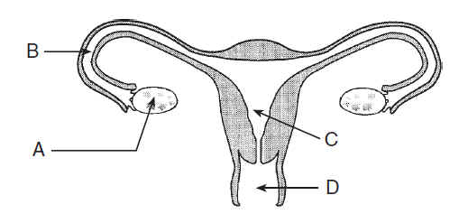

A.______________________

B.______________________

C.______________________

D______________________

E. Label the cervix

F. Add follicles to the

diagram and label them

25. Label the following diagram of the male reproductive system.

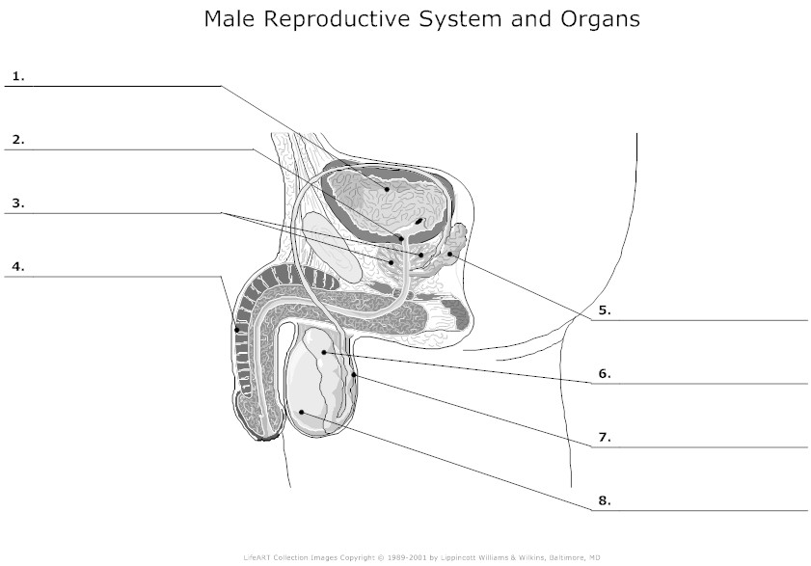

9. Label the Cowper’s gland 10. Label the scrotum

27. Where in the human body is the pituitary gland located? __________________________________

28. State the differences between sexual and asexual reproduction. Use diagrams of fertilization and

mitosis to help explain.____________________________________________________________

______________________________________________________________________________

______________________________________________________________________________

29. Name 3 STIs. What are some health risks associated with an STI? ___________________________

______________________________________________________________________________

______________________________________________________________________________

**Energy Transformations**

30. Fill in the blanks

a**.**

**C:\Users\user\AppData\Local\Microsoft\Windows\Temporary Internet Files\Content.IE5\3D4ZCY0K\MC900234008[1].wmf C:\Users\user\AppData\Local\Microsoft\Windows\Temporary Internet Files\Content.IE5\WK4ZESJF\MC900197730[1].wmf**

**______________________ _____________________**

b.



**______________________ _____________________**

c.

 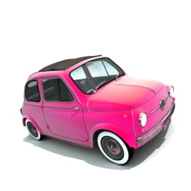

**______________________ _____________________**

d.

** C:\Users\user\AppData\Local\Microsoft\Windows\Temporary Internet Files\Content.IE5\3D4ZCY0K\MC900311102[1].wmf**

**______________________ _____________________**