**Name:___________________________ SCT 204**

**End of Cycle Final Exam Review**

**Properties of Matter**

**Mass**

1. What unit would you use to measure the mass of the following objects: milligrams (mg), grams (g) or kilograms (kg)?

a. Your school bag full of books ____________ b. A skateboard_________________

c. A pencil _________________ d. An Orange___________________

e. A stamp____________________

**Volume**

2. What unit would you use to measure the volume of the following objects: litre (L), millilitres (mL), cubic centimeters (cm3), or cubic meters (m3).

a. water in a swimming pool ____________________ b. a box of facial tissues ___________

c. a box of Smarties_________________________ d. A can of juice_______________

e. a bus_________________________

3. Determine the volume of the object in the graduated cylinders?

a. _______________ b.______________

[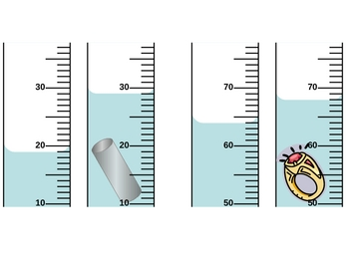](http://tcdn.teacherspayteachers.com/thumbitem/Graduated-Cylinders/original-99361-1.jpg)

4. What is the volume of the objects?

a.__________________ b. _________________

20 cm 2 cm

2 cm

4 cm 40 cm

20 cm

**Density**

5. Express the following information as a density:

a. An irregular object with a mass of 18 kg displaces 2.5 L of water.

b. A 250 g piece of rock has a volume of 50 cm3.

6. Metal A has a mass of 600 g and displaces 100 cm3 of water while Metal B has the same mass and has a volume of 75 mL. Which metal has a higher density?

7. What happens to the density of air in a balloon if the volume is increased while the mass remains constant?

**Particle Model**

8. Identify the following states of matter

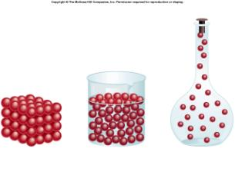

a.________ b.__________ c.___________

9. Describe what happens to particles

a. when they are heated __________________________________________________________

b. when they are cooled ___________________________________________________________

**Pure Substances and Mixtures**

10. A pure substance contains only ___________________ _________________________ of ___________________________. Examples are salt, sugar, distilled water, diamond, and carbon dioxide.

11. A mixture contains at least 2 types of particles. There are 2 types of mixtures:__________________

mixtures (called solutions) and _________________________________ mixture. Both have at least two types of particles.

12. Homogeneous mixtures have particles that are _________________________ ________________

or spread out evenly in the mixture so it appears when you look at it that there are only 1 types of particle but there are at least 2 types of particles there. Examples are ___________________________,

________________________, ________________________ and _________________________.

13. Heterogeneous mixtures have particles that are not uniformly distributed so that when you see at least ____________ __________________of __________________ either with your eyes or with the help of a microscope. Examples are _________________________, ____________________ and ________________________________.

14. Solutions are ________________________________ mixtures.

15. Complete the table by putting ONE check in the correct box for each substance.

|  |  |  |  |
| --- | --- | --- | --- |
| **Example** | **Homogeneous** | **Heterogeneous** | **Pure Substance** |
| Sugar |  |  |  |
| Tap water |  |  |  |
| Pond water |  |  |  |
| Plant cells |  |  |  |
| 7-up |  |  |  |
| Olympic medals |  |  |  |
| Porphyritic rock |  |  |  |
| Silver chain |  |  |  |
| Corn syrup |  |  |  |
| Milk |  |  |  |

**Atomic Structure**

16. Match the formula with the following molecular model given

gray = oxygen white = hydrogen black = carbon

Carbon dioxide (CO2) Oxygen (O2) Water (H2O) Methane (CH4)

a.______________________ b.________________________

c.______________________ d.________________________

**Cells**

17. Match the cell organelles on the left to their appropriate roles on the right

a. Cell membrane__________________ 1) Produce energy

b. Cytoplasm___________________ 2) Holds organelles in place

c. Nucleus____________________ 3) Absorbs energy from the sun for photosynthesis

d. Endoplasmic reticulum__________ 4) Controls what comes in and goes out of the cell

e. Vacuoles ___________________ 5) Storage of nutrients and other substances

f. Mitochondria________________ 6) Thick support for the cell

g. Cell wall__________________ 7) Directs cell’s activities

h. Chloroplast________________ 8) Cellular transport

18. Label the diagram of photosynthesis

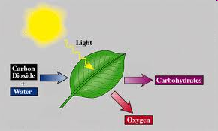

**Plate tectonics**

19. Describe what type of tectonic activities would take place for each of the following types of plate movement:

a. Divergent Plate Movement ____________________________________________________________________________________________________________________________________

____________________________________________

b. Convergent Plate Movement

____________________________________________________________________________________________________________________________________

____________________________________________

c. Transform Plate Movement

____________________________________________________________________________________________________________________________________

____________________________________________

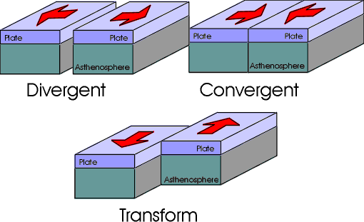

20. For each of the movements described in question 19, state which cause earthquakes, volcanoes, mountains, and tsunamis.

____________________________________________________________________________________

____________________________________________________________________________________

____________________________________________________________________________________

**____________________________________________________________________________________**

**Acids and Bases**

21. Determine whete the substances are acid, base, or neutral, by putting ONE check in the appropriate box.

|  |  |  |  |  |
| --- | --- | --- | --- | --- |
| *Substance* | *pH Value* | *Acid* | *Base* | *Neutral* |
| Glass Cleaner | 10.9 |  |  |  |
| Bottle Water | 7.0 |  |  |  |
| Antacid | 8.2 |  |  |  |
| Orange Juice | 2.0 |  |  |  |
| Spaghetti Sauce | 6.6 |  |  |  |

**Physical and Chemical Change**

22. From the statement below, circle the ones which ARE signs of chemical change:

a. A gas is formed b. A precipitate is formed c. The substance melts

d. The object breaks e. Light is emitted f. A substance dissloves into another

g. Heat is emitted h. The color changes i. The substance evaporates

23. Fill in the blanks by writing “Physical Change” OR “Chemical Change” in the space provided.

a. A _______________________________ is a change of matter from one form to another

without a chance in chemical properties.

b. A _________________________ is irreversible

c. Sublimination is an example of a ___________________________.

d. A _____________________________ is a change that occurs when a substance changes

composition by forming one or more new substances.

e. A _______________________ is reversible.

24. Changes in state are ______________________________ changes. In physical changes, the particles of teh substance remain the ________________________.

25. In physical chagnes, the only thing that changes is the ______________________ of the substance, The substance retains its _____________________ properties.

26. A substance that undergoes a physical change can return it its _____________________________

___________________________.

27. Changes in state are physical changes. Substances can undergo:

a. Melting: solid state to _________________________state. Temperature of transition is

called the ________________________ point.

b. Boiling and Evaporation: liquid state to the gaseous state. Temperature of tansition is called

the ________________________________ ___________________________. Examples

are boiling water and an example of evaporation is clothes drying in the sun.

c. Sublimation: solid state to the __________________________ state. Example – ice cubes

gradually disappearing in the freezer.

d. Condensation: ____________________________ state to liquid state – Temperature of

trnsition is called the condensation point. (It happens at the same temperature as the

boiling point). Example – water vapour forms clouds.

e. Solidification: __________________ state to ________________________ state.

Temperature of transition is called the freezing point. Example – liquid water freezing

into ice.

f. _________________________: gaseous state to solid state. Example – water vapour freezing

to form frost.

28. Unlike physical changes, chemical changes result in new ___________________________ that have their own properties. Chemical changes can be recogniced by the following signs:

a. _______________________________________________________________________

b.________________________________________________________________________

c.________________________________________________________________________

d.________________________________________________________________________

29. Determine wheter the following are physical (P) or chemical (C) changes.

a. Adding chlorine to water in a pool. __________

b. Humidity in the air from a shower transformed into droplets on the mirror __________

c. Moulding a figure out of plasticine. __________

d. Preparing hot chocolate using a concentrated syrup and water (or milk) __________

e. Melting ice that has built up under skis __________

f. Clothes drying in the sun ___________

g. Making frozen treats with fruit juice __________

h. Snoow crystals froming from water vapour in the air __________

i. Using dry ice to make smoke during a concert __________

**Phase Changes**

30. Identify the process in the following diagram: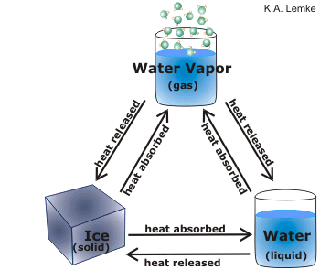

f.

e.

Phase Changes

d.

c.

b.

a.

a._____________________________________________

b._____________________________________________

c._____________________________________________

d._____________________________________________

e._____________________________________________

f._____________________________________________

31. Label the following diagram with the appropriate: state of matter for A, C, and E; phase change for changes B and D (Ignore F)

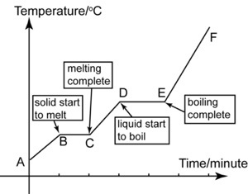

32. Name the three methods of asexual reproduction in plants:_______________________________

____________________________________________________________________________.

33. Name the three methods of sexual reproduction in plants:________________________________

_____________________________________________________________________________.

34. Define the following:

a**.**  Asexual reproduction:

b. Sexual reproduction:

c. Cotyledon:

d. Embryo:

f. Seed:

g. Seed coat:

h. Fertilization:

i. Pollination:

j. Self-pollination:

k. Cross-pollination:

l. Angiosperms:

m. Gymnosperms:

n. Spermatozoon:

o. Spores:

p. Ova:

35. How are seeds dispersed in nature? ___________________________________________________

_____________________________________________________________________________________

36. Which part of the flower becomes the fruit that we eat? __________________________________

37. How do flowers attract insects? **_____________________________________________________**

38. Label the following diagram of the flower:

Anther Filament Ovary

Pistil Stamen Stigma

Style

[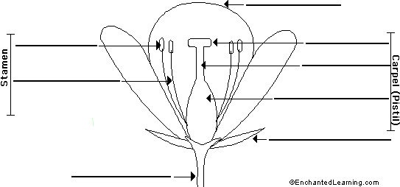](http://www.enchantedlearning.com/label/)

39. Describe, in steps, the reproductive process of a plant: _____________________________________

_____________________________________________________________________________________

_____________________________________________________________________________________

_____________________________________________________________________________________

_____________________________________________________________________________________

_____________________________________________________________________________________

40. Describe, in steps, the reproductive process of human: _____________________________________

_____________________________________________________________________________________

_____________________________________________________________________________________

_____________________________________________________________________________________

_____________________________________________________________________________________

_____________________________________________________________________________________

41. What are the stages of Human Development starting at fertilization with the zygote?

_____________________________________________________________________________________

_____________________________________________________________________________________

_____________________________________________________________________________________

42. Label the following diagram of the human reproductive systems

A. Female system

.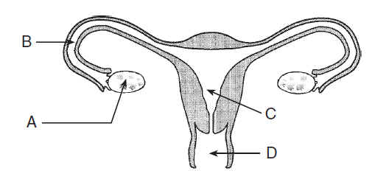

A._____________________________ B.______________________________

C._____________________________ D.______________________________

E. Label the cervix F. Add follicles to the diagram and label them

B. Male system

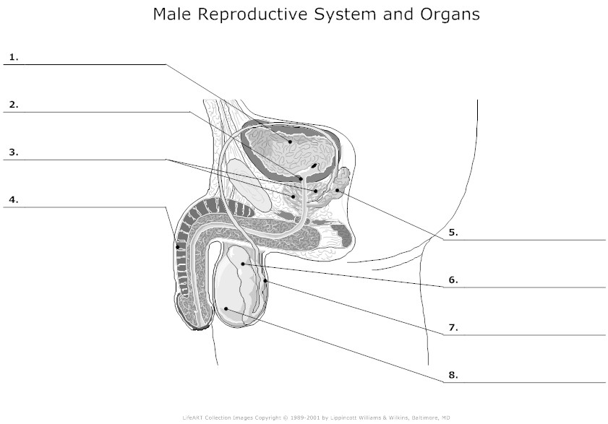

1.­______________________________________ 2._______________________________

3.­______________________________________ 4._______________________________

5.­______________________________________ 6._______________________________

7.­______________________________________ 8._______________________________

9. Label the cowper’s gland 10. Label the scrotum

43. Where in the human body is the pituitary gland located? __________________________________

**Rocks and Minerals**

44. Complete the table below on rocks

|  |  |
| --- | --- |
| Type of Rock | How it is formed |
|  |  |
|  |  |
|  |  |

**Technology**

45. For each of the following indicate the effort force, fulcrum, and load, and state the class of lever the object represents.

a. Class:________________

C:\Users\user\AppData\Local\Microsoft\Windows\Temporary Internet Files\Content.IE5\K2EURTH5\MC900215065[1].wmf

b. Class:_________________________

C:\Users\user\AppData\Local\Microsoft\Windows\Temporary Internet Files\Content.IE5\A17NRFQ7\MC900234446[1].wmf

c. Class:________________________

C:\Users\user\AppData\Local\Microsoft\Windows\Temporary Internet Files\Content.IE5\K2EURTH5\MC900391198[1].wmf

**Energy Transformations**

46. Fill in the blanks

a**.**

**C:\Users\user\AppData\Local\Microsoft\Windows\Temporary Internet Files\Content.IE5\3D4ZCY0K\MC900234008[1].wmf C:\Users\user\AppData\Local\Microsoft\Windows\Temporary Internet Files\Content.IE5\WK4ZESJF\MC900197730[1].wmf**

**______________________ _____________________**

b.

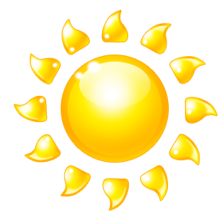

**______________________ _____________________**

c.

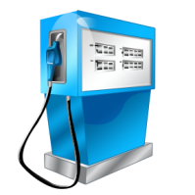 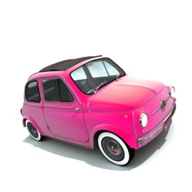

**______________________ _____________________**

d.

** C:\Users\user\AppData\Local\Microsoft\Windows\Temporary Internet Files\Content.IE5\3D4ZCY0K\MC900311102[1].wmf**

**______________________ _____________________**

**Scientific Reasoning**

47. Tommy wishes to conduct an experiment. He records the mass of a piece of paper. The mass is 4.4g. He then sets the piece of paper on fire and collects the resulting ashes. He records the mass of the ashes and notices that it is 3.2 g. Explain what has happened in this experiment.

___________________________________________________________________________________

___________________________________________________________________________________

___________________________________________________________________________________

___________________________________________________________________________________

___________________________________________________________________________________

___________________________________________________________________________________

**Solar System**

48. Explain how day and night, and the seasons of the year are related to the Earth’s rotation, revolution, and tilt.

___________________________________________________________________________________

___________________________________________________________________________________

___________________________________________________________________________________

___________________________________________________________________________________

___________________________________________________________________________________

___________________________________________________________________________________

**Forces and Motion**

49. All motion is a combination of 4 simple types. Name them and give an example of each one.

a. _________________________ motion example____________________________

b. _________________________ motion example____________________________

c. _________________________ motion example____________________________

d. _________________________ motion example____________________________

50. What type of for causes a bar to bend or break when something heavy is hung from it?

__________________________________________________________________________________

51. Pulling on an object might cause it to stretch or break. What type of force is described here? Name the force and provide an example. ______________________________________________________

___________________________________________________________________________________

52. What force is the opposite of tension? Name the force and provide an example.______________

___________________________________________________________________________________

53. What force creates a twisting motion? ? Name the force and provide an example.______________

____________________________________________________________________________________

54. What force will tear a piece of paper in half? ? Name the force and provide an example._________

_____________________________________________________________________________________

55. Describe the characteristics of the link produced in each of the following cases:

a. an ice cream container and its lid_______________________________________________________

b. a photo stuck to a bulletin board with a thumbtack_________________________________________

c. a sticker pasted in an album____________________________________________________________

56. Name 2 technical objects whose function is to guide a part__________________________________

_____________________________________________________________________________________

57. What is the difference between guiding rotation and guiding translation?______________________

_____________________________________________________________________________________

**Living Things**

58. Observe the following photo of a cat and kittens. All of the cats belong to *Felix catus* species.

[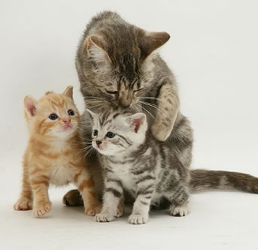](http://1.bp.blogspot.com/-2s1RQ0d6x0w/Trz-5SmJHUI/AAAAAAAAacU/7IslGTcApfY/s1600/cats+and+kittens+playing1.jpg)

What are the 4 criteria that help to determine whether two animals belong to the same species?

___________________________________________________________________________________

___________________________________________________________________________________

___________________________________________________________________________________

___________________________________________________________________________________

59. Each animal has specific physical adaptations that allow it to survive in its natural habitat. The following is a photograph of a hummingbird in its natural habitat:

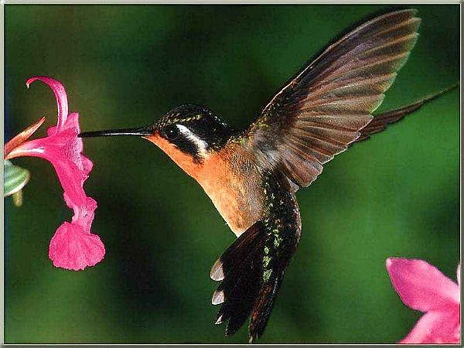

Name and explain two physical adaptations that this hummingbird has that allows it to survive and find food in its natural habitat.

___________________________________________________________________________________

___________________________________________________________________________________

___________________________________________________________________________________

___________________________________________________________________________________

**Water Cycle/Erosion**

60. The Sahel is a region in Africa that is located to the south of the Sahara desert. Many Africans who live in this region depend on herding animals that graze on the grasses that grow there. When the roots of these grasses get eaten, there is nothing holding down the soil. This means that when the desert winds blow from the north, all the fertile soil is blown away. Given that this is the situation in the Sahel, provide a detailed explanation of what should be done to deal with the issue of wind erosion in this regions.

___________________________________________________________________________________

___________________________________________________________________________________

___________________________________________________________________________________

___________________________________________________________________________________

___________________________________________________________________________________

___________________________________________________________________________________

___________________________________________________________________________________

___________________________________________________________________________________

___________________________________________________________________________________

___________________________________________________________________________________

___________________________________________________________________________________

___________________________________________________________________________________

61. List the methods used to obtain potable water from water that is contaminated.

___________________________________________________________________________________

___________________________________________________________________________________

___________________________________________________________________________________

___________________________________________________________________________________

___________________________________________________________________________________

___________________________________________________________________________________

___________________________________________________________________________________

___________________________________________________________________________________

___________________________________________________________________________________