Sec I Term 3 review
Students are to go over the Review from term 2 plus
Living World
1. How are seeds dispersed in nature? Animals, wind, water, plants themselves, and humans
2. Which part of the flower becomes the fruit that we eat? Ovary
3. How do flowers attract insects? By sweet smell and colourful petals
Technological World
1. Describe each of the following links as direct or indirect, removable or nonremovable:
a) a pen and cap direct and removable
b) the hands on a clock indirect and removable
c) the label on a bottle indirect and nonremovable

2. Define guiding control and provide an example for each: a) a translational guiding control
b) a rotational guiding control A guiding control directs the motion of the machine.
a) A translational guiding control would be the tracts of a window sliding up and down.
b) A rotation guiding control would be the holder of a paper towel roll

Earth and Space

1. Identify the four layers of the atmosphere and state the main activities in each layer.

Troposphere: The closest layer to Earth. Weather and clouds occur in here.
Stratosphere: The earth's ozone layer (absorbs ultraviolet rays) is located here.
Aircrafts fly in this layer, too.
Mesosphere: Meteors burn up while entering this layer.
Thermosphere: Air particles in this layer are electrically charged enabling radio waves.
Northern lights (aurora) is formed in this layer too.

2. What is the percentage composition of the atmosphere?

21% OXYGEN (O₂)
78% NITROGEN (N₂)
0.04% CARBON DIOXIDE(CO₂)
~0.9% ARGON (Ar)

3. List 4 ways in which the atmosphere acts as a protective envelope.

Blocking out harmful ultraviolet rays

Due to friction, the atmosphere destroys meteors

Due to the greenhouse effect, the atmosphere reduces temperature differences on Earth

Without the gases and water vapor in our atmosphere life would be impossible.

Without the atmosphere the temperature would rise to 80ºC during the day and drop to
-140ºC at night. Therefore, the atmosphere acts as an insulator

4. What are the main causes contributing to the decrease of the ozone layer? Why is this worrisome?

CFC’s and aerosol products

The ozone protects us from the harmful ultraviolet (UV) rays associated with skin cancer and
cataracts.

5. List the planets in our solar system in order and provide 2 characteristics about each planet.

Mercury - Closest to sun; Shortest orbit; Temperature: HOT on the side facing the sun and
FREEZING on the side turned away from the sun.

Venus - Brightest & Hottest; High levels of carbon dioxide; Rotates from East to West; Known
as the morning and evening star

Earth - Supports life; Mostly water; 1 moon

Mars - Reddish color; 2 moons; Frozen water

Jupiter – Largest; Colourful bands made of clouds; Famous large red spot which is a storm; 60
moons

Saturn - 2nd largest planet; Many rings; Stormy bands of gases; 31 moons

Uranus - Very cold; Greenish-blue colour; Thin rings; Rotates on its side; 27 moons

Neptune - Blue colour; Large storm spot called “Great Dark Spot”; Clouds for layers; 6 rings;
13 moons

6. List the four inner planets. Mercury, Venus, Earth, Mars

7. List the four outer planets. Jupiter, Saturn, Uranus, Neptune

8. Where is the asteroid belt located? Between Mars and Jupiter, separating the inner and outer
planets.

9. What are the main differences between the inner and outer planet? Inner planets are solid and hot; outer planets gaseous and cold.

10. Draw a diagram of a comet and label the head, tail, and nucleus.

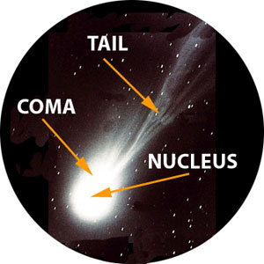
Head

11. Define: light year, astronomical unit, asteroid, and meteoroid.

Light year – the distance light travels in one year = 9.4605284 × 10¹⁵ meters
Astronomical unit – distance between the Earth and sun = 149 597 871 kilometers
Asteroid – A small celestrial body that has a diameter no greater than a few hundred Km
Meteoroid - A meteoroid is significantly smaller than an asteroid, ranging from small grains to
1-meter wide

12. What is the difference between rotation and revolution? Which is considered to be a day, and
which is a year?

Rotation – the amount of time required for a planet to spin around once on its axis allowing
for day and night.
Revolution – the amount of time that it takes the planet to make one complete orbit around
the sun – considered to by 1 year.
The seasons on Earth are due to the tilt of the Earth’s axis as it revolves round the sun.

13. The tilt of the Earth and the orbiting around the sun give rise to which phenomena? The seasons

14. What is the difference between a lunar eclipse and a solar eclipse? A lunar eclipse has the Earth located between the sun and the moon, blocking light to the moon. A solar eclipse has the moon between the Earth and sun, blocking light to part of the Earth.

15. List the four phases of the moon in order, starting with the new moon. New moon, first quarter, full moon, last quarter

16. What do we call a form of visible energy? Light

17. What are the colors of light, in order? Which has the longest wavelength? Which has the shortest?

Red, Orange, Yellow, Green, Blue, Indigo, Violet
Longest wavelength – red
Shortest wavelength - violet

18. Define the following: Umbra, penumbra, and gravity.
Umbra – total eclipse
Penumbra – partial eclipse
Gravity is a force of attraction between two objects and is explained by Newton’s law of
universal gravitation

19. Define asthenosphere and plate tectonics.

Asthenosphere - The upper layer of the earth's mantle, below the lithosphere
Plate tectonics – The movement of the vast rigid plates of the Earth’s crust including the
continents and underwater relief.

20. What are the three types of plate movements? Provide a diagram for each.

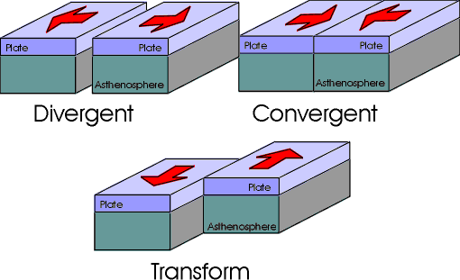

- Move apart (divergence)
- Move toward each other (convergence)
- Slide against each other (transform fault)

21. The tectonic plates move due to convection. Outline this process in three sentences.

Magma is heated and then rises. It cools when it reaches the surface. Cooler magma then sinks.

22. When two plates meet each other, two things can happen. What are those two things? Volcanoes
and Mountains.

23. What are two ways that volcanoes can form?

- Volcanoes can form when an oceanic plate sinks under a continental plate. The oceanic plate melts and becomes magma. This magma then tries to rise up.

- Volcanic eruptions can also occur when two plates move apart. These eruptions are less violent since there is no resistance.

24. What are the positive effects of volcanoes?

Fertilize the soil and Magma can heat water and allow for geothermal energy - Example: geysers.

25. What causes earthquakes? What is the name of the scale used to measure earthquakes?

Friction between two tectonic plates produces shock waves. These shock waves, called seismic
waves, can damage structures. Scale used is the Richter scale.

26. What level magnitude (range) of an earthquake produces the following: a) registered but not felt, b) felt but rarely causes damages, c) at the most slight damage, d) can cause damage in areas approximately 100 km across, d) causes major damage, e) “great” earthquake, f) rarely occurs ( Japan in recent years)

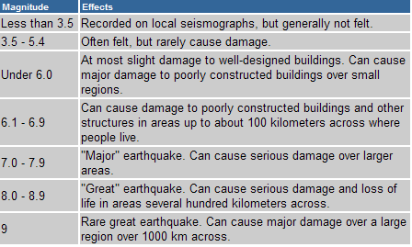

27. Label diagram of the water cycle.

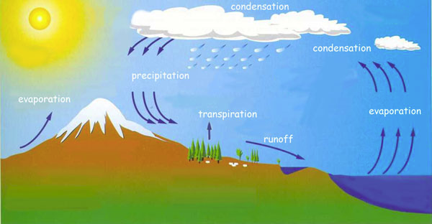

28. Define erosion and potable water.

Erosion is the wearing away of rocks and soil by water, wind, and human activity.
Potable water is another name for drinkable water.

29. What are the three states of erosion?

Weathering – Fragmenting (breaking down) of the surface rocks.

Transportation – Rock fragments are carried by runoff water and wind. Erosion is
compounded by the abrasive power of fragments transported by the water.

Sedimentation – The fragments suspended in the water, or transported by glaciers or wind,
accumulate and are compacted at the bottom of the oceans. They also accumulate in
valleys and plains.

30. What are the three categories of erosion? Give one example for each.

Biological – caused by living organisms. Ex – decomposition of living things can create an acid
which attack rocks. Ex – Tree roots infiltrate rocks and ultimately break them down.

Mechanical – caused by variations in temperature, pressure, wind, and water Ex Niagara Falls
which recedes 3 m every year because the water wears down the rock.

Chemical Erosion – Rain can become acidic because of pollutants and it chemically changes
certain minerals in the soil such as limestone. This process gradually destroys rocks.
Ex – Acid rain can alter the surface of public statues.

31. Prevailing winds are not distributed evenly over the Earth’s surface. What two factors explain this phenomena. Convection cells and Coriolis effect.

32. Explain how air circulates in convection cells.

When air warms up, it increases in volume and rises. This creates a low-pressure area on the
ground below it. Colder air thus rushes in to replace the air that has risen. The warm air
moves and is cooled, bringing it down to the surface again. The hot air mass and the cold air
mass are constantly in motion. The looping movements are called convection cells.

33. What is the Coriolis Effect? What three types of winds do they produce? Where are these winds located?

As the Earth rotates from west to east, it diverts air masses in the atmosphere to the right
(Northern Hemisphere) or to the left (Southern Hemisphere). This is called the Coriolis Effect.

This movement produces the trade winds (equator and tropics), prevailing west wind (middle
latitudes), and polar east wind (polar regions)

34. What is the difference between a raw material and material? Which would trees be considered as? Which would lumber be considered as?

Raw materials – natural resources from which we produce materials.
Material – processed natural resources from which we make objects

Trees are raw material and lumber is material.

