Name: _____________________________________

Review for Midyear Exam (2017-18)

Cells and Genetics

1. Which cells in the human body normally have a diploid number of chromosomes in their nuclei?
a) all cells b) only cells produced by mitosis
c) only cells produced by meiosis d) only reproductive cells
2. The diploid chromosome number in humans is…
a) 23 b) 46
b) 48 d) 92
3. The following is a portion of a DNA strand: CCG ATT TGC ACG. The complimentary DNA strand would be :
a) CCG ATT TGC ACG b) GGC TAA ACG TGC
c) GGC UAA UCG UGC d) CCG TAU UCG UGC
4. Crossing over of chromosomes is most likely to occur during:
a) meiosis b) mitosis
c) cell death d) fertilization
5. DNA is made up of ___________ types of nucleotides
a) 1 b) 2
c) 3 d) 4

6. Why do cells divide?
1. To make new cells (growth)
2. To repair tissue
7. Give 3 differences between the processes of Mitosis and Meiosis.
a. Cells produced by mitosis have 46 chromosomes, cells produced by meiosis have 23 chromosomes
b. Mitosis results in 2 daughter cells, meiosis results in 4 daughter cells
c. Mitosis is used for growth and repair of tissues, meiosis is used only to produces reproductive cells (gametes).

8. Identify the processes as Meiosis or Mitosis
- Produces identical cells Mitosis
- Used for sexual reproduction Meiosis
- Has 2 cell divisions Meiosis
- Contains 46 chromosomes (human cell) Mitosis
- Produces gametes Meiosis
- Produces 4 daughter cells Meiosis
- Contains half the genetic material of parent cell Meiosis
- Used for growth and repair of cells and tissues Mitosis

9. What do the letters GMO mean? Genetically modified organism
10. Give 2 methods to create a GMO:
1- Insert genes of another organism to make the first organism more resilient (ex: making wheat grow shorter so it is not killed by high winds)
2- Change the genes of an organism so it will not be effected by pesticides, herbicides etc.

Reproduction and Puberty

- Gametes are
a) Sex cells c) n

b) Haploid d) A, B and C are all correct

- Fertilization occurs….
a) When ovulation happens
b) When the sperm fuses with the ovum
c) When a female has her period
d) When a male and female have intercourse

- What is a Zygote?
a) A fertilized ovum c) An immature ovum

b) A follicle d) A gland which secretes hormones

- The _____1______ gland is found in both males and females it secretes _____2_____ and _____3_____.

 | 1 | 2 | 3
a) | Pituitary | Estrogen | Progesterone
b) | FSH | Estrogen | LH
c) | Pituitary | FSH | LH
d) | Pituitary | Testosterone | Estrogen

- Days 1-5 in the menstrual cycle are referred to as …1… and days 15 – 28 are referred to as…1…

 | 1 | 2
a) | Menstrual phase | Proliferation phase
b) | Proliferation phase | Secretory phase
c) | Menstrual phase | Secretory phase
d) | Secretory phase | Menstrual phase
6. In females, progesterone is responsible for:
a) Preparing the uterus for implantation and stimulating the production of milk in pregnant women
b) The degeneration of the uterine lining, causing females to get their periods
c) Causing the release of ova from the ovaries.
7. In the female, once fertilization takes place, the embryo implants itself in the…
a) Endometrium
b) Ovaries
c) Fallopian tube
8. What hormone is responsible for ovulation?
a) FSH
b) LH
c) Estrogen

9. True or False:
a- Hormones secrete glands F
b- The male hormones are testosterone, FSH and LH T
c- The primary sexual characteristic for males is the start of their cycle and sperm production F
d- A penis must be erect on order to ejaculate. T
e- A female cannot get pregnant form pre-mature ejaculation. F
10. Give three secondary sexual characteristics which occur in females only.
Breast development, pelvis widens, fatty tissues on the hips

11. Give a secondary sexual characteristic which occurs in both males and females.
Underarm hair appears, pubic hair appears, psychological changes occur

12. Name the two hormones responsible for the maturation of the follicle.

1. FSH
2. LH
13. What is the difference between an oocyte and an ovum?
An oocyte is a cell capable of becoming a mature ovum and a ovum is a mature oocyte capable of being fertilized
14. Define infertility.
The inability to conceive a child after 12 months of sexual relations without contraception
15. What are all of the methods couples can use to help have a child when they are deemed infertile?
Ovarian stimulation
Artificial Insemination
In Vitro Fertilization
Microinjection
16. List 2 pros and 2 cons that accompany assisted reproduction.
Pros:
-Infertile couples can have children
-Same-sex couples can have children
Cons:
-Risk of multiple births
-Expensive
-Frozen embryos need to be dealt with
- Risk of embryo selection based on desired traits

Nutrition & Digestion

1. . Fill in the table
 | Protein | Carbohydrates | Fats
Function | Growth and Repair  3rd source of Energy | 1st source of Energy | 2nd source of Energy
Examples of it | Meats and Alternatives  Tofu | Pastas and Grains  Fruits and Vegtables | Milk and Dairy  Meat and Oils
Number of grams  needed per day | 2 grams/KG of body weight | Approx 500 g | Approx 75 g
What you multiply  to get from grams (g) into kJ | X 17kJ/g | X 17 kJ/g | X 37 kJ/g
The amount of kJ  needed per day | 34 kJ per KG of body weight | 8500 kJ | 2775 kJ

2. What 4 nutrients are responsible for regulating metabolism?

Vitamins | Minerals | Water | Fibre

3. Calculate the kJ intake of the cookies:
15 g of carbohydrates 8 g of fat 3 g of protein

15 g x 17 kJ/g = 255 kJ 8 g x 37 kJ/g = 296 kJ 3 g x 17 kJ/g = 51 kJ

255kJ + 296kJ + 51kJ = 602 kJ in the cookie

4. Give the definitions of the following terms:
Chemical breakdown  or change | A breakdown or change that results in a chemical change, the new substance is chemically different from the original
Metabolism | The rate at which the body breaks down and uses nutrients  Nutrients + Oxygen → Carbon Dioxide + Energy + cellular waste
Physical breakdown  or change | A breakdown or change that only effects the physical appearance of a substance, it remains chemically unchanged (is still the same substance)
Gland | An organ or group of cells that produces secretions
Enzyme | A secretion produced by a gland that helps with the chemical digestion of nutrients
Peristalsis  _ | The sequential contractions of muscles
Absorption | The taking up of nutrients from the digestive system into the body (circulatory system)

5. What is the passageway food follows when it is digested and give the mechanical breakdown that occurs at each place?
Location | Mechanical Breakdown
Mouth | Chewing
Pharynx | Swallowing/Peristalsis
Esophagus | Peristalsis
Stomach | Mixing and Churning
Sm. Intestine | Peristalsis
Lg. Intestine | Peristalsis and Absorption

6. What are the 5 glands of the digestive system and what enzyme do they release?
Gland | Enzyme
Salivary | Salivary Amylase
Stomach Glands | Hydrochloric Acid  Gastric Juices  Pepsin
Intestinal Glands (Sm. Intestines) | Intestinal Amylase  Intestinal Juices  Lipase
Liver | Bile
Pancreas | Insulin  Trypsin
7. Write all the chemical breakdowns chicken will go through to bring it to its simplest form so absorption of the nutrient can occur. Include the locations of the chemical breakdown and the enzyme involved.

Chicken = Protein → Amino Acids

The gastric glands of the stomach release pepsin, which reacts with the hydrochloric acid also found in the stomach to begin breaking the bonds between the amino acids. The intestinal juices and the trypsin secreted by the pancreas into the small intestine finish breaking the bonds between the amino acids

8. Write all the chemical breakdown pasta will go through to bring it to its simplest form so absorption of the nutrient can occur. Include the locations of the chemical breakdown and the enzyme involved.

Pasta = Carbohydrate → Glucose (Simple Sugars)

Salivary amylase (saliva) starts breaking down the long glucose chains in the mouth. Hydrochloric acid and Intestinal amylase will complete the breakdown in the small intestines. Insulin secreted by the pancreas into the small intestines will help to regulate the process.

9. Write all the chemical breakdown butter will go through to bring it to its simplest form so absorption of the nutrient can occur. Include the locations of the chemical breakdown and the enzyme involved.

Butter = Fat → Glycerol and Fatty Acids

Lipase secreted by the small intestine and the pancreas break the fatty acids apart from the glycerol backbone in the small intestine.

10. Where does the absorption of all the simple nutrients occur? Why can it occur there?

Absorption occurs in the small intestine. It can occur here because the nutrients are in a simple enough form to pass (diffuse) through the cell membrane of the cells lining the small intestine.

11. Where does the absorption of water, vitamins and minerals occur?

In the large intestine

12. Explain the reason constipation occurs and give possible solutions.

Not enough water or fiber in a person’s diet or waste moving too slowly through the large intestine. This can be solved by increasing the intake of water and foods rich in fiber and increase physical activity.

13. Explain the reason diarrhea occurs and give possible solutions.

Not enough water being absorbed by the large intestines or the waste moving too quickly through the large intestine. This can be solved by monitoring and reducing the intact of water and fiber-rich foods, limiting physical activity and eating foods that take longer to digest, such as complex carbohydrates.

14. What is the function of the digestive system?

To break down food in simple nutrients so that it can be used by the body and to eliminate the waste products and excess substances.

15. Fill in passageway on the diagram.
Mouth
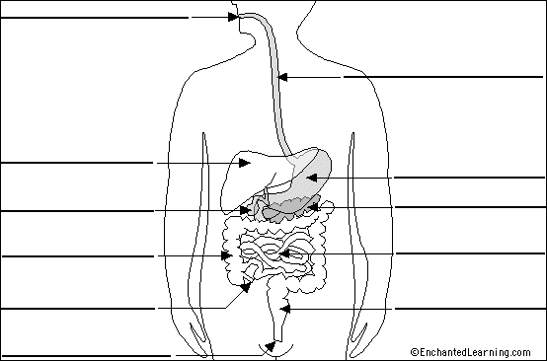
Esophagus

Liver
Stomach
Gall Bladder
Pancreas
Lg. Intestine
Sm. Intestine

Appendix
Rectum
Anus

16. Complete the following table concerning the digestive system:
Part | Mechanical Transformation | Chemical Transformation | Gland
Mouth | Chewing and Moistening | Salivary Amylase begins breaking down Carbohydrates | Salivary Glands
Pharynx | Swallowing (Peristalsis) | X | X
Esophagus | Peristalsis | X | X
Stomach | Mixing and Churning | Begin the breakdown of protein into amino acid | Stomach Glands
Sm. Intestine | Peristalsis | Complete the breakdown of protein into amino acids and the breakdown of carbohydrates in simple sugars (glucose).  Breakdown fats into fatty acids and glycerol | Intestinal Glands
Lg. Intestine | Peristalsis | X | X

Organization of, Properties of, and Changes to Matter

1. State whether the following are examples of chemical (c) or physical (p) changes:
a- Ice melting P | d- Mixing salt and water P | g- Toasting bread C
b- A bike rusting C  c- A fire occurring C | e- Making Jell-0 P  f- Water evaporating P | h- Separating a compound C  i- Making a compound C

2. What reactions (signs) tell you a chemical change occurred?

A change in colour A precipitate is formed

A gas is produced A light is emitted and/or heat is released or absorbed

3. Fill in the table
Give the 4 pure  substances | Give their definition | Give an example | Use symbols to  show an example
Atom | Smallest unit that makes up matter | 1 atom of hydrogen | ○
Element | A substance found on the periodic table | Hydrogen | ○
Molecule | 2 or more atoms bonded together | H₂ | ○○
Compound | 2 or more atoms of different substances bonded together | H₂O | ○●○

4. Explain what a decomposition reaction is. Give an example, and two reactions (signs) that tell you something was decomposed.

A chemical reaction where a substance is broken down into 2 or more substances.

Example: Water → Hydrogen + Oxygen ( 2 H₂O → 2H₂ + 2O )

The remaining product has a lower mass than the initial substance, a gas is released, a colour change is observed

5. Explain what a synthesis reaction is. Give an example and explain two reactions (signs) that tell you a something new was produced.

A chemical reaction where 2 or more reactants combine to form a new product.

Example: Hydrogen + Oxygen → Water ( 2H₂ + O₂ → 2H₂O )

The new product has a greater mass than either of the initial substances, a colour change is observed, a precipitate is formed.

6. Give the 4 types of properties and two examples of each.
Physical Property: colour, density Chemical Property: Conductivity, pH

Physical Characteristic Property: melting point, density Physical Non-characteristic Property: mass, volume

Chemical Characteristic Property: DNA, conductivity
Chemical Non-characteristic Property: transparency, lustre

.
7. What is the definition of density and what is the density of water?

Density is the amount of matter (mass) in a given volume of a substance. The density of water is 1.00 g/mL

8. How are the following properties determined (measured/calculated)?
 | Mass | Volume | Density
Regular solid | Place on the balance | L x W x H | Mass of the solid ÷ Vol. of the solid
Irregular solid | Place on the balance | Volume (water) displacement | M ÷ V
Liquid | -Mass a container (grad. cylinder)  -Add the liquid  -Mass the container+liquid | Read the volume off the grad. cylinder | M ÷ V

9. Fill in the table.
 | Test to ID | Reaction Observed
Carbon dioxide | Limewater | Limewater becomes cloudy
Oxygen | Glowing Splint | Splint re-ignites
Hydrogen | Burning Splint | “Pop”

10. Fill in the table for what reaction will be observed.
 | RLP | BLP | CCP | Conductivity
Saltwater | Stays red | Stays blue | Turns pink | Light flashes
Distilled water | Stays red | Stays blue | Turns Pink | No light
Alcohol | Stays red | Stays blue | Stays blue | No light
Acid | Stays red | Turns red | Turns pink | Light flashes
Base | Turns blue | Stays blue | Turns pink | Light flashes

11. What are the definitions of the following?

Malleability Ability of a substance to bend or flex when pressure is applied
Luster The way light reflects of a surface, how shiny a substance is

12. From a scale of 0-14 give the range of an acid, a base and a neutral solution.

Acid: 1-6 Base: 8-14 Neutral: 7

13. Which of the following are not characteristic properties of water?
a) boils at 100℃ b) dissolves sugar c) has a pH of 7 d) freezes at 0℃
e) volume of 25mL f) is transparent g) density of 1g/mL h) tasteless
B, E, F, H
14. Which of the following best describes the behaviour of the particles (use particle model)?
  - The bonds in a solid become stronger when phased into a liquid
  - The more the temperature increases, the more the particles vibrate in a liquid
  - The change from gas to solid allows the particles to stay as far away from each other as possible
  - An increase in temperature will cause the bonds of a liquid to weaken
15. Select the best definition of a characteristic property:
  - A property of a solid, liquid or gas, which is unique to that substance.
  - A property of a metal and nonmetal that describes where on the period table the element appears.
  - A property that is not unique to individual substances.
  - A property of any object or living thing, such as mass and colour.

16. Match the gas with the appropriate test:
i- Hydrogen A. Turns limewater cloudy
ii- Carbon dioxide B. Causes a flaming splint to pop
iii- Oxygen C. Causes a glowing splint to re-light
a) i -A, ii-B, iii-C b) i-C, ii-A, iii-B
c) i-B, ii-C, iii-A d) i-B, ii-A, iii-C

17. Bobby needs to find the density of a solid. Use the table below he created after conducting his experiment to find the objects mass and volume (by water displacement).
Mass | Volume Water | Volume  Water + Solid
12.32 g | 12.0 mL | 16.8 mL

How could Bobby solve for the density of the solid? (show all work)
Volume of Solid: 16.8 mL – 12.0 mL = 4.8 mL
Density = Mass ÷ Volume = 12.32 g ÷ 4.8 mL = 2.57 g/mL
Density: 2.57 g/mL

18. Decomposition is the transformation of complex molecules into simpler molecules or into atoms. What is the reverse process known as?
Reverse process: Synthesis

19. When 2 clear liquids are mixed together and result in a yellow solid being produced. What type of change took place? Solids can be produced in a chemical reaction with liquids. What do we call this solid?
a) Type of change? Chemical
b) Justification: A solid was formed
c) Name of solid? Precipitate

Respiratory System and Fluids
1. Which gas, referred to as an oxidizing agent, makes the combustion of nutrients possible?
Oxygen

2. During inhalation, in which direction does the diaphragm move?
Down (it lowers)

3. True or False
a) The volume of the rib cage increases during exhalation False
b) Air pressure in the lungs decreases during inhalation True

4. List three functions of the nasal cavities:
Warm the air
Filter the air
Humidify (moisten) the air

5. What body parts are shared by the digestive system and the respiratory system?
Mouth and pharynx

6. What defense do we have against foreign particles like pollen, dust and pollution?

Nasal hairs, mucus and cilia in the trachea to keep foreign particles from reaching the lungs

7. Give the definition of a fluid. What substances are fluids?

A fluid has no definite form and has the ability to flow in all directions. Liquids and gasses are fluids

8. What fluids are incompressible? Explain incompressibility is using the particle theory of matter.

Liquids are incompressible because the molecules are already too close together to have the volume reduced.

9. What fluids are compressible? Explain compressibility using the particle theory of matter.

Gasses are compressible; this is because the molecules have enough space between them that the volume of the substance can be reduced, or compressed.

10. Label the diagram below:
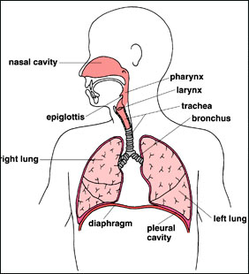
Nasal Cavity
Pharynx
Larynx
Trachea
Bronchi
Epiglottis

Right Lung
Left Lung
Diaphragm

11. Below is a diagram of a lung and it components. Label the diagram using the following words:
Cluster of Alveoli Alveolus
Capillaries Bronchiole

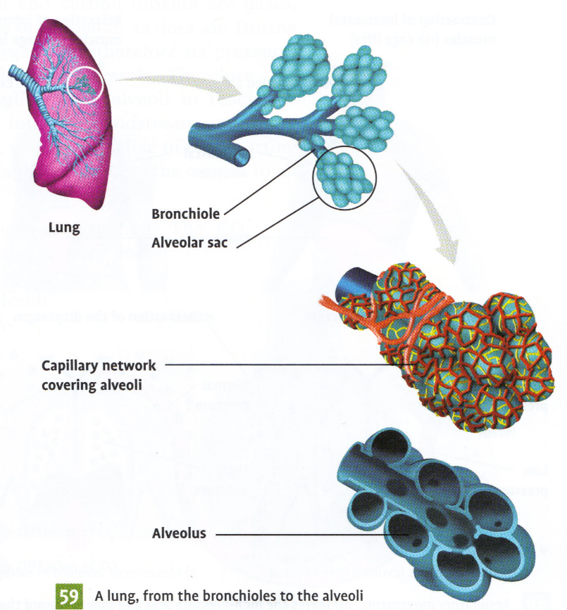
Bronchiole
Capillaries
Alveolus
Cluster of Alveoli

12. Place the following statements below in the order that they occur during inspiration:

- the molecule enters the alveolus
- the molecule crosses the trachea
- the molecule crosses the pharynx
- the molecule enters a bronchiole
- the molecule enters the nasal cavity
- the molecule crosses the larynx
- the molecule enters one of the bronchi

__E___ __C___ __F___ __B___ __G___ __D___ __A___

13. In order for inspiration to occur, does the air pressure inside the lungs have to be higher or lower than surrounding air pressure? Why?

It needs to be lowers because the air will move from the area of high pressure to lower pressure.
14. Explain why a gas is considered a fluid?
A fluid takes the shape of its container and has the ability to flow in all directions; both of these things are true for a gas.

15. Explain why a liquid is considered an incompressible fluid?
A liquid takes the shape of its container and has the ability to flow but it is considered an incompressible fluid because a liquid has a definite volume.

16. At a birthday party you fill balloons with helium and they all rise to the ceiling. The next morning the balloons were still floating but had fallen quite a bit. By nighttime the balloons had fallen to the floor and the volume has decreased greatly.

What term describes why the balloons have fallen down? Diffusion

Why was the helium able to escape?
The balloon is a semi-permeable membrane and the molecules of helium are small enough to slowly pass through.

Explain in detail, why the volume of the balloon decreases. As the volume of helium decreases there is less and less pressure being applied to the balloon from the inside. This results in the balloon decreasing in volume as there is less pressure keeping the balloon inflated.
17. a) What is the respiration formula? Nutrients + O₂ → CO₂ + Energy + Waste

b) Where does this reaction occur and why does it occur there? It occurs in the cells because that is where the nutrients and oxygen are able to combine and it is the cells that need the energy.

18. What is the waste product of respiration, where is it produced and why is it produced there?

Carbon dioxide is the waste product, it is produced in the cells because this is where cellular respiration takes place

19. What is the functional unit of the lungs?
Alveoli
Circulatory and Lymphatic Systems
1. Give three differences between arterial and venous blood?
1 Arterial blood is bright red, venous blood is dark red
2 Arterial blood is rich in oxygen, venous blood is rich in carbon dioxide
3 Arterial blood is found in the arteries and venous blood is found in the veins

2. Fill in the table
Blood component | Function(s)
Plasma | Liquid component of blood, contains the suspended blood cells and platelets, carry the nutrients
Red Blood Cells | Bind oxygen and carry it to the cells, bind CO₂ and carry it to the lungs
White Blood Cells | Engulf and digest dead and damaged cell, old red blood cells and microorganisms
Platelets | Clotting

.
3. What is the largest artery?
The aorta
4. What is the function of the systemic and pulmonary circulation?

The function of system circulation is to take oxygenated blood to the body’s cells and collect the carbon dioxide from cellular respiration.

The function of pulmonary circulation is to take the deoxygenated blood to the lungs and exchange the carbon dioxide for oxygen to take to the body’s cells.

5. What type of blood vessel allows for diffusion? Where does diffusion occur?

Capillaries allow for diffusion to occur. This occurs everywhere in the body at the cellular level because every single cell needs oxygen for cellular respiration and produces carbon dioxide as a waste product to be removed.

6. Fill in the table.
Passageway | Type of Blood | Type of Circulation
Left ventricle | Oxygenated | Systemic
Aorta | Oxygenated | Systemic
Arteries | Oxygenated | Systemic
Arterioles | Oxygenated | Systemic
Capillaries | Oxygenated to Deoxygenated  (Gas exchange) | Systemic
Venules | Deoxygenated | Systemic
Veins | Deoxygenated | Systemic
Vena Cava | Deoxygenated | Systemic
Right Atrium | Deoxygenated | Systemic
Right Ventricle | Deoxygenated | Pulmonary
Pulmonary Artery | Deoxygenated | Pulmonary
Lungs | Deoxygenated to Oxygenated  (Gas exchange) | Pulmonary
Pulmonary Veins | Oxygenated | Pulmonary
Left Atrium | Oxygenated | Pulmonary

7. Explain what blood pressure and pulse measures.

Blood pressure measures the force with which the blood is pushing against the arterial walls.

Pulse measures the number of times the heart beats (contract and relaxes) within a certain period of time, usually in 1 minute.

8. What is the minimum of a high blood pressure reading? Explain why a person will have a high blood pressure result. What are things that a person does that might cause them to have high blood pressure?

A systolic pressure of greater than 120 and/or a diastolic pressure of greater than 80 is considered to be high. A person might have high blood pressure due to narrowing of the arteries, which means the arteries will be under greater pressure as the blood moves through. High blood pressure can be caused by poor diet (ex: a diet high in saturated fats) or lack of physical activity. Situations of high stress or anxiety have also been linked to high blood pressure.

9. Fill in the diagram.
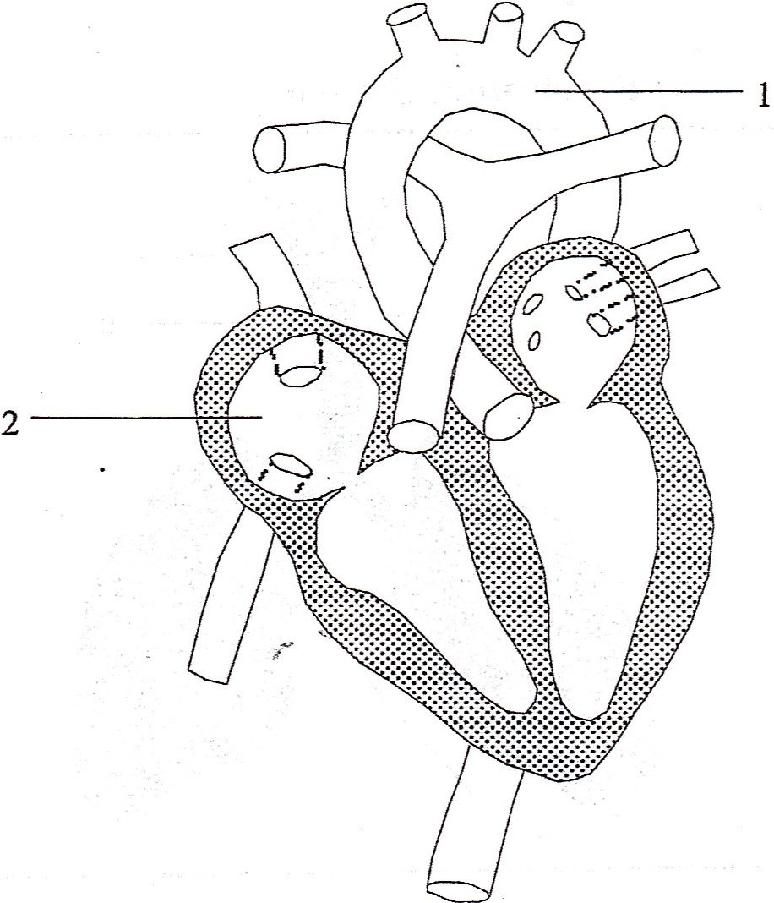

Aorta

Right Atrium
.

10. What is the function of the circulatory system?
To bring nutrients and oxygen to the cells of the body and collect cellular waste and carbon dioxide to be removed from the body.

11. Give 3 differences between white blood cells and red blood cells
1. Red blood cells are much smaller than white blood cells
2. There are more red blood cells in the blood than white blood cells
3. Reb blood cells are responsible for transporting gases (O₂ and CO₂), white blood cells are responsible for defending the body against microorganisms

12. What makes blood red? Hemoglobin
13. Describe what happens when an antigen enters the body:
The presence of an antigen will trigger an immune response by the body. White blood cells will begin to produce antibodies to destroy the antigens. If the body has been exposed to this antibody before, the production of antigens will be faster and more effective. If it is an antigen that the body has not yet encountered, the production of antibodies will take longer. In this case a person will experience symptoms and would be considered to be “sick”.

14. Define the following terms:
Term | Definition
Antigen | Viruses, bacteria, abnormal cells or other substances that produce an immune reaction
Antibody | Substance produced by certain white blood cells that can neutralize specific antigens.
Vaccine | A prepared substance designed to provide immunity from a particular antigen. It is often made from weakened or killed form of the microbe, which stimulates the body's immune system to recognize the agent as a threat, destroy it, and keep a record of it, so that the immune system can more easily recognize and destroy it in the future
Immunity | An organism’s resistance to an infection or disease
Blood transfusion | The process of receiving blood products into one’s own blood intravenously. Used to replace lost components of blood
Diffusion | The movement of molecules from an area of high concentration to one of lower concentration
Semi permeable membrane | A membrane that allows certain substances to pass through, while restricting others.

15. Complete the chart
Blood vessel | Description and Function
Pulmonary Artery | Transports the blood from the right ventricle to the lungs
Pulmonary Vein | Transports the blood from the lungs to the left atrium
Aorta | Transports the blood away from the heart, leaving the left ventricle for distribution to the body’s cells. It is the biggest artery in the body
Vena Cava | Transports the blood from the body into the heart, entering the right atrium. The vena cave are the largest veins of the body.
Arteries | Blood vessels that carry blood away from the heart.
Veins | Blood vessels that return blood to the heart.

16. On the heart diagram put in the following parts:

right ventricle, pulmonary vein, superior vena cava and left atrium

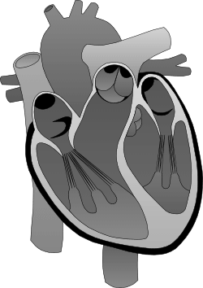
Left Atrium
Pulmonary Vein
Right Ventricle
Superior Vena Cava

17. Give the description and function of the parts mentioned in question 16.
Part of the Heart | Description and Function
right ventricle | The lower chamber on the right side of the heart. Deoxygenated blood enters from the right atrium and leaves by the pulmonary artery.
pulmonary vein | Transports the blood from the lungs to the left atrium
superior vena cava | Transports the blood from the upper portion of the body into the heart, entering the right atrium.
left atrium | The upper chamber on the left side of the heart. Oxygenated blood enter from the lung by the pulmonary veins and exits into the left ventricle.

18. Where are the following structures located (relative to the heart) and what are their functions:
Structure: | Function:
Pulmonary Artery | Located at the top of the heart, carries the deoxygenated blood to the lungs
Aorta | Located at the top of the heart, carries oxygenated blood to the other blood vessels to bring to the body’s cells
Inferior Vena Cava | Located at the right side of the heart, brings deoxygenated blood from the lower portion of the body to the right atrium.

19. Describe the pathway of Pulmonary Circulation.
Begins at the right ventricle → pulmonary artery → lungs (gas exchange: CO₂ out of the blood, O₂ into the blood) → pulmonary vein → left atrium
20. Describe the pathway of Systemic Circulation.
Begins at the left ventricle → aorta → arteries → arterioles → capillaries (gas exchange: O₂ out of the bool, CO₂ into the blood) → venules → veins → vena cave → right atrium
21. How do the digestive and circulatory systems work together to achieve cellular respiration? The digestive system breaks down food into simple nutrients that can diffuse into the blood to be transported to all of the body’s cells. The circulatory system bring the oxygen that enters the body through the respiratory system to the body’s cells and collects the carbon dioxide to return to the lungs to be exhaled. Cellular respiration requires both nutrients and oxygen to produce energy that can be used by the cells. This is how the two systems work together in order for cellular respiration to be possible
22. What can happen when there is a blockage in the circulatory system? A blockage in the circulatory system means the blood cannot pass properly to the body’s cells, the lungs and the heart. This can result in a serious medical condition such as a heart attack, stroke or damage to the bool vessels such as an aneurism
23. Explain the purpose of a vaccination and how it works.
To protect the health of the people that receive them which will prevent them from developing diseases with dangerous consequences. They contain antigens (bacteria, viruses, virus fragments, etc.) that are weakened and cannot transmit disease. The body still produces antibodies to eliminate these antigens that will be effective against the real disease.

24. What is the function of antibodies?
An antibody is a substance produced by certain white blood cells that can neutralize specific antigens.

25. What are the 2 ways someone will acquire immunity?
By contracting the virus or bacteria (natural acquisition).
By receiving a vaccine (artificial acquisition).
26. Explain how blood donation and receiving works.
A blood transfusion is the injection blood products (usually red blood cells) from one person to another. The blood types have to be compatible for them to be received by the recipient.

27. Can O- donate to B+, why?
Yes, because O- is the universal donor. Because there are no antigens on the O- blood, and therefore the B+ has no antibodies against it. .

28. Can B+ donate to O-, why?
No because the O- blood has antibodies against B antigens and RH antigens.

29. Why is O- the universal donor?
Because there are no antigens present therefore no antibodies against it.

30. Why is AB+ the universal recipient?
Because both antigens A and B are present and because it is RH positive it can receive blood that is RH negative.

31. Complete the table:
 | A+ | B+ | AB+ | O+ | A- | B- | AB- | O-
Donate | A+, AB+ | B+, AB+ | AB+ | O+,A+,B+,AB+ | A+, A-, AB+, AB- | B- B+, AB-, AB+ | AB-, AB+ | UNIVERSAL DONOR
Receive | A+, A-, O+, O- | B+, B-, O+, O- | UNIVERSAL RECIPIENT | O+, O- | A-, O- | B-, O- | AB-, A-, B-, O- | O-

32. During a blood typing lab, how can we determine what our blood type is?
Agglutination : you use anti A, anti B and anti RH serum, if there is a sandy like appearance with that serum then you have that antigen on your red blood cells.

33. Complete the following table regarding the lymphatic system
Terms | Definition
Lymph | A fluid that fills the spaces between the blood vessels and body cells. It allows for exchanges between blood and body cells.
Lymph Nodes | Small round structures found along the lymph vessels
Phagocytosis | When a white blood cell surrounds a foreign antigen and engulfs it to neutralize it.
Extracellular Fluid | Fluid outside of the blood vessels and cells. (plasma that leaks out of the blood vessels, mainly water, carries wbc, nutrients, oxygen, carbon dioxide)
Antibody | Substance produced by certain white blood cells and that is able to neutralize a specific antigen.
Antigen | A virus, or bacteria, or abnormal cells or any other substances that can trigger a reaction of the immune system

34. Our bodies are defended by: White blood cells
Defense mechanisms:
Mechanism | Action
Phagocytosis | Engulf’s antigens
Diapedesis | When the white blood cells leave the blood stream

