Name: _____________________________________

Review for Midyear Exam (2017-18)

Cells and Genetics

1. Which cells in the human body normally have a diploid number of chromosomes in their nuclei?
a) all cells b) only cells produced by mitosis
c) only cells produced by meiosis d) only reproductive cells
2. The diploid chromosome number in humans is…
a) 23 b) 46
b) 48 d) 92
3. The following is a portion of a DNA strand: CCG ATT TGC ACG. The complimentary DNA strand would be :
a) CCG ATT TGC ACG b) GGC TAA ACG TGC
c) GGC UAA UCG UGC d) CCG TAU UCG UGC
4. Crossing over of chromosomes is most likely to occur during:
a) meiosis b) mitosis
c) cell death d) fertilization
5. DNA is made up of ___________ types of nucleotides
a) 1 b) 2
c) 3 d) 4

6. Why do cells divide?
1. _____________________________
2. _____________________________
7. Give 3 differences between the processes of Mitosis and Meiosis.
a. ____________________________________________________________________
______________________________________________________________________
b. ____________________________________________________________________
______________________________________________________________________
c. ____________________________________________________________________
______________________________________________________________________

8. Identify the processes as Meiosis or Mitosis
- Produces identical cells _______________
- Used for sexual reproduction _______________
- Has 2 cell divisions _______________
- Contains 46 chromosomes (human cell) _______________
- Produces gametes _______________
- Produces 4 daughter cells _______________
- Contains half the genetic material of parent cell _______________
- Used for growth and repair of cells and tissues _______________

9. What do the letters GMO mean? ________________________________________________

10. Give 2 methods to create a GMO:
1- ________________________________________________________________________
2- ________________________________________________________________________

Reproduction and Puberty

- Gametes are
a) Sex cells c) n

b) Haploid d) A, B and C are all correct

- Fertilization occurs….
a) When ovulation happens
b) When the sperm fuses with the ovum
c) When a female has her period
d) When a male and female have intercourse

- What is a Zygote?
a) A fertilized ovum c) An immature ovum

b) A follicle d) A gland which secretes hormones

- The _____1______ gland is found in both males and females it secretes _____2_____ and _____3_____.

 | 1 | 2 | 3
a) | Pituitary | Estrogen | Progesterone
b) | FSH | Estrogen | LH
c) | Pituitary | FSH | LH
d) | Pituitary | Testosterone | Estrogen

- Days 1-5 in the menstrual cycle are referred to as …1… and days 15 – 28 are referred to as…1…

 | 1 | 2
a) | Menstrual phase | Proliferation phase
b) | Proliferation phase | Secretory phase
c) | Menstrual phase | Secretory phase
d) | Secretory phase | Menstrual phase
6. In females, progesterone is responsible for:
a) Preparing the uterus for implantation and stimulating the production of milk in pregnant women
b) The degeneration of the uterine lining, causing females to get their periods
c) Causing the release of ova from the ovaries.
7. In the female, once fertilization takes place, the embryo implants itself in the…
a) Endometrium
b) Ovaries
c) Fallopian tube
8. What hormone is responsible for ovulation?
a) FSH
b) LH
c) Estrogen

9. True or False:
a- Hormones secrete glands
b- The male hormones are testosterone, FSH and LH
c- The primary sexual characteristic for males is the start of their cycle and sperm production
d- A penis must be erect on order to ejaculate.
e- A female cannot get pregnant form pre-mature ejaculation.

10. Give three secondary sexual characteristics which occur in females only.

11. Give a secondary sexual characteristic which occurs in both males and females.

12. Name the two hormones responsible for the maturation of the follicle.

1.
2.
13. What is the difference between an oocyte and an ovum?

14. Define infertility.

15. What are all of the methods couples can use to help have a child when they are deemed infertile?

16. List 2 pros and 2 cons that accompany assisted reproduction.

Nutrition & Digestion

1. Fill in the table
 | Protein | Carbohydrates | Fats
Function
Examples of it
Number of grams
needed per day
What you multiply
to get from grams (g) into kJ
The amount of kJ
needed per day

2. What 4 nutrients are responsible for regulating metabolism?

3. Calculate the kJ intake of the cookies:
15 g of carbohydrates 8 g of fat 3 g of protein

4. Give the definitions of the following terms:
Chemical breakdown
or change
Metabolism
Physical breakdown
or change
Gland
Enzyme
Peristalsis
_
Absorption

5. What is the passageway food follows when it is digested and give the mechanical breakdown that occurs at each place?
Location | Mechanical Breakdown

6. What are the 5 glands of the digestive system and what enzyme do they release?
Gland | Enzyme

7. Write all the chemical breakdowns chicken will go through to bring it to its simplest form so absorption of the nutrient can occur. Include the locations of the chemical breakdown and the enzyme involved.

8. Write all the chemical breakdown pasta will go through to bring it to its simplest form so absorption of the nutrient can occur. Include the locations of the chemical breakdown and the enzyme involved.

9. Write all the chemical breakdown butter will go through to bring it to its simplest form so absorption of the nutrient can occur. Include the locations of the chemical breakdown and the enzyme involved.

10. Where does the absorption of all the simple nutrients occur? Why can it occur there?

11. Where does the absorption of water, vitamins and minerals occur?

12. Explain the reason constipation occurs and give possible solutions.

13. Explain the reason diarrhea occurs and give possible solutions.

14. What is the function of the digestive system?

15. Fill in passageway on the diagram.

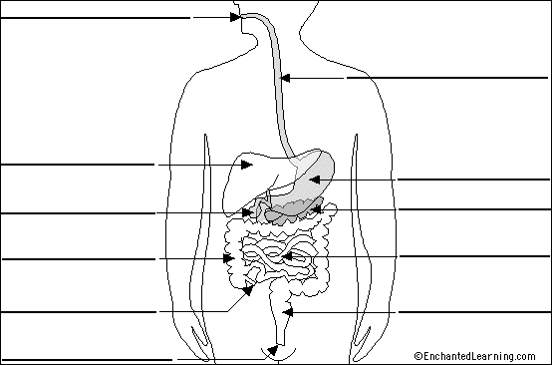

16. Complete the following table concerning the digestive system:
Part | Mechanical Transformation | Chemical Transformation | Gland

Organization of, Properties of, and Changes to Matter

1. State whether the following are examples of chemical (c) or physical (p) changes:
a- Ice melting | d- Mixing salt and water | g- Toasting bread
b- A bike rusting  c- A fire occurring | e- Making Jell-0  f- Water evaporating | h- Separating a compound  i- Making a compound

2. What reactions (signs) tell you a chemical change occurred?

3. Fill in the table
Give the 4 pure  substances | Give their definition | Give an example | Use symbols to  show an example

4. Explain what a decomposition reaction is. Give an example, and two reactions (signs) that tell you something was decomposed.

5. Explain what a synthesis reaction is. Give an example and explain two reactions (signs) that tell you a something new was produced.

6. Give the 4 types of properties and two examples of each.

.

7. What is the definition of density and what is the density of water?
8. How are the following properties determined (measured/calculated)?
 | Mass | Volume | Density
Regular solid
Irregular solid
Liquid

9. Fill in the table.
 | Test to ID | Reaction Observed
Carbon dioxide
Oxygen
Hydrogen

10. Fill in the table for what reaction will be observed.
 | RLP | BLP | CCP | Conductivity
Saltwater
Distilled water
Alcohol
Acid
Base

11. What are the definitions of the following?

Malleability ______________________________________________________
Luster ________________________________________________________

12. From a scale of 0-14 give the range of an acid, a base and a neutral solution.

13. Which of the following are not characteristic properties of water?
a) boils at 100℃ b) dissolves sugar c) has a pH of 7 d) freezes at 0℃
e) volume of 25mL f) is transparent g) density of 1g/mL h) tasteless
______________________________
14. Which of the following best describes the behaviour of the particles (use particle model)?
  - The bonds in a solid become stronger when phased into a liquid
  - The more the temperature increases, the more the particles vibrate in a liquid
  - The change from gas to solid allows the particles to stay as far away from each other as possible
  - An increase in temperature will cause the bonds of a liquid to weaken

15. Select the best definition of a characteristic property:
  - A property of a solid, liquid or gas, which is unique to that substance.
  - A property of a metal and nonmetal that describes where on the period table the element appears.
  - A property that is not unique to individual substances.
  - A property of any object or living thing, such as mass and colour.

16. Match the gas with the appropriate test:
i- Hydrogen A. Turns limewater cloudy
ii- Carbon dioxide B. Causes a flaming splint to pop
iii- Oxygen C. Causes a glowing splint to re-light
a) i -A, ii-B, iii-C b) i-C, ii-A, iii-B
c) i-B, ii-C, iii-A d) i-B, ii-A, iii-C

17. Bobby needs to find the density of a solid. Use the table below he created after conducting his experiment to find the objects mass and volume (by water displacement).
Mass | Volume Water | Volume  Water + Solid
12.32 g | 12.0 mL | 16.8 mL

How could Bobby solve for the density of the solid? (show all work)

Density: _____________________
18. Decomposition is the transformation of complex molecules into simpler molecules or into atoms. What is the reverse process known as?
Reverse process: _________________________________________

19. When 2 clear liquids are mixed together and result in a yellow solid being produced. What type of change took place? Solids can be produced in a chemical reaction with liquids. What do we call this solid?
a) Type of change? ____________________________
b) Justification ___________________________________________________________
c) Name of solid? _________________________________________________________

Respiratory System and Fluids
1. Which gas, referred to as an oxidizing agent, makes the combustion of nutrients possible?
________________________________________________________

2. During inhalation, in which direction does the diaphragm move?
________________________________________________________

3. True or False
a) The volume of the rib cage increases during exhalation _____
b) Air pressure in the lungs decreases during inhalation _____

4. List three functions of the nasal cavities:
_________________________________________________________ _________________________________________________________ _________________________________________________________

5. What body parts are shared by the digestive system and the respiratory system?
_________________________________________________________
6. What defense do we have against foreign particles like pollen, dust and pollution?

7. Give the definition of a fluid. What substances are fluids?

8. What fluids are incompressible? Explain incompressibility is using the particle theory of matter.

9. What fluids are compressible? Explain compressibility using the particle theory of matter.

10. Label the diagram below:
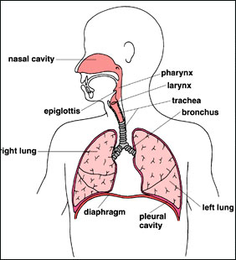

11. Below is a diagram of a lung and it components. Label the diagram using the following words:
Cluster of Alveoli Alveolus
Capillaries Bronchiole

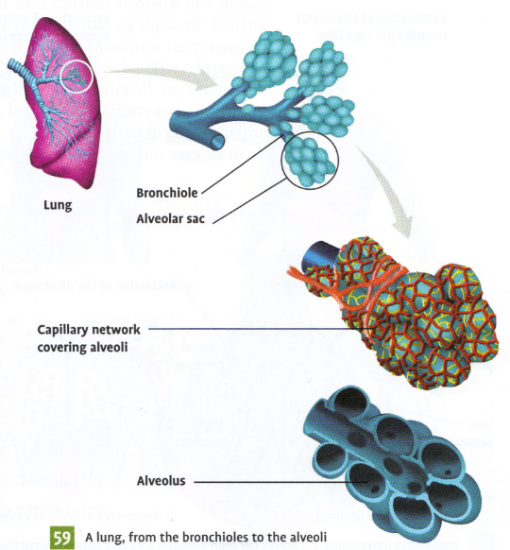

12. Place the following statements below in the order that they occur during inspiration:

- the molecule enters the alveolus
- the molecule crosses the trachea
- the molecule crosses the pharynx
- the molecule enters a bronchiole
- the molecule enters the nasal cavity
- the molecule crosses the larynx
- the molecule enters one of the bronchi

_____ _____ _____ _____ _____ _____ _____

13. In order for inspiration to occur, does the air pressure inside the lungs have to be higher or lower than surrounding air pressure? Why?

14. Explain why a gas is considered a fluid?

15. Explain why a liquid is considered an incompressible fluid?

16. At a birthday party you fill balloons with helium and they all rise to the ceiling. The next morning the balloons were still floating but had fallen quite a bit. By nighttime the balloons had fallen to the floor and the volume has decreased greatly.

What term describes why the balloons have fallen down?

Why was the helium able to escape?

Explain in detail, why the volume of the balloon decreases.

17. a) What is the respiration formula?

b) Where does this reaction occur and why does it occur there?

18. What is the waste product of respiration, where is it produced and why is it produced there?

19. What is the functional unit of the lungs?

Circulatory and Lymphatic Systems
1. Give three differences between arterial and venous blood?
1 ____________________________________________________________
2 ____________________________________________________________
3 ____________________________________________________________

2. Fill in the table
Blood component | Function(s)

.
3. What is the largest artery?

4. What is the function of the systemic and pulmonary circulation?

5. What type of blood vessel allows for diffusion? Where does diffusion occur?

6. Fill in the table.
Passageway | Type of Blood | Type of Circulation
Left ventricle

7. Explain what blood pressure and pulse measures.

8. What is the minimum of a high blood pressure reading? Explain why a person will have a high blood pressure result. What are things that a person does that might cause them to have high blood pressure?

9. Fill in the diagram.
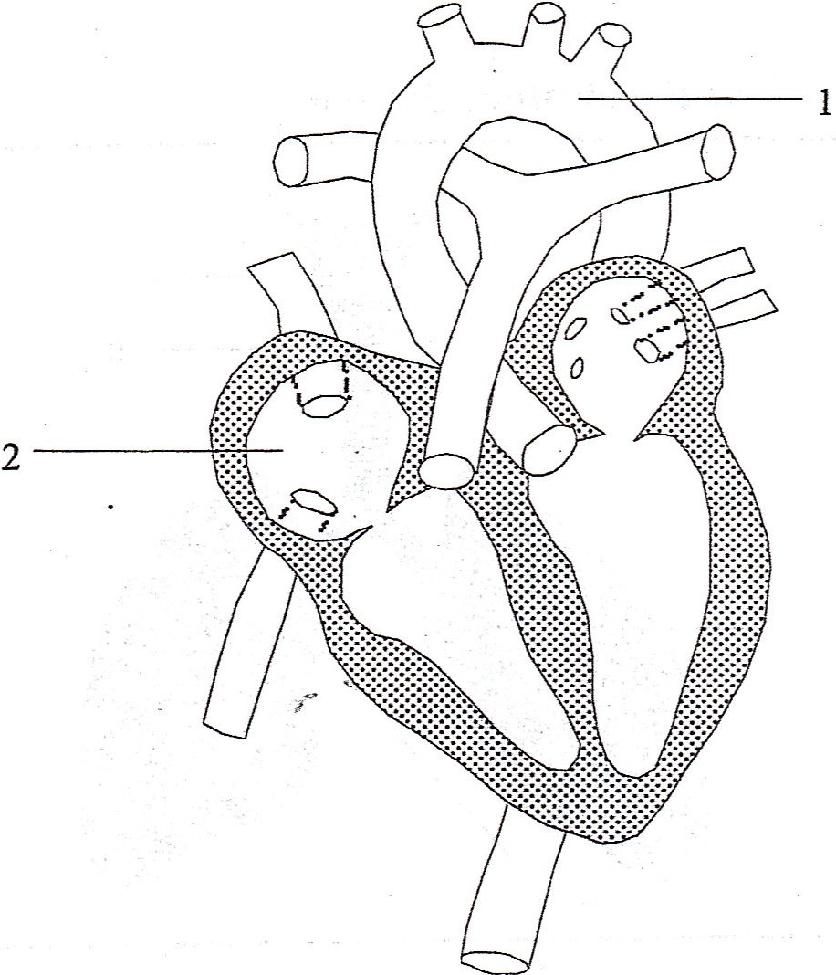

.

10. What is the function of the circulatory system?

11. Give 3 differences between white blood cells and red blood cells
1. _________________________________________________________________________
2. _________________________________________________________________________
3. _________________________________________________________________________

12. What makes blood red? ________________________________________________________
13. Describe what happens when an antigen enters the body:

14. Define the following terms:
Term | Definition
Antigen
Antibody
Vaccine
Immunity
Blood transfusion

Diffusion
Semi permeable membrane

15. Complete the chart
Blood vessel | Description and Function
Pulmonary Artery
Pulmonary Vein
Aorta
Vena Cava
Arteries
Veins

16. On the heart diagram put in the following parts:

right ventricle, pulmonary vein, superior vena cava and left atrium

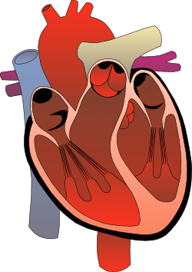

17. Give the description and function of the parts mentioned in question 16.
Part of the Heart | Description and Function
right ventricle

pulmonary vein
superior vena cava
left atrium

18. Where are the following structures located (relative to the heart) and what are their functions:
Structure: | Function:
Pulmonary Artery
Aorta
Inferior Vena Cava

19. Describe the pathway of Pulmonary Circulation.
______________________________________________________________________________
______________________________________________________________________________
______________________________________________________________________________
______________________________________________________________________________

20. Describe the pathway of Systemic Circulation. ______________________________________________________________________________
______________________________________________________________________________
______________________________________________________________________________
______________________________________________________________________________

21. How do the digestive and circulatory systems work together to achieve cellular respiration?
_______________________________________________________________________________
_______________________________________________________________________________
_______________________________________________________________________________

22. What can happen when there is a blockage in the circulatory system? _____________________________________________________________________________
_____________________________________________________________________________
_____________________________________________________________________________

23. Explain the purpose of a vaccination and how it works.
_____________________________________________________________________________
_____________________________________________________________________________
_____________________________________________________________________________

24. What is the function of antibodies?

25. What are the 2 ways someone will acquire immunity?

26. Explain how blood donation and receiving works.

27. Can O- donate to B+, why?

28. Can B+ donate to O-, why?

29. Why is O- the universal donor?

30. Why is AB+ the universal recipient?

31. Complete the table:
 | A+ | B+ | AB+ | O+ | A- | B- | AB- | O-
Donate

Receive

32. During a blood typing lab, how can we determine what our blood type is?

33. Complete the following table regarding the lymphatic system
Terms | Definition
Lymph
Lymph Nodes
Phagocytosis
Extracellular Fluid
Antibody
Antigen

34. Our bodies are defended by ________________________
Defense mechanisms:
Mechanism | Action
Phagocytosis

