Review for Mid-Year Exam
The Material World
1. Define characteristic properties and non-characteristic properties. Give 3 examples of each.
2. Define mass and give 2 examples of objects with the units mg, g, and kg. How would you find the mass of a solid and of a liquid?
3. Define volume and describe how to find the volume of a regular object and irregular object. What are the units associated with each?
4. Define density and give the formula to calculate it. Be able to compare densities using numerical data or by diagrams.
5. Define temperature and state the boiling point and freezing point of water.
6. What is considered to be room temperature?
7. State 3 units of temperature.
8. State the pH levels for an acid, a base, and a neutral substance.
9. What is the difference between a physical change and a chemical change? Give 3 examples of each.
10. What are the indications or signs that a chemical change has occurred?
11. List the characteristics of each of the following : a) solid b) liquid c) gas
12. Create a chart using the following terms: solid, liquid, gas, freezing (solidification) , melting (liquidification), boiling (evaporation), condensation and sublimation.
13. Give 3 example for each of the following: a) homogeneous mixture b) heterogeneous mixture and c) pure substance

14. Compare and contrast homogeneous mixtures and heterogeneous mixtures.

15. How do mixtures differ from pure substances.

16. Briefly describe the 4 methods for water purification and the materials needed for each method. Give an example of a mixture that can be separated by each method.

17. Explain the difference between a pure substance and a mixture.

18. How is a homogeneous mixture different from a heterogeneous mixture?

19. Define solution.

20. Give two examples for each of the following: pure substance, heterogeneous mixture, and homogeneous mixture.

Earth

1. Compare and contrast rocks and minerals.

2. List the 3 types of rocks and describe how they are formed.

3. What are the 3 types of igneous rock and what are their characteristics?

4. What are the tests that we do on minerals in order to identify they? Briefly describe each test.

5. Define hardness, lustre, and clarity.

6. Which scale is used to determine the hardness of a mineral? What would a value of 1 indicate? What would a value of 10 indicate?

7. State the three layers of the Earth’s internal structure. Which part of an egg would each layer correspond to?

8. Describe each layer of the Earth’s internal structure in terms of temperature, thickness, and state of matter.

9. What are the layers or horizons of the soil? What are 2 main characteristics of each horizon?

10. What are the 2 main changes that effect the relief? What are some other influences?

11. Label the diagram of the water cycle: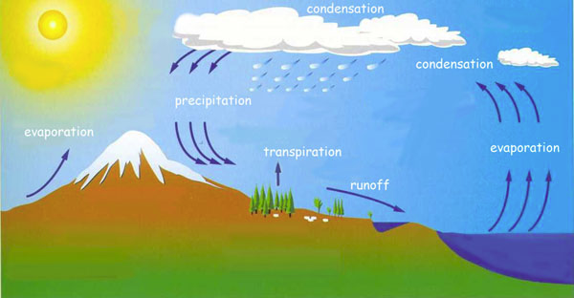

12. Complete the chart below about the 4 separation methods:

Method | Brief Description | Equipment needed
Sedimentation

Decantation

Filtration

Distillation

13. What percentage of Earth is water? What percentage is potable?

14. What is another term for potable water?

15. Is the salinity of water constant in different bodies of water?

16. How have humans influenced the water cycle?

Technological World

1. Give 2 examples for each of the following simple machines: wedge, pulley, wheel and axle, inclined
plane, and lever

2. Briefly outline the 8 steps of the design process.

3. Use arrows to show each of the following types of motion: rectilinear, alternating, circular, and oscillatory.

4. Complete the chart below regarding forces:

Type of Force | Description | Diagram | Example
Flexion

Tension

Compression

Torsion

Shearing

