Review for Optics and Waves Quest
- Label the trough, crest, amplitude and wavelength on the diagram, below.

- On the line below, re-draw the image above, but the diagram must have short wavelengths and a high frequency.

_________________________________________________________

- State the type of wave described:
- The only wave we can see
- The most dangerous wave
- The wave with the lowest frequency
- The wave with the highest frequency
- The wave with the longest wavelength
- The wave with the shortest wavelength
- The colour with the shortest wavelength

- Explain why we can see different colours.

- Explain the process of reflection.

- Label parts 1 to 6, which is the real and which is the virtual image?
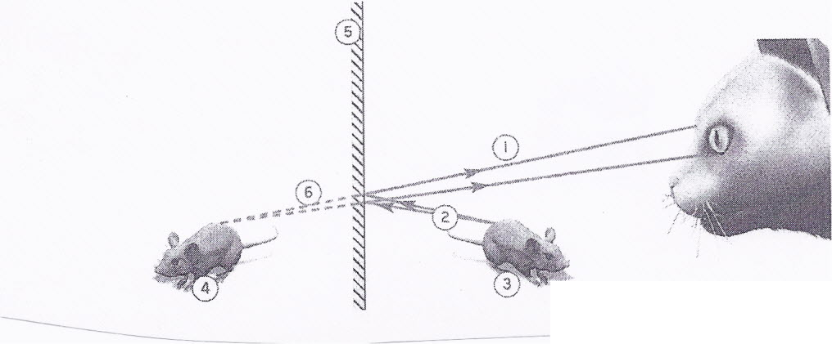

- Explain the process of refraction.

- What are the differences between the images below? Label the F and F¹ for each.

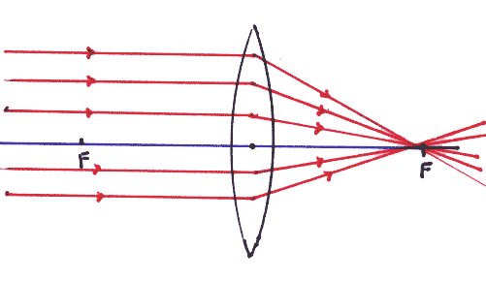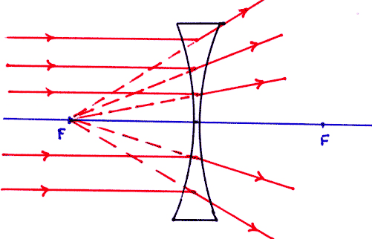

- Explain how a sound wave is produced?

- What type of frequency does a low pitched sound produce?

- What is the decibel for a conversation?

- What decibel can you get hearing loss with long exposures?

- What decibel can cause immediate hearing loss?

- What are differences between light and sound waves?

