EST 4 Name:

Review

**Simplified Atomic Model, Trends, Isotopes, Radiation and Nuclear Transformations**

1. The atomic number of fluorine (F) is 9 and its mass number is 19.

Which of the following diagrams correctly represents the simplified model (Rutherford-

Bohr) of a fluorine atom?

|  |  |  |  |
| --- | --- | --- | --- |
| A) | qa3 | C) | qc3 |
| B) | qb3 | D) | qd3 |

1. The mass number of lithium (Li) is 7 and its atomic number is 3.

Which of the following diagrams represents the simplified atomic model of a lithium atom?

|  |  |  |  |
| --- | --- | --- | --- |
| A) |  | C) |  |
| B) |  | D) |  |

1. Which of the following best represents the aluminum (Al) atom according to the Rutherford-Bohr model?



1. Give the definition and trend for the following:

|  |  |  |
| --- | --- | --- |
|  | Definition | Trend |
| Atomic radius |  |  |
| Reactivity |  |  |
| Ionization Energy |  |  |
| Electronegativity |  |  |

1. Answer the following questions on trends and explain each answer.

|  |  |
| --- | --- |
| Which is bigger Al or Si? |  |
| Which is smaller N or P? |  |
| Which is more reactive  Na or Mg? |  |
| Which is less reactive  Cl or Br? |  |
| Which has a greater  ionization energy C or N? |  |
| Which has a weaker  electronegativity B or Al? |  |

1. What is an isotope?
2. Phosphorus has 3 isoptopes: P-30, P-31 and P-32. How many neutrons does each of the isotopes have?
3. Bromine has three possible isotopes: Br 78, Br 79 and Br 80. Determine which form of bromine is most abundant.
4. Element «X» has two isotopes.

|  |  |  |
| --- | --- | --- |
| **Isotope** | Mass number | Atomic number |
| I | 63 | 29 |
| II | 65 | 29 |

The isotope with 36 neutrons has an abundance of 30.9%.

What is the average atomic mass for this element?

|  |  |
| --- | --- |
| A) | 29.00 μ |
| B) | 34.62 μ |
| C) | 63.62 μ |
| D) | 64.38 μ |

1. A soft, malleable, ductile, grey-coloured metal has four stable isotopes, as shown in the table

below.

|  |  |  |
| --- | --- | --- |
| Z | Isotope | % abundance |
| 82 | 204Pb | 1.5 |
| 82 | 206Pb | 24.1 |
| 82 | 207Pb | 22.1 |
| 82 | 208Pb |  |

According to the data above, what is the atomic mass of the unknown metal?

|  |  |
| --- | --- |
| A) | 82.00 u |
| B) | 206.25 u |
| C) | 207.24 u |
| D) | 208.00 u |

1. The following table lists the characteristics of some of the isotopes of element A.

|  |  |  |  |  |
| --- | --- | --- | --- | --- |
| Isotope | Atomic Number | Mass Number | Relative Abundance | Number of Neutrons |
| 1  2  3 | 22  22  22 | 45  46  47 | 15%  75%  10% | 23  24  25 |

Given this information, what is the atomic mass of element A?

|  |  |  |  |
| --- | --- | --- | --- |
| A) | 23.95 | C) | 46.00 |
| B) | 45.95 | D) | 47.90 |

1. Fill in the table for the three types of radioactive rays.

|  |  |  |
| --- | --- | --- |
| type | charge | Penetrating ability |
| Alpha |  |  |
| Beta |  |  |
| Gamma |  |  |

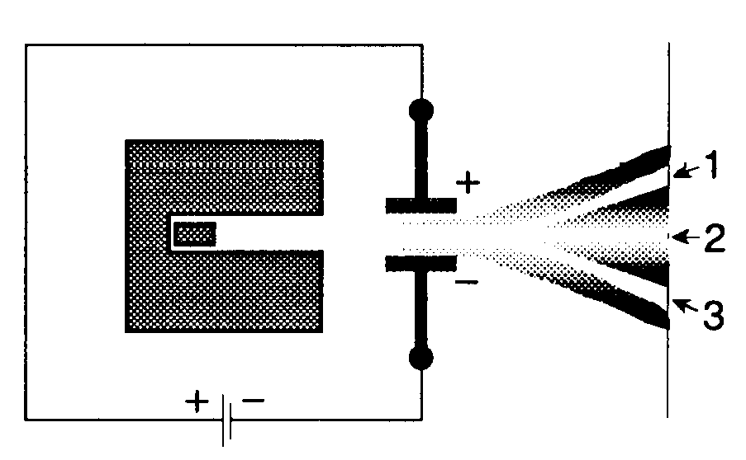

|  |  |
| --- | --- |
| 1. The illustration at the right shows radiation from a radioactive point source passing through an electric field. |  |

Which of the following correctly describes the rays formed after the radiation has passed through the electric field?

1. Ray 1 : negatively charged gamma (γ) rays

Ray 2 : neutral alpha (α) particles

Ray 3 : positively charged beta (β) particles

1. Ray 1 : negatively charged beta (β) particles

Ray 2 : neutral gamma (γ) rays

Ray 3 : positively charged alpha (α) particles

1. Ray 1 : positively charged beta (β) particles

Ray 2 : neutral gamma (γ) ray

Ray 3 : negatively charged alpha (α) particles

1. Ray 1 : negatively charged alpha (α) particles

Ray 2 : neutral beta (β) particles

Ray 3 : positively charged gamma (γ) rays

1. Calculate the time it would take to have less than 4.0 g of tellurium if its half-life is 7 days and you begin with 25.0 g of the substance.
2. Carbon-14’s half-life is 5 770 years. How old is a bone that contains only 10% of carbon-14? Show your work.
3. Explain what is meant by each of the following:

a) nuclear fission

b) nuclear fusion

1. Identify the following as fission or fusion reactions

a) 0n1 + 92u235 → 55Cs140  + 37Rb93 + 20n1  ___________________________

b) 1H2 + 1H2 →2He3 + 0n1 ___________________________

1. a) Identify the following equation as a nuclear fusion or fission reaction. Justify your choice.

________________________

b) There are over 200 pairs of isotopes that have been discovered to form during this reaction.

Explain why Xe and Sr could be one of these pairs. (Cr 3)

1n + 235U → 137Xe + 96 Sr + 31n

0 92 54 38

1. True or false
2. Sodium is bigger than magnesium because it has less valence electrons.
3. Chlorine has more electronegativity than Argon because it has less valence electrons.
4. Nuclear fusion is a source of energy used today.
5. During nuclear fission, a heavier nucleus becomes 2 lighter nuclei.
6. During nuclear fusion, a heavier nucleus becomes 2 heavier nuclei.
7. An element with the two isotopes will have the same number of protons.
8. Which of the following compounds are made up of covalent bonds?

1. Na2CO3 5. Ca3N2

2. C3H8 6. P2O5

3. Al4C3 7. PBr5

4. Si3N4 8. Mg3P2

|  |  |
| --- | --- |
| A) | 1, 3, 5 and 8 |
| B) | 1, 3, 6 and 8 |
| C) | 2, 4, 5 and 7 |
| D) | 2, 4, 6 and 7 |

1. Which two of the following compounds are formed by ionic bonds?

|  |  |  |  |
| --- | --- | --- | --- |
| A) | CH4 and P2O3 | C) | CaO and P2O3 |
| B) | CH4 and Na2S | D) | CaO and Na2S |

1. For each compound, draw a Lewis diagram representing the compound and give the molecular formula.

|  |  |  |
| --- | --- | --- |
|  | Lewis diagram | Molecular formula |
| Aluminum fluoride |  |  |
| Phosphorus trichloride |  |  |
| Chlorine gas |  |  |
| Carbon dioxide |  |  |
| Calcium chloride |  |  |

1. An element ‘X’ from group II and an element ‘Y’ from group VII form a compound.
2. Write the molecular formula for this compound.
3. Illustrate with a diagram how these elements transfer electrons from their last shell to respect the Octet Rule.
4. The molecular model of a substance is illustrated below.

O––O––O

|  |  |
| --- | --- |
|  | represents the atom whose second energy level contains 5 valence electrons. |
|  | represents the atom having three orbitals and forming a -2 ion. |

Which substance is represented by this molecular model?

A) Nitrogen trisulfide, N2S3 C) Dinitrogen trisulfide, N3S2

B) Dinitrogen trisulfide, N2S3 D) Trinitrogen sulfide, N3S2

1. Give the molecular formula for the following.

|  |  |  |  |
| --- | --- | --- | --- |
| Beryllium sulfide |  | Hydrogen fluoride |  |
| Sodium oxide |  | Hydrogen  sulfide |  |
| Diphosphorus trisulfide |  | Iodine gas |  |
| Carbon tetrachloride |  | Aluminum sulfide |  |

1. Name the following molecules.

|  |  |  |  |
| --- | --- | --- | --- |
| Na3P |  | SCl2 |  |
| NaCl |  | PF3 |  |
| NH3 |  | C2S4 |  |
| O2 |  | BeCl2 |  |

1. Name the following polyatomic ions.

|  |  |
| --- | --- |
| OH- |  |
| NO2- |  |
| NO3- |  |
| SO42- |  |
| SO32- |  |
| NH4+ |  |

1. Name the following compounds. Circle the polyatomic ions in each compound if present.

|  |  |
| --- | --- |
| KSO4 |  |
| MgOH |  |
| CaS |  |
| CO |  |
| (NH4)3PO4 |  |