**Periodic table worksheet 2**

1. Which of the following is the Lewis structure for magnesium?



1. Which one of these characteristics alone provides the information you need to represent an atom using the Lewis notation?
2. The group number C) The atomic mass
3. The period number D) The number of protons
4. During ionization, an atom can become a positive ion. How does an atom become a positive ion?
5. It gains one or more electrons C) It loses one or more electrons
6. It gains one or more protons D) It loses one or more protons
7. An element from period 3 is represented below in Lewis notation.

**•?** **•**

1. What is the name of this element?
2. Draw the Rutherford diagram of this element.
3. Which atom is correctly represented with the Lewis notation?

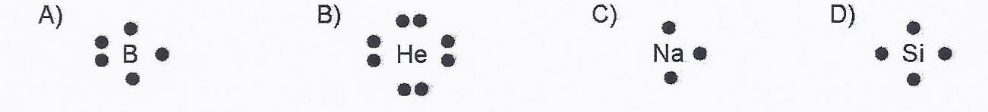

1. The salinity of water is due to the presence of mineral salts. Sodium chloride (NaCI)

is one of the salts dissolved in seawater. Use Lewis notation to represent each atom that makes up sodium chloride (NaCI).

1. Represent the Lewis notation for the following.

|  |  |  |  |  |  |  |  |
| --- | --- | --- | --- | --- | --- | --- | --- |
| Li | Be | B | C | N | O | F | Ne |

1. Each statement is incorrect, correct the wrong part so that it reads correctly.
2. O has a -2 charge because it donates 2 electrons during a chemical reaction.
3. Mg has a -2 charge because it donates electrons during a chemical reaction.
4. Ar has no charge because it is chemically active.
5. Al has a +2 charge because it donates 2 electrons during a chemical reaction.
6. Elements within the same group form different ions.