Changes in Matter

Def: __________________________________________________________________________

There are 4 types of changes: chemical, physical, neutralization and combustion.

Review
Chemical changes signs | Physical changes signs
- _____________________________  - _____________________________  - _____________________________  - _____________________________  - _____________________________ | - _____________________________  - _____________________________  - _____________________________  - _____________________________  - _____________________________

Neutralization

Def: __________________________________________________________________________
______________________________________________________________________________

Once neutralization has occurred, acids and bases are no longer present. Instead you have created two new substances.

Examples

NaOH + HCl ⇒

Ca(OH)₂ + 2 HBr ⇒

Al(OH)₃ + 3 HF ⇒

Molecules always produced are?

Neutralizations labs using indicators

- How to determine whether an unknown is an acid, base or neutral solution?

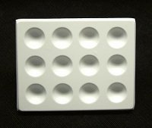
HCl NaOH NaCl Unknown

+Indicator

- How to neutralize unknown once its origin is determined?

- What if you have many indicators to choose from?

HCl NaOH NaCl Unknown

Indicator 1

Indicator 2

Indicator 3

