Constraints and Material Notes
Constraints
____________________________________________________________________________________________________________________________________________________________
Constraints | Examples | Description | Symbol
Compression | 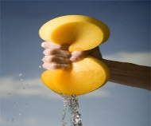 |  | 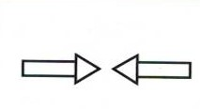
Tension | 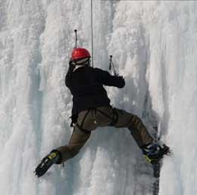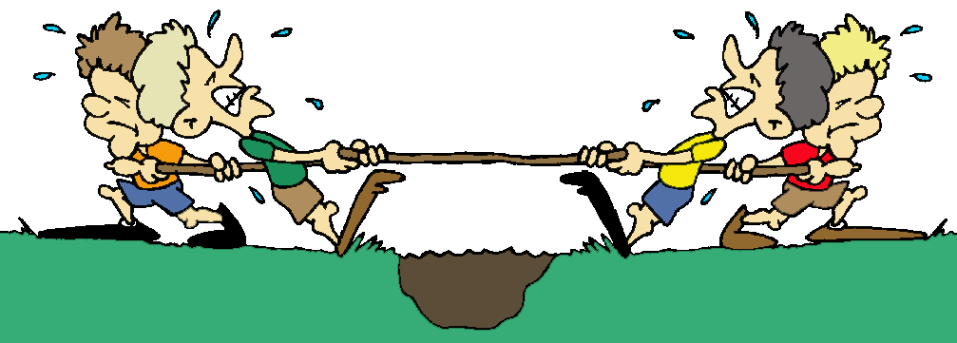
Torsion | 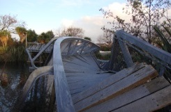
Deflection |  |  | 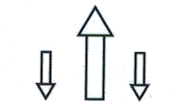
Shearing | 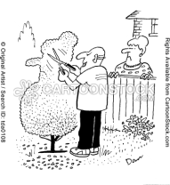 |  | 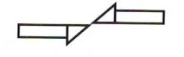

Deformations
Depending on the constrains there are three types of deformations which can occur.
Type of deformation | Example | Description
Elastic
Plastic | 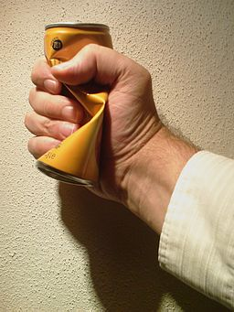
Fracture | 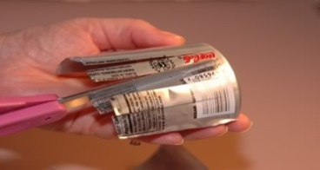

Properties
Mechanical properties describe how a material reacts when subjected to one or more constraints.

Property | Description | Example
Hardness |  | Diamonds  Ceramic
Elasticity |  | Elastics  Bedsprings
Resilience |  | Plastics  Metals
Ductility |  | Elastics  Metals
Malleability |  | Metal  Plastics
Stiffness |  | Ceramics  Concrete
Fragility |  | Ceramic  Glass
Other properties
Resists corrosion |  | Ceramics  Plastic
Electrical conductivity |  | Metals  Salt water
Thermal conductivity |  | Metals
Materials
Looking at characteristics, degradation and protection.

Degradation: breaking down or wearing down of a material.

5 Materials
 | Wood and modified wood | Ceramics | Metals and alloys
Fact | Wood is produced by the harvesting of trees and modified wood is wood mixed with other substances (glue, plastics) | Created by heating inorganic matter Usually formed using an oxide, sand and clay. | A metal is extracted from an ore. An alloy is made up of many metals and or other substances. Ferrous alloy has iron in it.
Pros | Resilient and does not conduct. Can recover from water damage | Hard, does not rust and does not conduct. Used in building materials. | Conducts heat and electricity. Malleable and ductile.
Cons | Can be ruined by too much water. Damaged by insects | Very fragile | Will rust
Degradation | Sun, insects and water | Can be deteriorated by certain acids and bases. | Rust due to water and salt
Protection | Treating wood with a solution containing copper | Care in baking process can determine its resiliency | Coatings are put on the metal (paint and oils). Galvanized- coated with zinc.

 | Plastics | Composites
Fact | Plastics are made from fossil fuels. Thermoplastics will soften when heated and changes shape when cooled. Thermosetting plastics remain hard even when heated. | Made up of 2 parts: 1- Matrix (skeleton and gives shape) 2- Reinforcement (fills the matrix). Used in airplane wings, bulletproof vests and sport equipment.
Pros | Can be used for basically everything and anything. Cheap to produce. Can be molded in all colours and sizes. | Produces high quality products.
Cons | All thermosetting plastics are not recyclable. Cheap, therefore creates a lot of waste. | Very expensive to produce.
Degradation | Water, oxygen and UV rays can damage them. | Matrix and reinforcement loses its adherence. Deformation or fracture of materials.
Protection | Use waterproof coating, add antioxidants and add pigments which absorb UV rays. | Using products which will adhere together well.

Past exam question
      - A circuit performer holds onto a twisted rope, maintaining the same position for a few seconds.
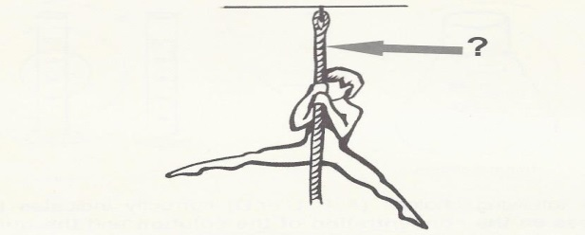
Which of the following choices indicates the two mechanical constraints to which the rope is subjected at the location where the arrow is pointing?
A) tension and compression C) deflection and torsion
B) compression and deflection D) torsion and tension

