**Magnetism Notes**

In order for a substance to be considered magnetic it must have 2 criteria:

1. __________________________________________________________________
2. __________________________________________________________________

**Magnet rules**

1. ________________________________________________________________________
2. ________________________________________________________________________
3. ________________________________________________________________________
4. ________________________________________________________________________

________________________________________________________________________

**Magnetic Fields**

* A magnetic field is the area around which the effects of a magnet are felt by another magnet.
* A magnetic field always travels from a **N to S** pole and can travel in all directions as long as there is attraction or repulsion.

Example 1

N S

Example 2

N S

N S

Example 3

S N

N S

Example 4

N S

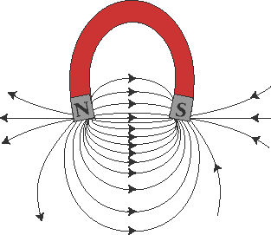

**Earth’s Magnetic Field**

* Inside the earth's surface there is a huge amount of ferromagnetic liquids (Fe, Co, Ni). These liquids are constantly in motion and produce a massive magnetic field which can be felt anywhere around the world.

**How a compass works**

* A compass has a magnetic north setting which works like a magnet. A compass points you to geographic north because this is where magnetic south is.
* It points away from geographic south because this is where magnetic north is.
* A compass will give you magnetic field direction, it will point into south and away from north,

N S

**Magnetic Field of a Live Wire**

* When current is passing through a wire, a magnetic field is created which cannot be seen or feel the magnetic field, but a compass will react to it.

**The right hand rule**

* Gives us current direction and magnetic field direction.

Thumb:_______________________________________________________________________

Fingers: _______________________________________________________________________

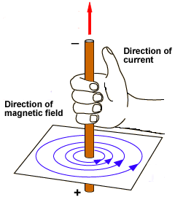

* Your fingertips are like the N part of the compass, they are pointing you towards south.

**Bulls eye**

**Past exam Questions**

1. 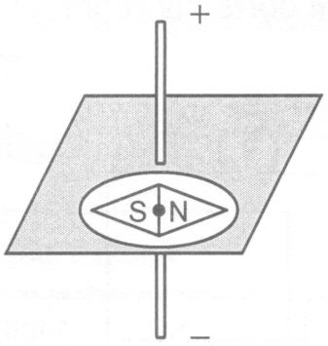Which diagram(s) correctly show the relationship between the magnetic field and the electric current producing it?





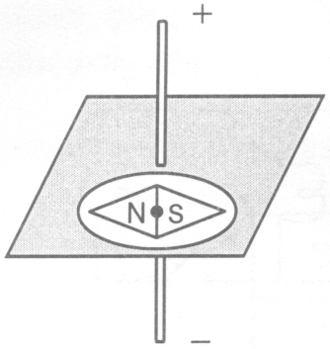



1. An electric current flows through a straight wire and produces a magnetic field.

Which of the following diagrams correctly represents this magnetic field?

|  |  |  |  |  |  |  |  |
| --- | --- | --- | --- | --- | --- | --- | --- |
| A) |  | B) |  | C) |  | D) |  |

1. Study the five diagrams below. Which diagram(s) correctly show the relationship between a magnetic field and the electric current producing it?



1. Given a point M in the magnetic field surrounding a bar magnet. Of the four arrows shown below, which one correctly shows the magnetic force which would act on a point charge at point M?



1. 1 B) 2 C) 3 D) 4
2. A magnetic compass is placed on the piece of cardboard near the wire. Which of the following diagrams shows the direction in which the compass needle will point?



1. The following diagram shows a straight current-bearing wire that runs through a surface on which a compass has been placed.



Which of the following compass needles is pointing in the direction of the magnetic field produced by the current flowing through the wire?



7. The diagram below shows two compasses placed at the ends of the two magnets.

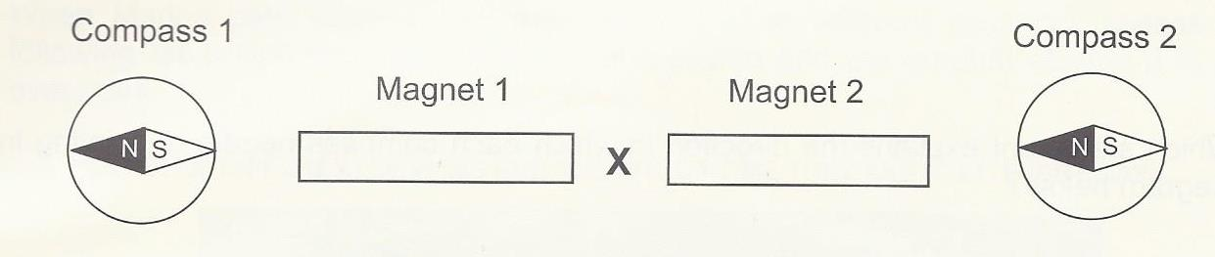

Which statement correctly describes the force acting between the two magnets at the location marked with an X?

1. The north pole of magnet 1 and the south pole of magnet 2 attract each other.
2. The south pole of magnet 1 and the north pole of magnet 2 attract each other.
3. The south pole of magnet 1 and the south pole of magnet 2 repel each other.
4. The north pole of magnet 1 and the north pole of magnet 2 repel each other.