**Review for Statics and Magnetism Quest**

1. **Multiple Choice**
2. The following diagram shows two bar magnets and two compasses placed in a certain way.



The poles are not indicated on magnets 1 and 2 in the diagram, but the compass needles show the direction of the magnetic fields of these magnets.

Which of the following diagrams correctly indicates the poles of these magnets?

|  |  |
| --- | --- |
| A) |  |
| B) |  |
| C) |  |
| D) |  |

1. The following diagram shows a bar magnet and four compasses.



Which compass shows the needle pointing in the correct direction?

1. Compass 1 B) Compass 2 C) Compass 3 D) Compass 4
2. 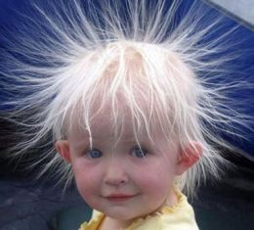Static electricity can make hair stand up straight in the air as shown in the picture below.

Which statement explains the behavior of hair in this situation?

1. The strands of hair have opposite charges and therefore repel one another.
2. The strands of hair and the air have opposite charges, so the hair is attracted by the air.
3. The strands of hair have like charges and therefore repel one another.
4. The strands of hair and the air have like charges, so the hair is attracted by the air.
5. Which of the following diagrams correctly shows the direction of the magnetic field lines?

|  |  |
| --- | --- |
| A) | Numériser0328 |
| B) | Numériser0329 |
| C) | D)  Numériser0331Numériser0330 |

1. The following diagram shows a compass placed over a conducting wire. Electricity is flowing through this wire.



Which of the following compasses shows the needle pointing in the correct direction for this situation?

|  |  |  |  |
| --- | --- | --- | --- |
| A) |  | C) |  |
| B) |  | D) |  |

1. The triboelectric series (electrostatic list) below shows the tendency of certain materials to acquire or give up negative charges.

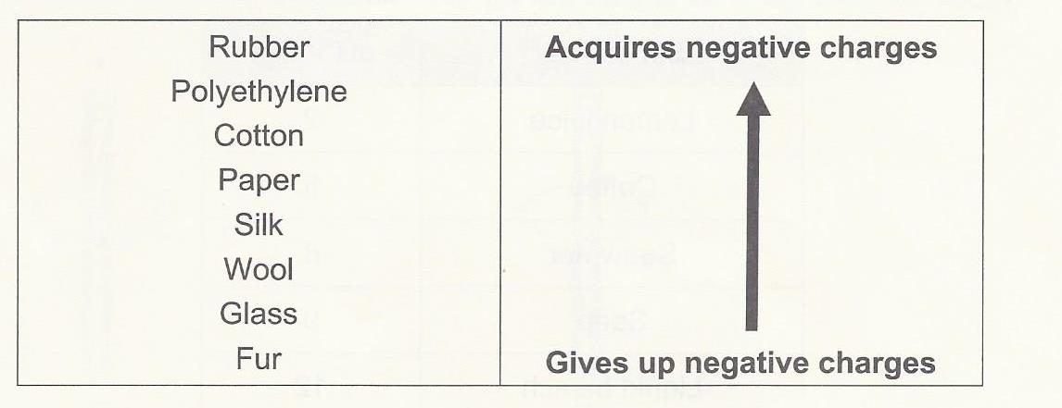

After a glass rod and a piece of wool are rubbed together for a few seconds, they are brought close together. Which of the correctly indicates the charge of the glass rod and the piece of wool after they are rubbed together, as well as their behavior when they are brought close to each other?

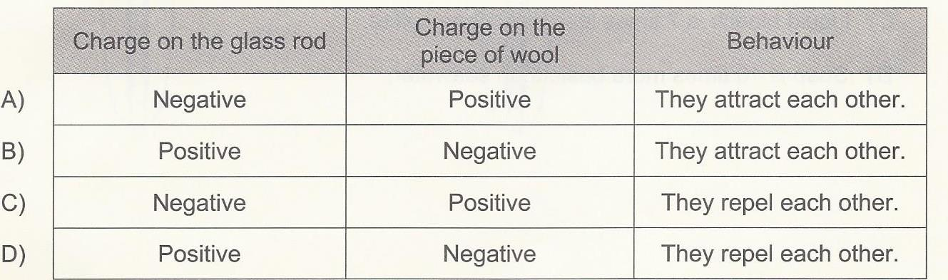

1. Two charged spheres (A and B) are suspended from a wire as shown in the diagram below. Sphere A is negatively charged, but we do not know the charge on sphere B.

A student carries out the following steps to see how the spheres behave.

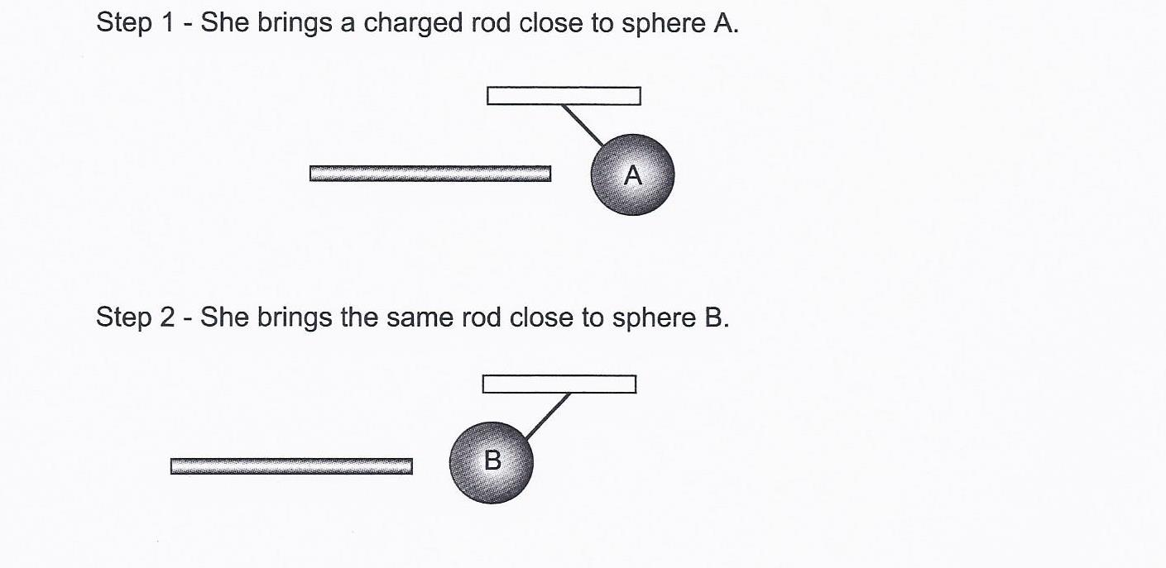

Which statement correctly describes the charge on the rod and the behavior of the spheres A and B if they are brought close together?

1. The rod is negatively charged, and spheres A and B will repel each other.
2. The rod is positively charged, and spheres A and B will attract each other.
3. The rod is negatively charged, and spheres A and B will attract each other.
4. The rod is positively charged, and spheres A and B will repel each other
5. Which statement explains the direction in which each compass needle is pointing in the diagram below?

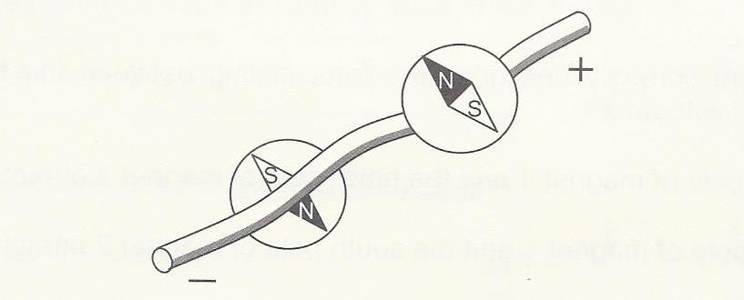

* 1. The magnetic field produced in a wire creates a current parallel to the compasses.
  2. The magnetic field produced in a wire reverses the direction of the electric current.
  3. The current flowing in a wire produces a circular magnetic field around the wire.
  4. The current flowing in a wire produces a magnetic field parallel to the wire.

1. When compasses are placed near a bar magnet, their needles point in different directions because the magnet has a magnetic field that influences the position of the compass needles.

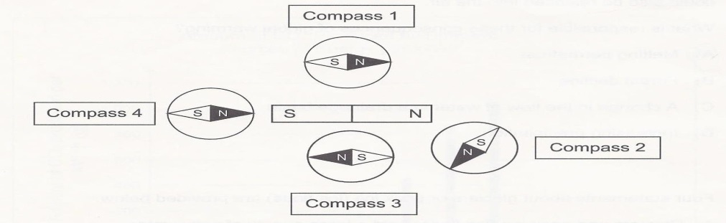

Which of the four compasses shown above has a needle that is **not** pointing in the correct direction?

1. Compass 1 B) Compass C) Compass 3 D) Compass 4
2. Through friction, electrical charges can be transferred from one material to another. Two examples of this are given below.
   * + 1. When a plastic ruler is rubbed with a cotton cloth, negative charges are pulled away from the cotton toward the plastic.
       2. When a wooden rod is rubbed with a wool cloth, the rod becomes negatively charged.

Which statement below correctly describes the behavior of the four objects after they have been rubbed together?

1. The ruler and the rod attract each other, and the cloths also attract each other.
2. The ruler and the rod attract each other, but the cloths repel each other.
3. The ruler and the rod repel each other, and the cloths repel each other.
4. The ruler and the rod repel each other, but the cloths attract each other.
5. An electrically neutral metal sphere is placed on an insulating stand, as shown in figure 1.

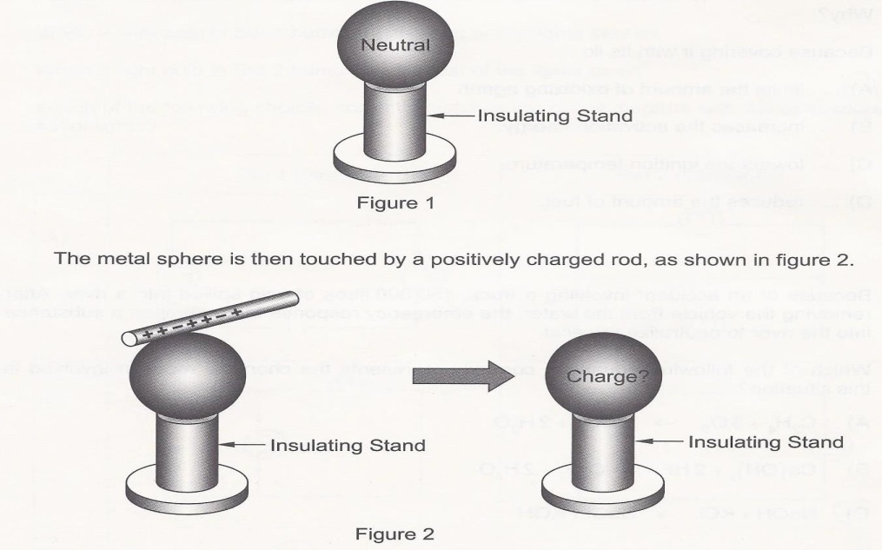

Which statement correctly explains how the sphere became charged after it was touched with the rod?

* 1. The sphere became negatively charged because the positive charges were transferred from the sphere to the rod.
  2. The sphere became negatively charged because the negative charges were transferred from the rod to the sphere.
  3. The sphere became positively charged because the positive charges were transferred from the rod to the sphere.
  4. The sphere became positively charged because the negative charges were transferred from the sphere to the rod.

1. Two magnets and a compass are shown below.

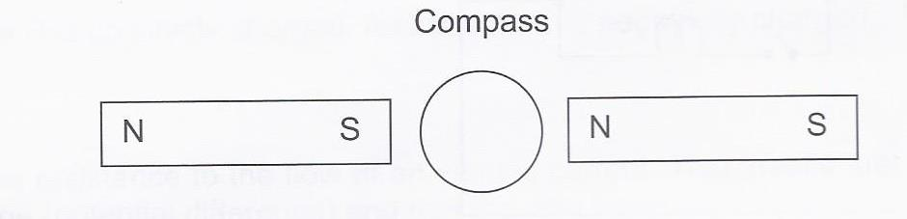

In which direction will the compass needle be pointing in this situation?

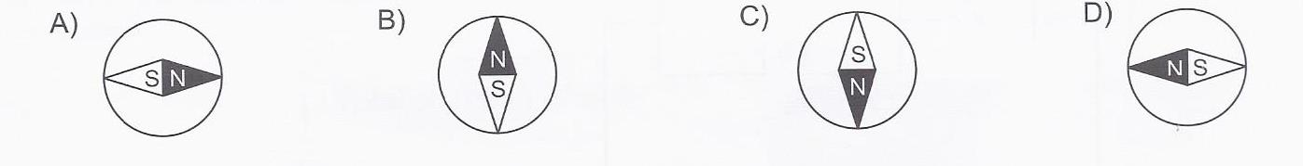

1. A simple experiment can be conducted to show that a straw can be used to turn the pages of a book.

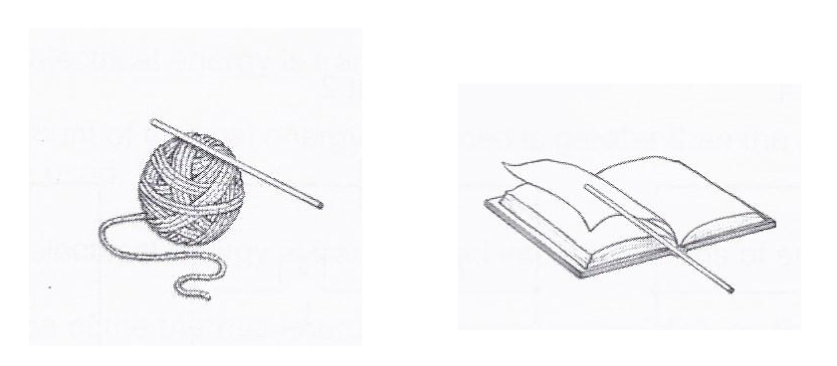

To do this, simply rub the polypropylene straw with the wool and then bring the straw close to the page of a book. The page will move toward the straw and stick to it, as illustrated above.

The following materials are listed according to their tendency to attract negative charges. The materials higher up on the list attract negative charges more easily.

|  |
| --- |
| Polypropylene  Ebonite  Cotton  Silk  Wool  Fur  Glass |

Which of the following is the correct explanation for why the paper sticks to the straw?

1. The straw is positively charged and attracts the negatively charged paper.
2. The straw is negatively charged and attracts the neutral paper.
3. The straw acquires the negative charges from the wool and then attracts the negatively charged paper.
4. The straw gives its negative charges to the wool and then attracts the neutral paper.
5. You are given four electrically charged spheres. You know that sphere 1 is negatively charged. The following diagrams show what happens when these spheres are suspended in pairs close to each other.



Which of the following diagrams correctly indicates the charge on spheres 3 and 4 and shows what will happen to them when they are suspended close to each other?

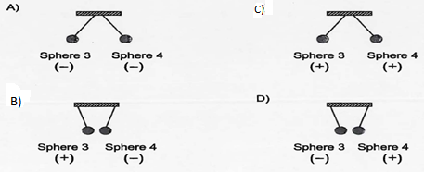

1. The diagrams below show four copper wires with a compass placed on each wire.

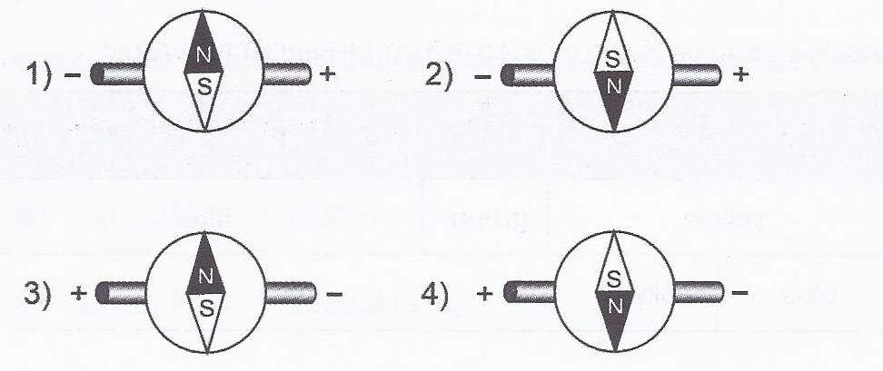

Which diagrams show the compass needle pointing in the CORRECT direction?

* 1. Diagrams 1 and 3 C) Diagrams 2 and 3
  2. Diagrams 1 and 4 D) Diagrams 2 and 4

**B. Short Answer**

1. A student rubbed two identical inflated balloons on a piece of fur and suspended them from a high stand. He then rubbed a plastic ruler with a piece of wool and placed it between the two suspended balloons. The balloons quickly went high in the air as

shown in the diagram below.

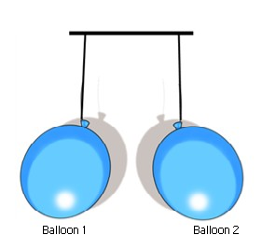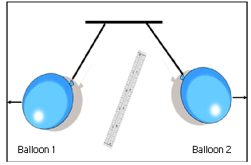

Knowing that the wool cloth transferred electrical charges to the ruler, determine the overall charge of the balloons, fur, ruler and wool cloth.

1. In the laboratory, you are asked to observe the electrical behaviour of certain materials using the following electrostatic list.



You start by rubbing a glass rod with a piece of silk and then suspend the electrically charged glass rod from an insulated wire.



You then rub a vinyl ruler with a piece of wool.

Last, you bring the electrically charged vinyl ruler close to the suspended glass rod.

A) State the charge on the glass rod.

B) State the charge on the vinyl ruler.

C) Will the glass rod and the vinyl ruler attract or repel?

1. On the pictures below, put in the correct compass direction for each diagram.

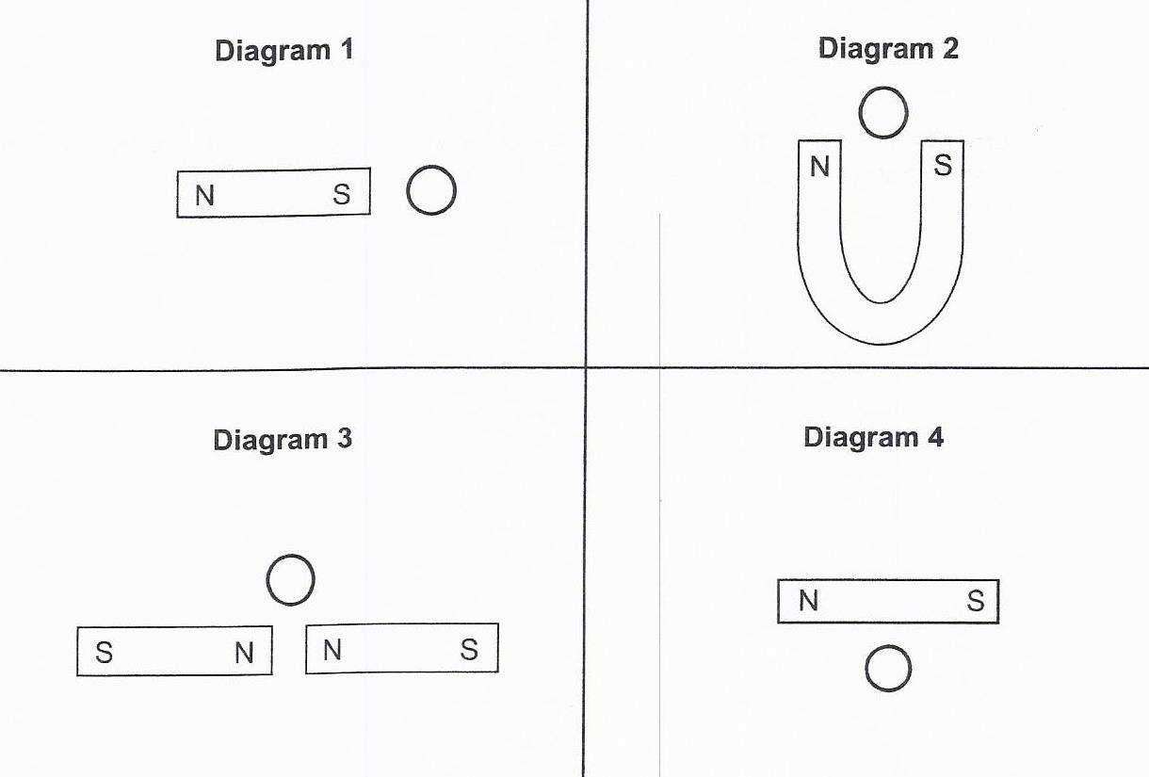

1. 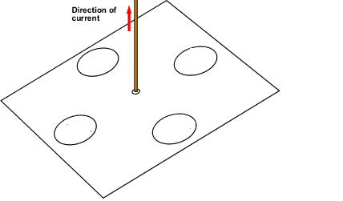Put in the correct compass directions in the diagram below.
2. During a static electricity lab, a student rubs 5 pieces of different materials together two at a time. Table 1 below shows which of two materials were rubbed and which became negatively charged once they were rubbed.

**Table 1- Negatively charged materials**

|  |  |
| --- | --- |
| **Materials being rubbed** | **Substance which gained electrons** |
| Wood and nickel | Nickel |
| Wood and silk | Wood |
| Wood and lead | Wood |
| Lead and nickel | Nickel |
| Lead and silk | Silk |
| Nickel and silk | Nickel |
| Nickel and glass | Nickel |
| Wood and glass | Wood |
| Glass and lead | Lead |
| Glass and silk | Silk |

Using the information in Table 1, you must put the 5 materials in order starting with the substance which will most easily gains electrons (becomes negatively charged) to the substance which will most easily lose electrons (becomes positively charged).

|  |  |
| --- | --- |
| **Object** | **Tendency to attract electrons** |
| 1. |  |
| 2. |
| 3. |
| 4.  5. |

1. Using the information in the table below, give the charge for spheres A, B and C and justify your answer.

|  |  |  |
| --- | --- | --- |
| **Test** | **Observation** | **Sketch** |
| 1. The positively charged glass rod is brought close to sphere A without touching it. | Sphere A is repelled. | Rubbed glass rod |
| 2. Sphere A is brought close to sphere B without touching it. | Spheres A and B are repelled. |  |
| 3. A positively charged glass rod is brought close to sphere C without touching it. | Sphere C is attracted to the glass rod. | Rubbed glass rod |
| 4. The piece of silk used to rub the glass rod is brought close to sphere C without touching it. | Sphere C is attracted to the piece of silk. | Silk |

|  |  |  |
| --- | --- | --- |
|  | **Charge** | **Explanation** |
| **Sphere A** |  |  |
| **Sphere B** |  |  |
| **Sphere C** |  |  |