**Links Notes**

Def : __________________________________________________________________________

______________________________________________________________________________

|  |  |
| --- | --- |
| **Direct** | **Indirect** |
|  |  |
| http://admintell.napco.com/ee/images/uploads/gadgetell/glowingsocket.PNG  http://thumbs.dreamstime.com/z/bike-wheel-12919506.jpghttp://www.photo-dictionary.com/photofiles/list/8401/11442paper_clip.jpg | [http://www.ying-fang.com/data/goods/rivet_b301007-10x7.jpg](http://www.ying-fang.com/en/goods.php?act=view&no=1794)http://www.endlessroll.com/pictures/rollerblade%20twister%20243.jpghttp://www.angiesroost.com/wp-content/uploads/2011/11/PA290041.jpghttp://hometolife.co.za/wp-content/uploads/2012/12/buildzone-installing-door-hinge-diy-renovation.jpg |

|  |  |
| --- | --- |
| **Rigid** | **Flexible** |
|  |  |
| http://admintell.napco.com/ee/images/uploads/gadgetell/glowingsocket.PNG http://thumbs.dreamstime.com/z/bike-wheel-12919506.jpg  http://hometolife.co.za/wp-content/uploads/2012/12/buildzone-installing-door-hinge-diy-renovation.jpg | http://1.bp.blogspot.com/_sCABPHjYvRs/TLzKFEc-87I/AAAAAAAAFvQ/t6MfTOTwJ3I/s1600/il_fullxfull_118902724.jpghttp://www.photo-dictionary.com/photofiles/list/8401/11442paper_clip.jpg |

|  |  |
| --- | --- |
| **Removable** | **Non-removable** |
|  |  |
| http://admintell.napco.com/ee/images/uploads/gadgetell/glowingsocket.PNG  http://thumbs.dreamstime.com/z/bike-wheel-12919506.jpghttp://www.photo-dictionary.com/photofiles/list/8401/11442paper_clip.jpg | http://www.angiesroost.com/wp-content/uploads/2011/11/PA290041.jpghttp://digitaldeconstruction.com/wp-content/uploads/2012/06/opening-of-beer-cap-with-the-gas-output.jpg |

|  |  |
| --- | --- |
| **Complete** | **Partial** |
|  |  |
| http://admintell.napco.com/ee/images/uploads/gadgetell/glowingsocket.PNG  http://thumbs.dreamstime.com/z/bike-wheel-12919506.jpg | http://hometolife.co.za/wp-content/uploads/2012/12/buildzone-installing-door-hinge-diy-renovation.jpghttp://www.endlessroll.com/pictures/rollerblade%20twister%20243.jpghttp://www.photo-dictionary.com/photofiles/list/8401/11442paper_clip.jpg |

**Guiding Components**

* ________________________________________________________________________________________________________________________________________________
* ________________________________________________________________________________________________________________________________________________

|  |  |  |
| --- | --- | --- |
| **Translational** | **Rotational** | **Helical** |
|  |  |  |
| http://beehiverenovations.com/wp-content/oqey_gallery/galleries/windows/galimg/sliding-window.jpghttp://ranzom.com/wp-content/uploads/2013/12/kitchen-astonishing-custom-kitchen-island-solid-wood-butcher-block-counter-top-with-drawers-pull-out-spice-rack-for-inspiring-modern-small-kitchen-design-amazing-butcher-block-island-with-simplistic-d.jpg | http://strengthforthesoul.com/blog/wp-content/uploads/2013/07/open-door.jpghttp://www.cmstatic1.com/42548/42548.159568.jpg | http://2ndstartotherightyoga.files.wordpress.com/2011/11/peanut-butter-jar.gifhttp://www.harborfreight.com/media/catalog/product/cache/1/image/9df78eab33525d08d6e5fb8d27136e95/i/m/image_17226.jpg |

Example Questions.

1. Characteristics of the link between the handle and the punch of a hole punch. (A rivet is used)

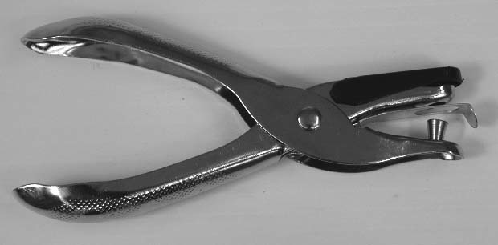

Punch

Handle  
The characteristics of the link between the handle and the punch are:

1. The shelf and side panel. (The shelf is glued into the side panel).

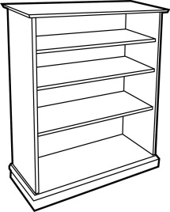

1. Light bulb and socket

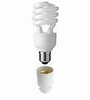

1. Clothes pin prongs

