Label the Parts of the reproductive systems below (use page 260 and 261):

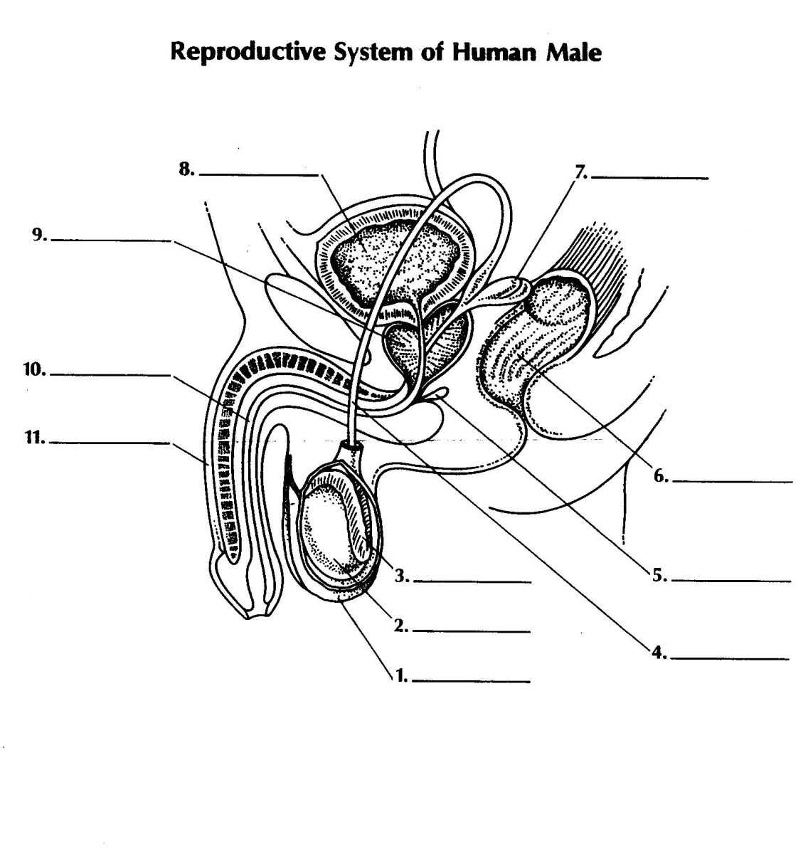

[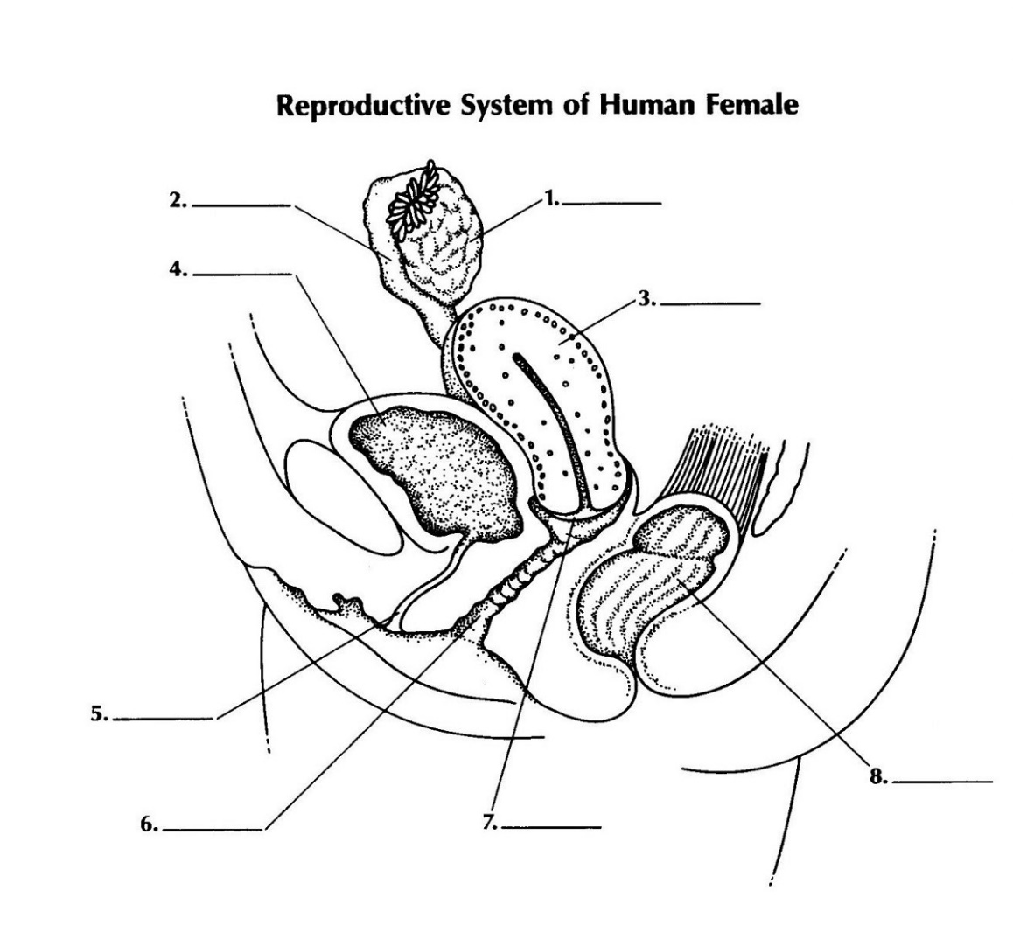](http://www.diagrama.xyz/female-genitalia-diagram/female-genitalia-diagram-simple/)