January Exam Review

Test 1- Periodic table
- Which statement proper explains Rutherford’s finding using the gold foil experiment?
- The atom was very small with protons in the nucleus and electron on orbits.
- The atom was very small with electrons in the nucleus and protons on orbits.
- The atom was very big with protons in the nucleus and electrons on orbits.
- The atom was very big with protons in the nucleus and electrons outside of the nucleus.

- The following diagram represents the simplified atomic model (Bohr-Rutherford) of an element.
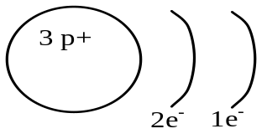
Which of the following is true?
- The element is located in period 1 and is an alkaline earth metal.
- The element is located in period 1 and is an alkali metal.
- The element is located in period 2 and is an alkali metal.
- The element is located in period 2 and is an alkaline earth metal.

- In the diagram below, the circles numbered 1 to 6 represent a characteristic shared by categories of elements in the periodic table.
2 |  |  |  |  |  |  |  |  |  |  |  |  |  |  |  |  | 5
D | 3 |  |  |  |  |  |  |  |  |  |  |  |  |  |  | 4 | C
  B | F |  |  |  |  |  |  |  |  |  |  |  |  |  |  | A
 |  |  |  |  |  |  |  | 6
E
Each numbered circle is associated with one of the statements below concerning categories of elements. Write the appropriate letter in each of the numbered circles.
A – The elements in this family have 7 valence electrons.
B – This space is used to indicate the number of energy levels.
C – The elements in this family are very chemically stable.
D – The outermost energy level of these elements contains one electron, )1e⁻.
E – The elements in this category are very malleable and are good conductors of heat and electricity.
F – One of the elements in this family has 4 protons and 5 electrons.
- In a laboratory, a scientist noted the following facts about 2 elements:
Element 1 has 3 energy shells and a 5 valence electrons.
Element 2 has 2 full shells
What are elements 1 and 2?
- Element 1is potassium and element 2 is neon
- Element 1is phosphorus and element 2 is neon
- Element 1is potassium and element 2 is argon
- Element 1is nitrogen and element 2 is argon

- Five elements are identified in the following periodic table.
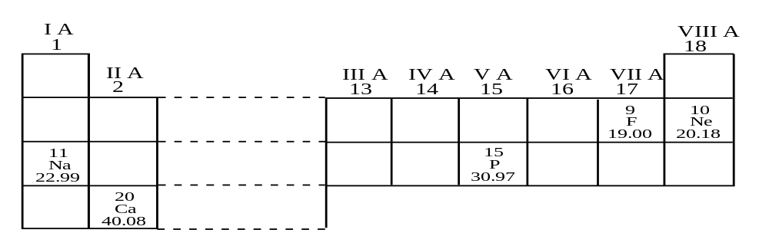
Match each of the five elements with one of the characteristics listed below.
1. Its third energy level contains 5 valence electrons.
2. It is a gas that does not react with metals or nonmetals.
3. It is an element whose chemical reactions are similar to those of potassium.
4. It is one of the most corrosive gases.
5. It is an alkaline earth metal that is a component of bones and teeth.
A) 1- P, 2- Ne, 3- Na, 4- F, 5- Ca C) 1- P, 2- Ne, 3- F, 4- Na, 5- Ca
B) 1- Ne, 2- F, 3- Na, 4- P, 5- Ca D) 1- Ca, 2- Ne, 3- F, 4- Na, 5- P

- Which of the elements in the table below possess the properties of shininess, electrical conductivity and malleability?
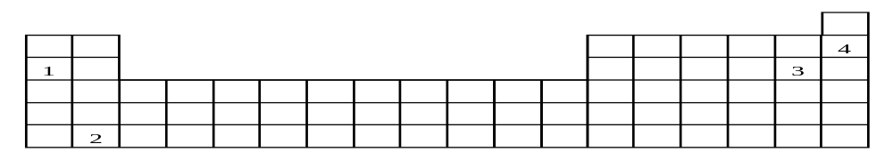
A) 1 and 2 B) 1 and 4 C) 2 and 3 D) 3 and 4

- The illustration represents two elements X and Y:
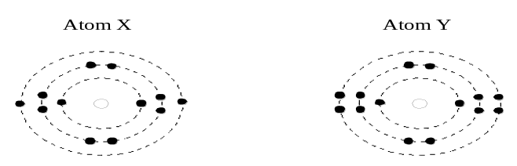
Write the names of atoms X and Y.
X= Mg
Y= Si

- While doing a research project, you noted the following information about five elements.
Element A : | . | is a solid;
 | . | conducts electricity;
 | . | has 2 electrons in its outermost shell;
Element B : | . | has a very low density;
 | . | does not conduct electricity;
 | . | has 7 electrons in its outermost shell;
Element C : | . | is found in very small quantities in nature;
 | . | does not form compounds with other elements;
 | . | is in a gaseous state;
Element D : | . | is a poor conductor of heat;
 | . | in non-ductile and non-malleable;
 | . | conducts electricity.
Element E : | . | is ductile and malleable;
 | . | is a solid;
 | . | is a good conductor of heat and electricity;
Classify the elements above as metals, non-metals or metalloids.
A and E= Metal D= Metalloid
B and C = non-metal

- A student is given an unknown solid substance belonging to family II A (family 2).
To determine the nature of this substance, he conducts the tests listed in the following table.
Give the expected result for each test.
TEST | EXPECTED RESULT
- Reacts with a strong acid | Bubbles
- Electrical conductivity test | Conducts
- Thermal conductivity test | Conducts
- Malleability test | Bends

Test 2- Solution, electrolytes and pH

- Chlorine is sometimes used in a city’s water filtration system to kill micro-organisms. To ensure fish in an aquarium are not affected by the chlorine, tap water could be left sitting for 24 hours to allow the chlorine to evaporate. The lethal dose of chlorine for most goldfish is 0.05 mg/L. Most water filtration systems use 45.5 ppm to kill micro-organisms. Do you need to let the water sit for 24 hours so the chlorine could evaporate?
0.00005 g = _____x_____ 0.05 ppm
1 000 mL 1 000 000
Yes because 45.5 ppm will kill fish since lethal does is 0.05 ppm

- You have a 40 g/L solution. You want to make a 300 mL solution. Solve and explain the process of making the solution.
40_ = __x__ = 12g 1- Weigh 12 g of solute
1000 300 2- Put 12 g in 300 mL volumetric flask
3- Add water and swirl
4- Add water to line
5- Check meniscus

- Which of the following categories of substances are considered to be electrolytes?
- Acids and neutral salts C) Acids, bases and salts
- Acids and bases D) Salts and bases

- Associate each substance with the correct characteristic
Substances | Characteristics
1. Aqueous aluminium hydroxide, Al(OH)_{3(aq)}  2. Aqueous calcium hydroxide, Ca(OH)_{2(aq)}  3. Aqueous acetic acid, HCH₃CO_{2(aq)}  4. Aqueous lithium hydroxide, LiOH_{(aq)}  5. Aqueous hydrogen chlorate, HClO_{3(aq)} | a) Acid  b) Neutral  c) Basic
- 1a, 2a, 3c, 4a and 5c C) 1c, 2a, 3b, 4c and 5a
- 1c, 2c, 3a, 4c and 5a D) 1a, 2c, 3b, 4c and 5a

- In order to classify three unknown solutions as acids, bases or salts, you have been given the following information :
Solution / Information | 1 | 2 | 3
Electrical conductivity | yes | yes | yes
Reaction of blue litmus paper | turns red | stays blue | stays blue
Reaction of red litmus paper | stays red | stays red | turns blue
On the basis of this information, how do you classify the three solutions?
- Solution 1 : acid Solution 2 : base Solution 3 : salt
- Solution 1 : acid Solution 2 : salt Solution 3 : base
- Solution 1 : base Solution 2 : acid Solution 3 : salt
- Solution 1 : base Solution 2 : salt Solution 3 : acid

- Which one of the following describes an acidic solution?
- A solution that does not change the colour of blue litmus paper and that conducts electricity
- A solution that does not change the colour of blue litmus paper and that does not conduct electricity
- A solution that turns blue litmus paper red and that conducts electricity
- A solution that turns red litmus paper blue and that does not conduct electricity

- Which of these aqueous solutions contains a neutral salt?
 | Solution 1 | Solution 2 | Solution 3 | Solution 4
Effect on litmus paper | Paper turns red | No effect | Paper turns blue | No effect
Electrical conductivity | Yes | Yes | Yes | No
- Solution 1 B) Solution 2 C) Solution 3 D) Solution 4

- Which answer shows the correct electrolytic dissociation for CaCl₂?
- CaCl₂ → Ca²⁺ + 2Cl⁻ C) CaCl₂ → Ca + 2Cl
- CaCl₂ → 2 Ca + 2Cl⁻ D) CaCl₂ → 2 Ca + 2Cl

- The following table gives the colours of the indicator phenol red in solutions whose pH values vary from 0 to 14.
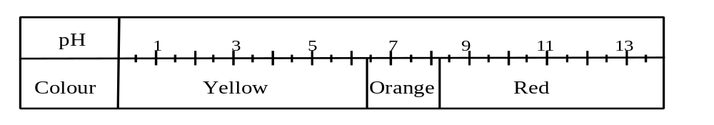
A few drops of this indicator are added to a basic solution.
What colour does the phenol red become?
- Orange or red C) Yellow or orange
- Yellow only D) Red only

pH Scale | 2 | 3 | 4 | 5 | 6 |  | 7 | 8 |  | 9 | 10 | 11 | 12
Indicator 1 | Yellow |  |  |  |  | Green |  |  | Blue
Indicator 2 | Colourless |  |  |  |  |  |  |  | Pink |  | Fuchsia
Indicator 3 | Red |  | Orange |  |  | Yellow
Indicator 4 | Red |  |  |  | Orange |  |  |  | Yellow |  |  | Green
The pH of a given solution is unknown. Indicators 1 and 3 turn yellow in this solution.
What colour will indicator 4 become in this solution?
- Red B) Orange C) Yellow D) Green

- The following table gives the colours of the indicators phenolphthalein and methyl red in solutions that have pH values ranging from 1 to 14.
Phenolphthalein | Colourless |  |  |  |  |  |  |  | Pink |  | Red
pH | 1 | 2 | 3 | 4 | 5 | 6 |  | 7 | 8 | 9 | 10 | 11 | 12 | 13 | 14
Methyl Red | Red |  |  |  | Orange |  | Yellow
A mixture of these two indicators is added to a neutral solution. What colour will the mixture of the two indicators be in this neutral solution?
- Colourless B) Yellow C) Orange D) Pink

- This table gives the behaviour of certain indicators.
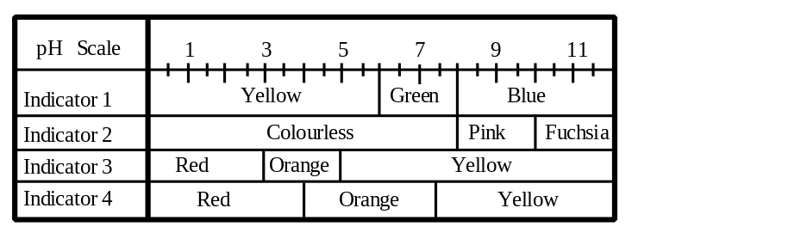
The pH of a given solution is unknown. Indicators 1 and 3 turn yellow in this solution. Between which values will the pH of this solution fall?
- Between 0 and 5 C) Between 5 and 12
- Between 5 and 6 D) Between 6 and 12

- Answer the questions below using the 3 indicators
pH | 1 | 2 | 3 |  | 4 | 5 | 6 | 7 | 8 | 9 | 10 | 11 | 12 | 13
A | Red |  |  | Orange |  |  |  |  | Yellow
B | Blue |  | Green |  |  | Yellow
C | Red |  |  |  |  | Purple |  |  |  | Blue
A) Which indicator would you use to find a strong acid? B
B) What is an unknown's pH if it turns orange with A and green with B? 4
C) What is an unknown’s pH if it turns yellow with A and purple with C? 8

Test 3- Changes in matter, balancing equations, neutralization and combustion

- A student performed four tests and made the following observations.
Test | Observation
1. Brought a magnet close to a piece of metal. | The two objects attracted each other.
2. Added lime water to a test tube containing a gas. | The lime water became cloudy.
3. Mixed two colourless liquids in a beaker. | The beaker became warmer.
4. Ground a piece of chalk. | The chalk turned to a very fine white powder.
Which of these tests produced chemical changes?
A) 1 and 2 B) 1 and 4 C) 2 and 3 D) 3 and 4

- Which of the following equations is correctly balanced?
- H₂SO₄ + 2 NaOH → Na₂SO₄ + H₂O
- 2 K₂O₂ + 2 H₂O → 4 KOH + 2 O₂
- 2 C₂H₂ + 5 O₂ → 4 CO₂ + 2 H₂O
- 3 NO₂ + 2 H₂O → 4 HNO₃ + NO

- Richard complained about a thin black film that formed on his aluminum windows. Kim told him that this film was the result of oxidation (rusting) of the aluminum by oxygen in the air. Which balanced equation represents this reaction?
A) 2 Al + O₂ → Al₂O₃ C) 2 Al + 3 O₂ → Al₂O₃
B) 4 Al + 3 O₂ → 2 Al₂O₃ D) 4 Al + 2 O₂ → 2 Al₂O₃

- One liter of nitrogen (N₂) reacts with three liters of hydrogen (H₂), to produce two liters of ammonia, according to the following equation :
N_{2(g)} + 3 H_{2(g)} → 2 NH_{3(g)} Hydrogen: Ө Nitrogen: O
Which of the following models best describes the chemical change that occurs?
A
B
C
D

- The neutralization of hydrochloric acid (HCl) by calcium carbonate (CaCO₃) produces calcium chloride (CaCl₂), carbon dioxide (CO₂) and water (H₂O).
Write the balanced equation for this neutralization reaction.

- Balance the following equations.
A) C₂H₅OH + 3 O₂ → 2 CO₂ + 3 H₂O

- 3 CuO + 2 NH₃ → N₂ + 3 H₂O + 3 Cu

- 2 ZnS + 3 O₂ → 2 ZnO + 2 SO₂

- The neutralization of 24.5 g of sulphuric acid (H₂SO₄) requires 42 g of sodium bicarbonate (NaHCO₃). This neutralization reaction produces 35.5 g of sodium sulphate (Na₂SO₄), 22 g of carbon dioxide (CO₂) and a certain amount of water (H₂O).
What is the mass of the water produced during this neutralization reaction?
H₂SO₄ + NaHCO₃ → Na₂SO₄ + CO₂ + H₂O
24.5 + 42 35.5 22 ?

  - – 35.5 – 22 = 9 g

- Each of the three statements listed below can be matched with the fire triangle component.
FIRE TRIANGLE

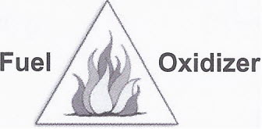
Ignition temperature

Statement 1- One way of fighting forest fires is to remove all the vegetation from certain areas.
Statement 2- Most laboratories have a blanket that can be wrapped around a person whose
clothes catch fire.
Statement 3- Buildings adjacent to the one on fire can be sprayed with water to prevent a fire
from spreading in a city.

Which of the following choices shows the correct match between the three statements above and the fire triangle components?
 | Statement 1 | Statement 2 | Statement 3
A | Fuel | Oxidizer | Ignition temperature
B | Ignition temperature | Fuel | Oxidizer
C | Fuel | Ignition temperature | Oxidizer
D | Oxidizer | Ignition temperature | Fuel

Test 4- Biomes, Populations, Communities and Ecosystems

- State the biome being described for each statement
1 | Where fresh and marine water mix | Estuary
2 | Produces a large amount of the world’s oxygen | Rainforest
3 | Current flows in 1 direction | River
4 | Has permafrost | Arctic
8 | The largest ecosystem | Ocean
9 | Rains all year long and very warm temperatures | Rainforest
11 | Acidic, nutrient poor soil | Boreal
12 | Became towns and cities | Temperate
13 | Type of wetland where trees can grow | Swamp
14 | Has grazing animals | Grasslands
15 | Contains the benthos | Ocean
16 | Saturated soil | Wetlands
17 | Has cold winters and warm summers | Temperate
18 | Not enough moisture for trees, but enough not to be a desert | Grasslands
19 | Shore acts as a filter and attracts species | Lake
20 | As the altitude increases the colder it becomes | Alpine
21 | The deeper you go the colder it gets | Ocean
22 | Salmon will fight the current to go lay their eggs | River

- Below are descriptions of different biomes. Determine the type of biome described in each statement.
  - This summer I am going on the most amazing vacation. I’m hoping to see polar bears, birds, seals and caribou. Even though it’s the summer, my mother told to pack sweaters, pants and a few light coats. Arctic

  - I was sitting near water and I saw salmon swimming upstream against a very strong current. They would jump out of the water which made it seem like they were flying for a few seconds and then dove back down in the water. River

  - This biome has lots of grazing animals in a very open space. I was told to bring sunscreen because there are few trees around and it gets very hot. Grasslands

  - A person needs an umbrella for this biome since it rains all year long. It’s hot enough to wear shorts and t-shirts, but I’m afraid the bugs will eat me for lunch. Bug spray will be a necessity. Rainforest

- At the beginning of winter there were 22 polar bears in a small area of the arctic. 4 polar bears died because of the lack of food, 5 polar bears left the area to look for food, 2 bears were shot by hunters and 3 bears came to the area to look for food. Was there a population increase or decrease? By how much?

Decrease of 8

- A population of 113 snowshoe hares lives on an island with an area of 25 000 m². What is the population density of the hares?
113/25000 = 0.00453 / m²

- Name the following species distribution.
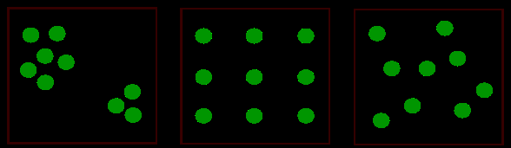
A B C
Clumped uniform random

- The table below lists the contents of two aquariums, A and B, both with a capacity of 50 L. Find the relative abundance of each species.
Aquarium A | Aquarium B
150 goldfish 26% | 78 goldfish 18%
76 striped fish 13% | 22 striped fish 5%
44 snails 7.6% | 0 snails 0%
88 green algae 15% | 24 green algae 6%
220 fern 38% | 300 ferns 71%
Which aquarium has the greater biodiversity? Why
Aquarium A because it has more species, a relative abundance of species and a greater overall number of species.

- Apple cultivators must consider all aspects of the Orchard’s ecosystem in order to ensure the highest possible crop yield. The trees in the orchard obtain their energy through the process of photosynthesis.
Using the following information, identify all the species on the food web. (put answers on the diagram)
An Apple Orchard’s Food Web
Legend: |  | 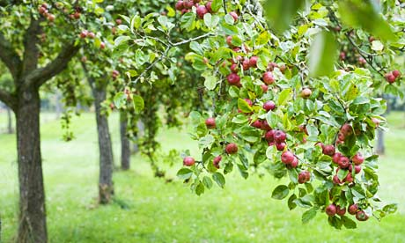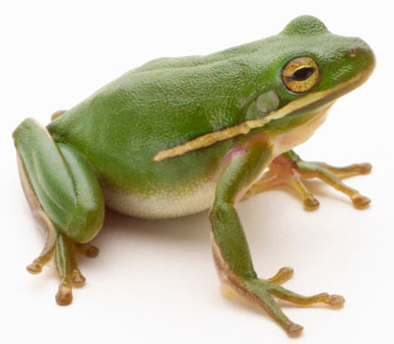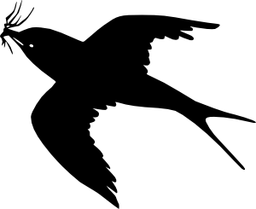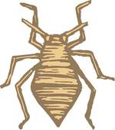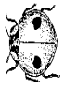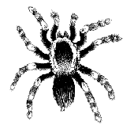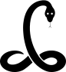
Aphid:
Apple tree shoots: | 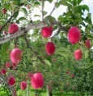
Frog:
Kite:
Ladybug:
Snake:
Spider:
Worms: | 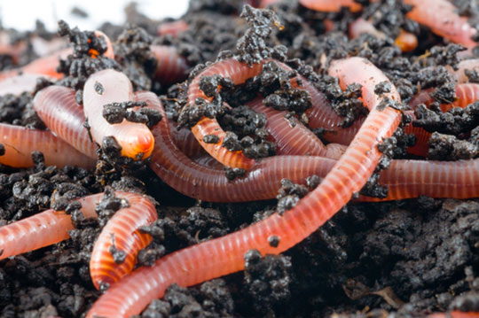 | SOIL
Aphid = primary consumer
Apple tree = producer
Frog = third and fourth level consumer
Kite = fifth and sixth level consumer
Snake = fourth and fifth level consumer
Spider = third consumer
Worms = decomposers

- Use the diagram below to answer the questions.

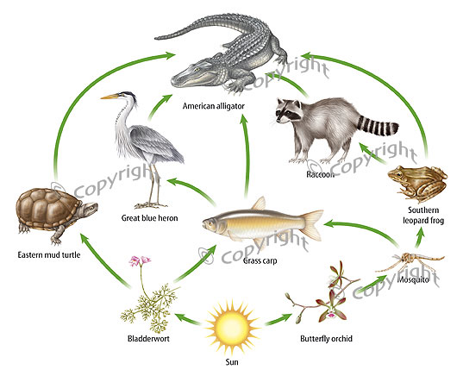

  - Name an animal that could be a second, third or fourth order consumer. Give the food chain for each example.
Alligator
Producer – carp – alligator
Producer – carp – heron – alligator
Producer – mosquito – carp – heron – alligator

  - Which trophic level is missing from the food web?
Decomposer

  - What would occur to the food web if the raccoons were to disappear?
- decrease in mosquito
- increase in frogs

  - What would occur to the food web if the Butterfly orchids were to disappear?
- mosquito, frog and raccoon would die off
- decrease in carp and alligator

  - What would occur to the food web of the alligator disappeared?
- increase in turtle
- increase in raccoon
- decrease in producers

- Use the diagram below to answer the questions.

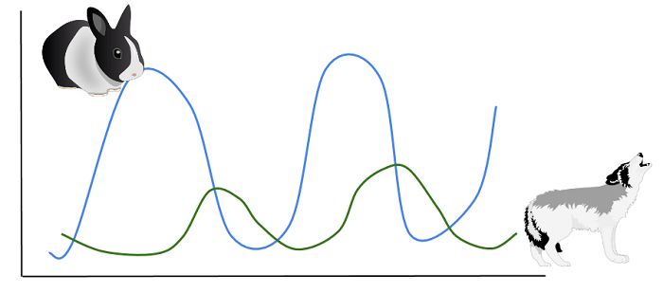
- What happens to the wolf population when the rabbit population decreases?
Decrease

- What happens to the rabbit population when the wolf population increases?
Decrease

- What happens to the rabbit population when the wolf population decrease?
Increase

- Define the following words.
Population : number of a specific type of specie
Community : different species in an area
Ecosystem : Living and non-living in an area
Autotroph : producer
Heterotroph : consumers
Detrivores : decomposers
Mutualism : both organisms benefit
Predation : A predator kills a prey
Competition : two organisms competing for the same thing
Biotic : living
Abiotic : non-living
Limiting factor : affects an organism negatively
Commensalism : one organism benefits and the other is neither harmed or helped
Parasitism : An organism living off of its host

