Particle Model
Models are visual representations of abstract things. They:
- __________________________________________________
- __________________________________________________
- __________________________________________________
- __________________________________________________
The particle model is _________________________________________ ____________________________________________________________________________________________________________________
It can help explain how particles behave and are arranged in the 3 phases of matter (solid, liquid and gas).
- Matter is not _______________ but is made up of specific kinds of _____________________ (extremely small)
- Forces of ____________________ hold particles together
- Particles are always ____________________________
- At ______________ temperatures, particles move _____________ (at low temperatures particles move slower)
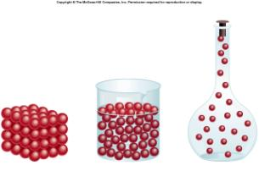
 | Solid | Liquid | Gas
Description
Space between particles
Force of attraction
Movement of particles
Energy
Phase Changes
Chemical changes signs | Physical changes signs
- _____________________________  - _____________________________  - _____________________________  - _____________________________  - _____________________________ | - _____________________________  - _____________________________  - _____________________________  - _____________________________  - _____________________________  - _____________________________
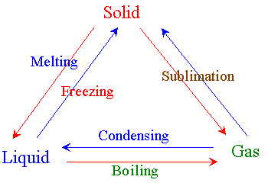
Boiling Point
Melting Point
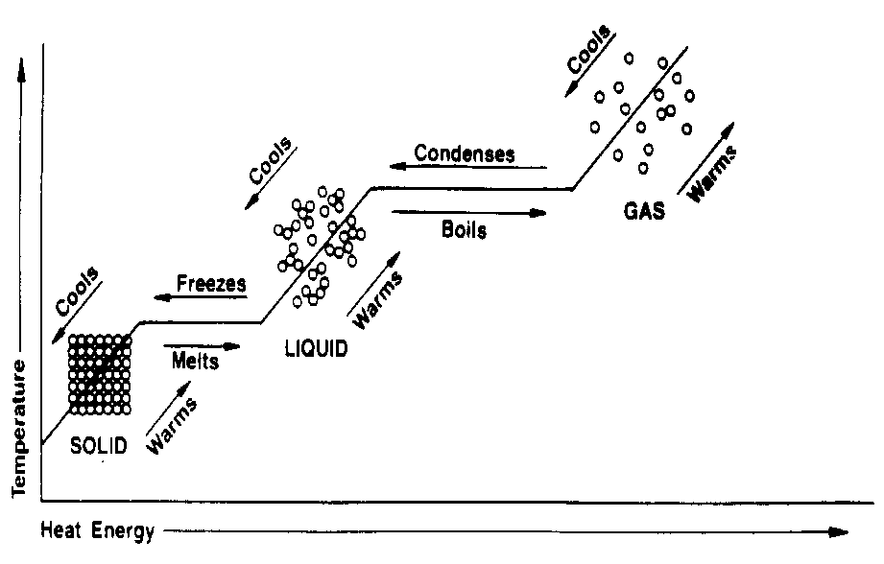
Fluids

Def: ______________________________________________________
__________________________________________________________
______________________________________________________________________________

Examples in the body: blood = liquid, air = gas

Exception: Powders such as flour or sand are not considered fluids even though they have no form and flow. They are composed of small particles with a definite form.

Properties of Fluids
Viscosity
Density
These properties vary between fluids.

 | Compressible Fluids | Incompressible Fluids
Definition
State
Examples
Why?
Pressure vs. Volume

Pressure
Def: ______________________________________________________
__________________________________________________________
- When we push something we are applying a force to it.
- If that force is large enough it will move or deform the object.
- ____________________________________________________________________________________________________________
- Force = ________________________________________________ ______________________________________________________

Pressure (newtons/meter²) = _______________(newtons) (meter²)

Relationship between Pressure and Area
- The force an object exerts on the floor consists of the person’s mass and the gravitational pull
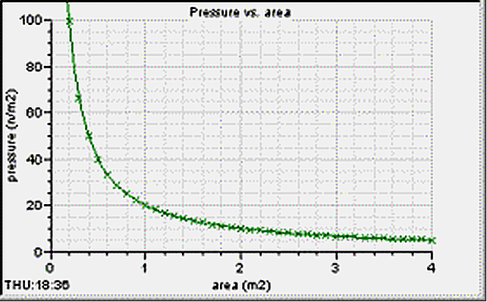
- This is what we call an objects:_____________________________
If 1,000N were applied to an area of 100m² what would the exerted pressure be?

If the same force (1000N) were applied to ½ the previous area (50m²) what would the pressure be?

The Relationship Between Pressure and Force
- ____________________________________________________________________________________________________________
- The pressure at the bottom of the barrel = the weight of the column of water directly above an area of 1cm²
- If the barrel were _________ high there would be ___________ of water (1kg) pushing down (1cm³ =1g)

If 1,000N were applied to an area of 100m² what would the exerted pressure be?

If a larger force (2000N) were applied to the same area (100m²) what would the exerted pressure be?

Particle Theory
- A tire pumped up with air has a __________ exerted upon it by the air inside.
- If the pressure is ___________ enough the tire will remain firm even if _______________ is applied to it.
- This is explained by the _____________________ inside the tire having lots of ___________________ hitting the walls
- Adding more “air” _________________ the number of molecules pushing outward = harder tire

Compressible fluid Pressure
- ____________________________________________________________________________________________________________
- With each ___________________ the fluid particles exert a _____________________ on the obstacle
- ____________________________ that create the pressure from a compressible fluid
- Depends on: ____________ (the more collisions = more pressure)
  - Factors that increase collision:
    - ______________________ (the more particles = the more collisions)
    - ______________________ (speed of particles increase when temp. increase) (Higher temperature= more pressure. Lower temperature=less pressure)
    - _______________________ (available space)

In the Body
- In the body, fluids exert pressure on _________________ (arterial pressure)
- The pressure ______________________ causes fluids to move (______________________________________________)
    - Lungs – air moves into lung
Atmospheric Pressure
