Types of energy
Found in Lithosphere
 | Explanation | Positive and Negative
Fossil fuels  Non-renewable  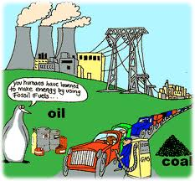 | - result from the transformation of organic matter to inorganic matter  - humans mine fossil fuels and burn them  - includes coal, natural gas and oil which are compressed over millions of years and formed fossil fuels | -when fossil fuels are burned they produce CO₂ and CH₄ which are main contributors to global warming  - also produce SO₂ and NO_{x}.  - also contributes to acid rain
Uranium  (Nuclear)  Non  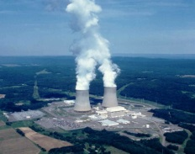  renewable | ·natural occurring radioactive element in the earth’s crust.  -splitting the nucleus allows a huge output of energy  -uranium is mined | -waste material and equipment remains radioactive for hundreds of years. It is buried underground.  -risk of accidents is a constant concern (radioactivity)  -one handful provides as much energy as 70 tonnes of coal  - no atmospheric pollutants are released
Geothermal  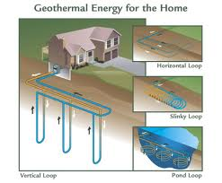  Renewable | - from the internal heat of the Earth where hot magma lies  - a fluid is circulated deep underground, heated, and then returned to surface | - very expensive and difficult to install  - no green gases emitted  - the hot ground water used in the power plants contains sulfur, mercury, hydrogen sulfide and ammonia which can be released in the water supply.
Found in hydrosphere- All renewable
 | Explanation | Positives and negatives
Hydroelectric  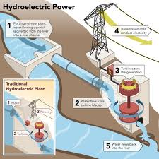 | - derived from movement of falling water to spin turbines which are located in a dam  - main source of energy in Quebec | - no greenhouse gases emitted  - severe damage to ecosystems and affect many animal and plant species
Wave and  ocean current  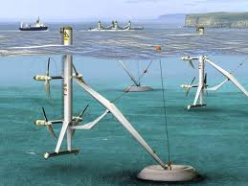 | -energy obtained from the flow of ocean tides  - ocean currents spin underwater turbines , which are similar to wind turbines | - no pollutants  - not very popular because very expensive and not always reliable  - can affect ecosystem organisms
Tidal  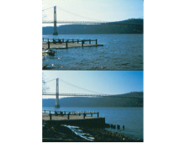  Renewable | -Electricity can be generated from tides when water from a high tide is collected (sometimes using a dam) and then falls through turbines converting mechanical energy into electrical energy. | - a tidal range of 5 cm is necessary to use this technology  - no pollutants  - dams used can affect fish migrations and water flow levels
Tides: levels changing due to its attraction to the sun and moon and the earth’s rotation
- there are 2 high tides and 2 low tides per day
- when closest or furthest from the moon = high tide
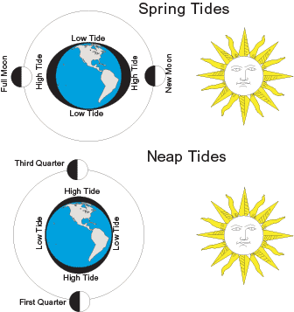
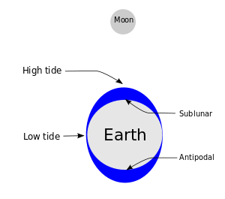
- when the earth, moon and sun are aligned Spring tides are created which are the highest tides.

Found in atmosphere + other
 | Explanation | Positives and negatives
Wind  Renewable | - energy that can be drawn from the wind  - as blades turn, they activate an electric generator | - cannot be stored so needs to be used with another source of energy  - no pollutants, but does create sound pollution  - disturbs ecosystem and can kill birds  - very expensive
Solar (other)  Renewable | - energy that comes from the sun in the form of radiation  - solar energy causes electrons to flow creating current electricity | - no pollutants  - very expensive  - must rely on other forms of energy also
