Biomes, Populations and Communities worksheet

- Which of the following communities living in a forest has the greatest biodiversity?
- 50 bears, 60 rabbits, 58 beavers, 25 for trees and 15 birch trees
- 4 bears, 30 rabbits, 7 beavers, 25 fir trees and 10 birch trees
- 50 bears, 100 rabbits, 7 beavers, 25 for trees and 15 birch trees
- 25 bears, 60 rabbits, 58 beavers, 5 fir trees and 7 birch trees

- Which answer best describes what a coral reef is?
- Coral reefs are non-living substances that float in the ocean
- Coral reefs are a type of fish that live in oceans
- Coral reefs are organisms whose skeleton is made up of CaCO₃ and feed on algae
- Coral reefs are a type of rock that other fish use as shelter

- Scientists wanted to monitor the population of tigers in the savannah over a 2 year period. Use the information on the table to determine whether there was an increase, decrease or stable population after the 2 years. Show the calculations.
 | Births | Deaths | Emigration | Immigration
Year 1 | 9 | 4 | 7 | 3
Year 2 | 12 | 6 | 5 | 9

- You counted 23 tulips in an 800 m² area, what is the population density?

- The table below lists the contents of two aquariums, A and B, both with a capacity of 50 L. Find the relative abundance of each species.
Aquarium A | Aquarium B
37 goldfish | 35 goldfish
2 striped fish | 30 striped fish
5 snails | 31 snails
3 green algae | 45 green algae
0 fern | 32 ferns

Find the relative abundance for each species.
 | Goldfish | Striped fish | Snails | Green algae | Ferns
Aquarium A
Aquarium B
Explain which aquarium has a greater biodiversity.

- Identify the type of interaction between the living organisms in each of the following situations. (competition, predation, parasitism, mutualism and commensalism)
Bees pollinate flowers
A bird finds and lives in an old empty nest
A maggot lays eggs in a wasp
Crows eat the remains of an animal left by a wolf
Two gorillas are fighting over a mate
Photosynthesis respiration processes
A clown fish’s waste provides food for the sea anemone, while the sea anemone provides shelter and protection to the clown fish
Two wolves fighting over territory

- Looking at the diagram below, state whether the arrow is pointing to the prey or the predator and explain your answer.
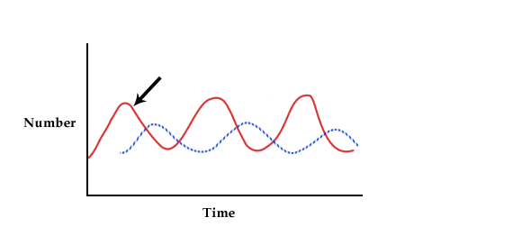
- State the biome being described in each statement.
Lack of clouds causes high temperature variations
Cold all year long
Temperature and light varies on depth
Not enough moisture for trees, but enough not to be a desert
Current flows in 1 direction
Has permafrost
Rains all year long and very warm temperatures
Contains the benthos
Produces a large amount of the world’s oxygen
Has acidic, nutrient poor soil
Became towns and cities
Type of wetland where trees can grow
Type of biome that has saturated soil
The largest ecosystem
Where fresh and marine water mix
Has the ability to survive drought and fire
Made from corals
Sensitive to fire, insects and disease
Defined by altitude

