Notes: Atomic Theory & Periodic Table

**Rutherford-Bohr Model**

* Rutherford later made the discovery of the proton
* The nucleus is not just one large positive particle, but rather made up of **___________ _____________________________________________________________________** depending on the element
  + It is this **__________________________________________________________ _________________________________________________________________**!
  + **________________________________________**have **____________________________________________________________**
  + Atoms have the **___________________________________________________ _______________________________________________________________** so that they are overall **________________________________________**

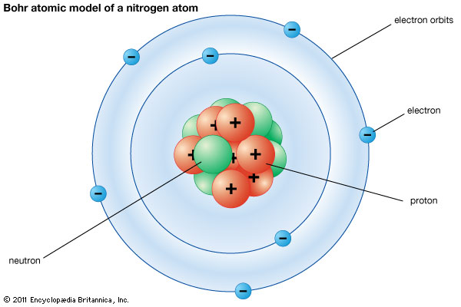

* Protons → in the **____________________**
  + Number of protons = **________________________________________**on Periodic Table
* Electrons → in**____________________** around the nucleus
  + The **________________________________________________________________________________________________________________________________________________**
    - overall charge has to be neutral
  + Remember: each orbital can only hold a certain number of electrons
    - 1st orbital: **____________________**
    - 2nd orbital: **____________________**
    - 3rd orbital: **____________________**

# Periodic Table

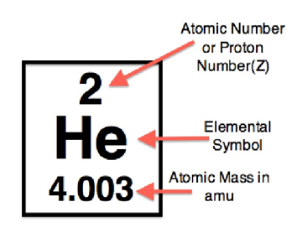 **Atomic Number**

* + Tells you the **________________________________________** each atom of an element has
  + This is **_____________________________________________ _____________________________**
    - This differing number of protons gives each element **________________________________________**
* **Atomic Mass**
  + Protons have a mass of **______________________________________________**
  + Neutrons also have a mass of **____________________**
  + Electrons are so small they have **______________________________________**
    - We say their mass is **____________________**

|  |  |  |  |  |  |  |  |
| --- | --- | --- | --- | --- | --- | --- | --- |
|  |  |  |  |  |  |  |  |
|  |  |  |  |  |  |  |  |
|  |  |  |  |  |  |  |  |
|  |  |  |  |  |  |  |  |

Periodic Table of Elements

The First Twenty Elements

# Summary/Review

Periodic Table of Elements

The First Twenty Elements

**Matter**

* Anything that **________________________________________________________________**

**Atom**

* **___________________________________________________________________________**
* Made of **__________________________________________________________**
* Centre is called the **_____________________**

**Nucleus**

* Centre of an atom
  + **_____________________________________________________________________**

**Proton**

* Sub-particle of an atom with a positive charge
* **_______________________________________________________________**

**Electron**

* Sub-particle of an atom with a negative charge
* **_______________________________________________________________**

**Neutron**

* Sub-particle of an atom with a neutral charge
* **_______________________________________________________________**

**Nucleus**

* Centre of an atom
  + **_____________________________________________________________________**

**Element**

* Substance made from **_________________________________________________________**

**Molecule**

* A **_____________________**of atoms that are **______________________________________**

**Compound**

* A **_____________________** formed by combining **________________________ ___________ _____________________________________________**