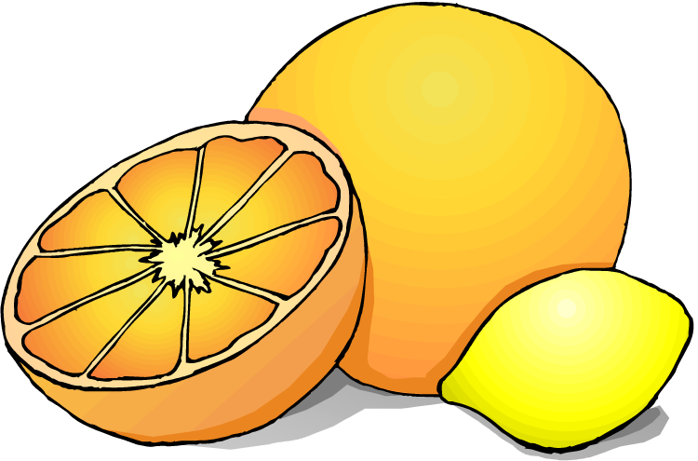
Name __________________________________________

How Much Vitamin C is in Fruit Juice?

INTRODUCTION
Vitamin C or ascorbic acid is found in many fruits and vegetables. The ingestion of Vitamin C is necessary to maintain a healthy body and to prevent diseases. Important uses of Vitamin C in the human body include the following:
1. Vitamin C serves as an antioxidant, removing harmful free radicals from the tissues of the body.
2. Vitamin C is important in the production of collagen. Collagen is a protein and an essential part of the connective tissues of the body.
3. Vitamin C helps to maintain a healthy cardiovascular system.
4. Vitamin C strengthens the immune system.

In this experiment you will use a lab procedure known as a titration to determine the amount of Vitamin C found in a 180 mL serving of each of the following juices: orange juice, pineapple juice, and apple juice.

A titration is the controlled addition and measurement of the amount of a solution of known concentration required to react completely with a measured amount of a solution of unknown concentration. Titration provides a means of determining the chemically equivalent amounts of two substances.

PURPOSE
1. To determine the amount of Vitamin C in a standard solution.
2. To determine the amount of Vitamin C in various fruit juices.

MATERIALS
10 mL beaker Disposable pipets
White paper for background Ascorbic acid standard solution
Apple juice Orange juice
Pineapple juice Starch solution
Lugol’s solution

SAFETY PRECAUTIONS
1. Safety goggles are required for this lab.
2. Notify the instructor in the event of spills or accidents.

Hypothesis: Which juice do you predict will have the most Vitamin C? List the other juices in the order you predict, ranging from most Vitamin C to least Vitamin C.

_________________________________________________________________________________________________________________________

_________________________________________________________________________________________________________________________
Copyright © Science Stuff

PROCEDURE

1. In order to determine the amount of vitamin C in each of the fruit juices, we must first conduct a titration using a Vitamin C solution of known concentration so that we have a basis of comparison between the known solution and the fruit juice.

2. Perform a titration to determine the average number of drops needed to titrate a standard solution of ascorbic acid (vitamin C). The standard solution contains 1 mg of ascorbic acid per 1 milliliter of water. The standard = 1mg/mL. To titrate:

a) Place 10 drops of the standard solution into the 10 mL beaker.
b) Add 5 drops of starch solution.
c) In order to see the color change more easily, place the beaker on top of a piece of white paper.
d) Add one drop of Lugol’s. Swirl the mixture very gently.
e) Continue to add drops of Lugol’s (one at a time, then swirl) until the color in the well remains blue-black.
f) Record in the data table below the number of drops of Lugol’s solution required to titrate this standard solution.
g) Dispose of solution in the waste beaker, clean the beaker, and repeat the titration 2 more times. Calculate the average number of drops of Lugol’s required to titrate the standard.

3. Place 10 drops of orange juice in the clean beaker. Add 5 drops of starch solution. Add drops of lugol one at a time just as you did above. Continue to add drops of Lugol’s until the color remains blue-black. Record the number of drops of Lugol’s used in the data table. Repeat 2 more times and average.

4. Repeat using 10 drops of apple juice.

5. Repeat using 10 drops of pineapple juice.

6. Rinse out the beaker when finished.

DATA TABLES:

 | Trial 1 | Trial 2 | Trial 3 | Average number of drops
Standard Solution
Orange Juice
Apple Juice
Pineapple Juice
Copyright © Science Stuff

CALCULATIONS:

1. How many mg of vitamin C are found in 1 mL of fruit juice? Use the formula below to calculate for each fruit juice. Show your work for each calculation.

Amount of vitamin C in standard = Amount of vitamin C in juice
# of drops of Lugol’s used to # of drops of Lugol’s used to
titrate standard titrate the juice

Calculation for orange juice:

Calculation for apple juice:

Calculation for pineapple juice:

2. The above calculation reveals the number of mg of vitamin per milliliter of solution. How much vitamin C would be present in a 180 mL serving of each juice? Calculate for each type of juice.

Calculation for orange juice:

Calculation for apple juice:

Calculation for pineapple juice:

Copyright © Science Stuff

3. What is a titration?

4. Why did you have to begin the experiment by performing a titration on the standard solution?

5. Which fruit juice contained the most vitamin C? Does this agree with your hypothesis?

Copyright © Science Stuff

