Name: __________________
Eating Disorders
Anorexia Nervosa
- Is an eating disorder characterized by a _______________________________. The individual has an irrational dread of becoming fat coupled with a relentless pursuit of thinness.
Bulimia
- Bulimia is characterized by ______________________. The individual will over eat (_________) followed ________________________.

Types of bulimia
- Purging type bulimics _______________________________ (usually by triggering the gag reflex)
- Non-purging type bulimics (approximately 6%-8% of cases) ______________________________ after a binge to offset the caloric intake after eating.

How do they control their weight?
- Voluntary _____________________
- Excessive ____________________
- Diet pills
- Diuretic drugs
- __________________

Males and Eating Disorders
- There is still little research to provide exact rates of occurrence of eating disorders in young males but best estimates are that ____________ of diagnosed cases are in males (90’s = 10%)
- Age of diagnosis: most commonly in the late teens/early 20’s
- Boys are often more ___________________________ than girls when diagnosed with an eating disorder; less likely to discuss body size/image/food with ________________
- _____________ of normal weight males perceive themselves to be _____________________
- _____________ of teenage boys reported exercising with the goal of “____________________”
- 68% of college-aged males reported having “__________________________________”

Sexual Bias
- The belief that boys don’t have eating disorders
- The differences in _____________________________________
- The use of ______________________________ as opportunities to engage in behaviors out of sight of parents
- The new pressures put on boys by __________________________ around size/shape concerns that did not exist 15 years ago, (thinner male models, new men’s fashions, new male fashion magazines)
- The presence of behaviors like _______________________________ which may be similar to __________________________ in girls
- The misperception that eating disorders in boys relate to ______________________________
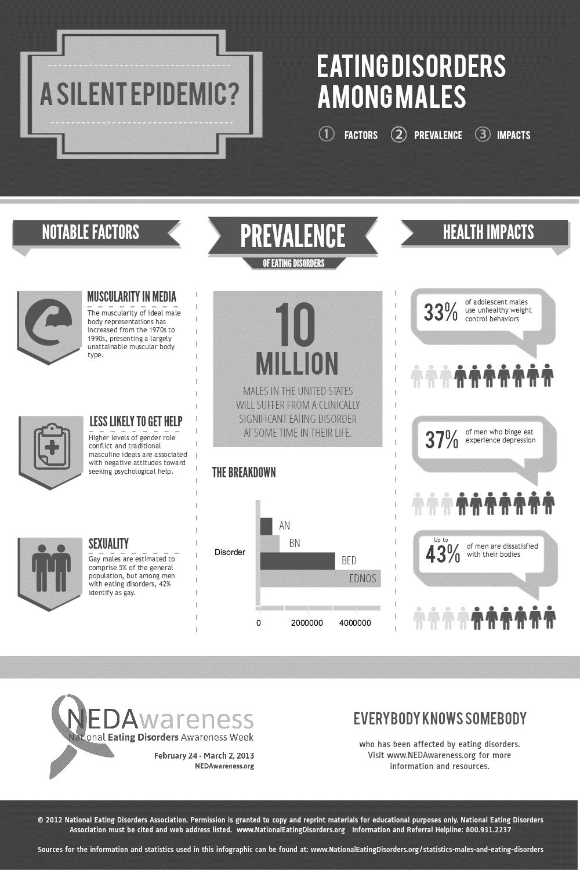
Why do people become anorexic?
- Low self esteem
- ___________________
- One thing they can _________________
- Stress
- Guilt
- ________________________________
- Need to fit in
- Sexual abuse as a child

What to do if you think somebody has an Eating Disorder

- Tell __________________________
- You might find it hard to help someone else, the best thing you can do for any and all people involved in this situation is to tell an adult (_________________________________________ …even outside of school can be an option)
- Just ______________________________ the information to yourself

Dieting Vs Anorexia
Healthy Dieting | Anorexia
Weight loss is viewed as a way to improve health and appearance. | Weight loss is viewed as a way to ______________________________
Self-esteem is based on more than just weight and body image. | Self-esteem is __________________ on how much you weigh and how thin you are.
Is an attempt to control weight, the goal is to lose weight in a healthy way | Is an attempt to control __________________________, Becoming thin is all that matters; health is not a concern

Statistics in teenagers
- Anorexia is the _________________________________________________ among adolescents.
- ____________________ of high school girls diet.
- 50% of girls between the ages of 13 and 15 __________________________________________.
- 80% of 13 year old girls have dieted.
- 40% of _______________________ girls dieted.

Signs
- Being able to determine that someone has an eating disorder is not always easy. They become masters at hiding the disease and are always ready with a legitimate excuse for their behavior.

Signs to look for
- Dieting despite being thin
- _______________________ with calories, fat and nutrition
- Pretending to ____________
- _______________ about eating
- Dramatic weight loss
- Always going to the bathroom during or after meals

Symptoms
- Sudden dramatic __________________________
- Amenorrhea ( ___________________________ )
- Bone density loss
- Sensitivity to _____________
- ___________________ : fine hair that grows on the skin to keep it warm
- Thinning hair

Can an anorexic die?
YES from
- ____________ failure
- ____________ failure
- ____________ failure
- Multiple organ failure

Why?
- The body and its vital organs are not receiving enough ________________ obtained from food. The energy allows the body and its systems to function normally on a daily basis.

Statistics
- ________________ of all female adolescents and young women have an eating disorder.
- The average age of onset is ___________.
- It is rare, but not unheard of, for children under the age of _________ to have the condition.
- Older woman can have it as well, although it is usually diagnosed in the teens or twenties.
- Anorexic statistics show that it is very rarely diagnosed after the age of __________.
- About _____________________of those who do get treatment don’t get enough of it.
- Mortality rates higher in _______________________________________ as more often combined with other conditions such as depression, excessive exercise, substance abuse and anxiety

Hope
- With counseling and support from loved ones, anorexics can make a full recovery
- Nearly ____________________ of anorexia sufferers recover
- ___________________ show some improvement

