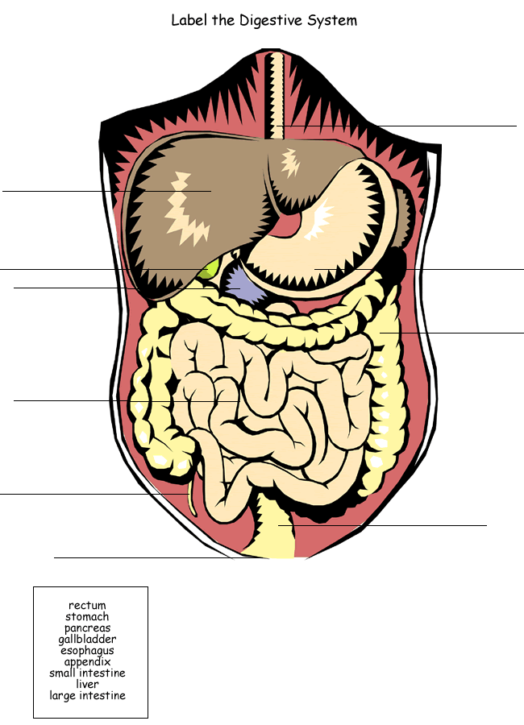

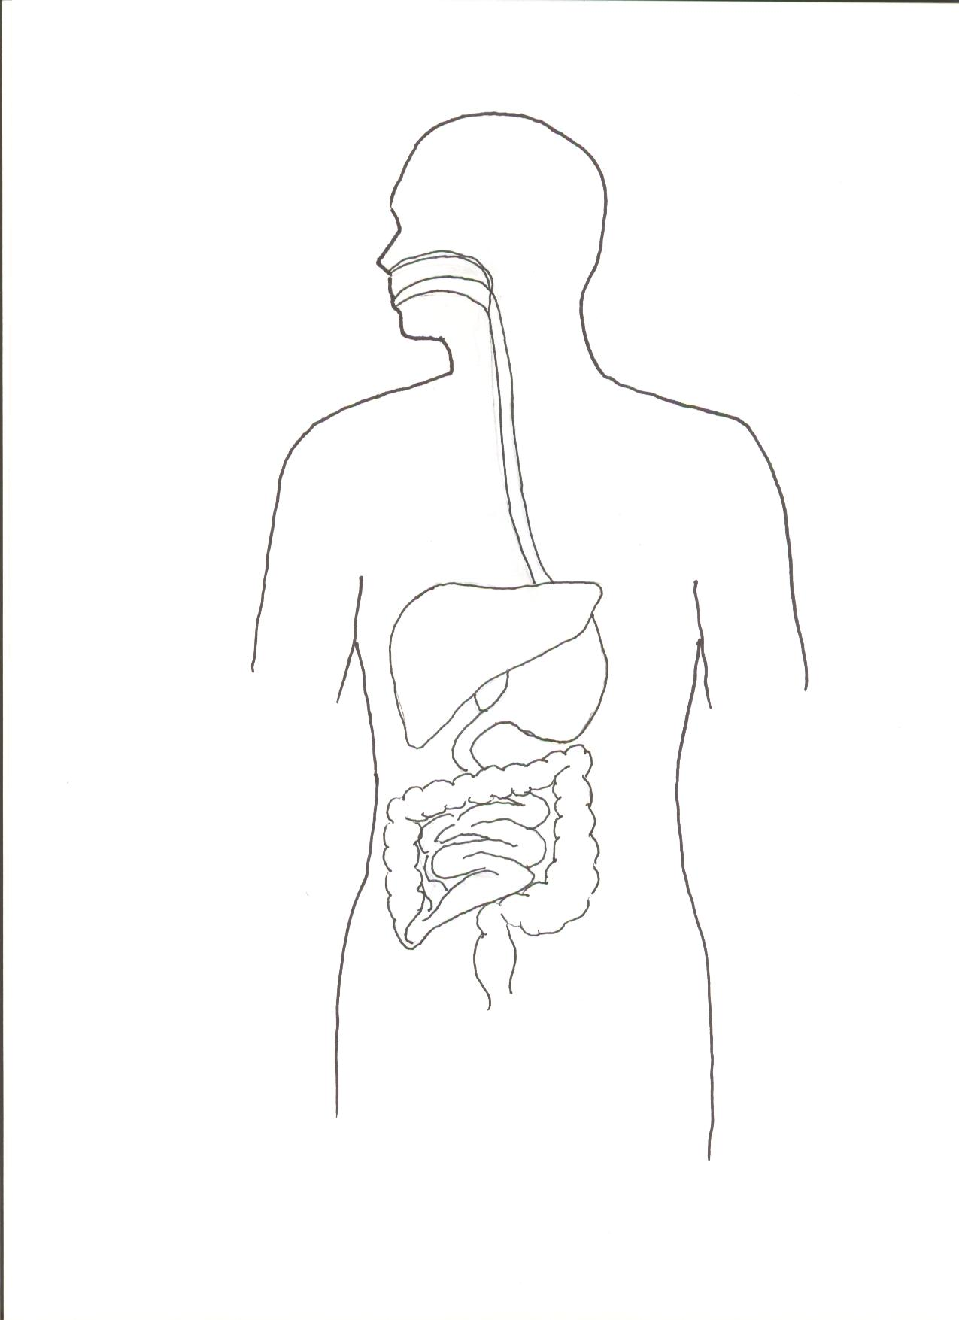
Describe the path that food takes in the body. (Can use point form.)
Name all of the important Digestive Tract and Gland parts.
- Name the four main food groups.

- List the site where digestion first takes place for each food group.

- Describe the mechanical and chemical changes that each food group undergoes when you eat it.

- List and describe the parts of the Digestion Tract and Glands in the body and their functions. (continue on the back of page if needed)

