Review for Sec II Mid-Year Exam Answer Key
The Material World
1. List and describe the steps of the scientific method

Initial Observation: Notice a phenomenon in nature.
Question: Ask a question about your observation that can be answered by doing an experiment.
Hypothesis: Answer to your question with as much detail as possible (an educated guess)
Controls and Variables: Controls are factors that are staying the same or constant. Variables
are factors that change. The dependent variables are what is purposely
changed and the independent variable is the measured result.
Materials: List the exact quantity and size of materials you will be using - be as specific as possible.
Procedure: Enumerate all the steps, as specifically as possible, that you will follow to complete your
experiment
Results: Present your quantitative (numerical) and/or qualitative (descriptive) observations in point
form and/or table form
Analysis: Describe your results in sentences and using graphs
Conclusion: Accept or reject your hypothesis and why. Explain the scientific principle behind your
Experiment. List any possible errors.

2. Be able to create a graph including the labels of axes (the dependent and independent variables), title, and scale. Example below
Title: Independent (y) vs Dependent (x) variable

Number of worms by length
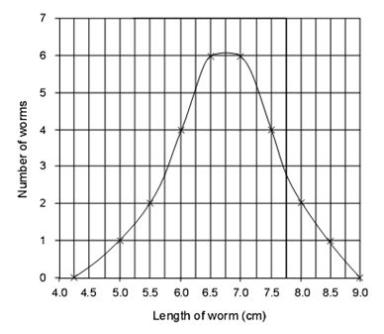
Label (unit
Label (unit)
3. Define characteristic properties and non-characteristic properties. Give 3 examples of each.
A non-characteristic property is a physical or chemical property that is not unique to one particular substance. Examples are temperature, mass, volume, shape, colour and acidity & alkalinity (pH).
A characteristic property is a physical or chemical property that is unique to a particular substance.
Examples are density, solubility, melting point, boiling point, and magnetism.

4. Define mass and give 2 examples of objects with the units mg, g, and kg. How would you find the mass of a solid and of a liquid?
Mass: amount of matter present in a substance. Examples: mg – medicine, postage stamp; g – orange, candle; kg – person, truck.
To find the mass of a solid – zero a triple balance beam (scale) and place object on platform. Move the largest slide first, then the middle slider, and finally the smallest one. Record mass.
To find the mass of a liquid – zero a triple balance beam (scale) and place an empty graduated cylinder on the platform. Record mass. Add liquid then find new mass. Subtract the mass of the empty cylinder for the total mass and the result is the mass of the liquid.
5. Define volume and describe how to find the volume of a regular object and irregular object. What are the units associated with each?
Volume: amount of space occupied by a substance.
To find the volume of a regular object: measure the length, width, and height, and multiply them all together. The unit is cm³.
To find the volume of an irregular object: Put water in a graduated cylinder and record the volume. Add irregular solid and record total volume. Subtract initial volume from total volume. This will be the volume of the object.
6. Define density and give the formula to calculate it. Be able to compare densities using numerical data or by diagrams.
Density is the amount of matter (mass) for a given volume. It is calculated by dividing mass by volume. A substance of density 2.5 g/mL is more dense (denser) than a substance of density 1.5 g/mL. Also
A B Substance B is more dense then A

⃝ ⃝ ⃝ ⃝ ⃝
⃝⃝⃝⃝⃝

7. Define temperature and state the boiling point and freezing point of water. Temperature is the indication of the average speed of the movement of particles. The Boiling point of water is 100 ºC and the freezing point is 0 ºC.
8. What is considered to be room temperature? 21 ºC
9. State 3 units of temperature. . ºC (Celsius), ºF (Fahrenheit),ºK (Kelvin)
10. State the pH levels for an acid, a base, and a neutral substance. Acid 1-7 (below 7), Neutral 7, Base 7-14 (above 7)
11. What is the difference between a physical change and a chemical change? Give 3 examples of each.
A physical change does not alter the make up of a substance, just the way it looks – examples are breaking an egg, freezing water, tearing paper.

A chemical change does alter the make up of a substance and a new substance is formed – cooking, rusting and burning, are all types of chemical changes.

12. What are the indications or signs that a chemical change has occurred?
1) the color changes
2) a gas is produced (eg. bubble produced)
3) heat is given off (sometimes taken in)
4) a precipitate is formed
5) a odor is produced
6) a light is given off

13. List the characteristics of each of the following : a) solid b) liquid c) gas
a) Definite shape, definite volume, hard to compress, do not flow, strong forces between molecules
b) No definite shape, definite volume, flow easily, hard to compress, forces between molecules are
weaker than solids
c) No definite shape, no definite volume, easy to compress, spread out to fill all available space –
diffusion, forces between molecules are very weak.

14. Create a chart using the following terms: solid, liquid, gas, freezing (solidification) , melting (liquification), boiling (evaporation), condensation and sublimation.
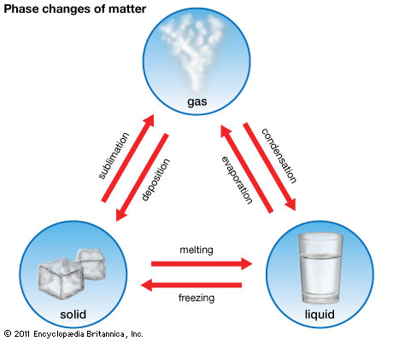

15. Give 3 example for each of the following: a) homogeneous mixture b) heterogeneous mixture and c) pure substance
a) salt water, Koolaid, air
b) chocolate chip cookies, sand and iron, starch and water, oil and water
c) hydrogen, carbon, carbon dioxide, salt

16. Compare and contrast homogeneous mixtures and heterogeneous mixtures. Both have two or more different types of particles which can be separated by physical means. Homogeneous mixtures are of uniform composition throughout whereas heterogeneous mixtures have a composition that varies throughout the substance.

17. How do mixtures differ from pure substances. Mixtures contain at least two types of particles which can be separated by physical means.

18. Briefly describe the 4 methods for water purification and the materials needed for each method. Give an example of a mixture that can be separated by each method.

Method 1: Sedimentation – a form of separating substances. This process involves letting an insoluble substance (a substance that will not dissolve in a solvent) settle at the bottom of a solvent.

Method 2: Decantation - For separating the mixture of water & sand, first, we should let the sand to settle on the bottom of the container (sedimentation). Then we pour off the water at the top into the other container using a glass rod. This method cannot be used to separate the mixture of a liquid and a light solid, like chalk in water

Method 3: Filtration - used to separate particles based on their size. The mixture is poured through filter paper – this is paper that is porous (small openings) which allows small particles such as water to pass through and larger particles (such as chalk) to remain in the filter paper.

Method 4: Distillation - Distillation is based on the idea that different substances have different boiling points. A mixture (such as salt and water) is heated until one of the substances (such as water) reaches its boiling point and becomes a vapour. The vapour rises, is collected, and then is condensed (cooled) back into a liquid. This process continues until all the liquid (water) is boiled off. The liquid collected is called the distillate.

19. Explain the difference between a pure substance and a mixture. A pure substance contains only one type of particle – ex carbon, hydrogen, water, sugar. A mixture contains two or more types of particles that can be separated by physical means – ex. Air, salt water, salad dressing, muddy water

20. How is a homogeneous mixture different from a heterogeneous mixture? A homogeneous mixture has the particles evenly distributed and particles cannot be distinguished by the naked eye. A heterogeneous mixture has particles unevenly distributed and particles can be distinguished by the naked eye.

21. Define solution. A solution is a homogenous mixture which has one substance called the solute dissolved in another called the solvent.

22. Give two examples for each of the following: pure substance, heterogeneous mixture, and homogeneous mixture. Pure substance: hydrogen, carbon dioxide
Heterogeneous mixture : starch and water, salad dressing
Homogeneous substance: salt water, air

Earth

1. Compare and contrast rocks and minerals. A mineral is homogenous (pure), natural (not man-made), and non-living substance. A rock is a heterogeneous blend of differently sized grains of different kinds

2. List the 3 types of rocks and describe how they are formed. Igneous rocks results from cooling and solidification of magma . Sedimentary rock derives from fragments of rock called sediment that are subject to erosion and also may contain fossils. Metamorphic rock has undergone a transformation caused by heat and pressure

3. What are the 3 types of igneous rock and what are their characteristics?
Intrusive (or Plutonic)
    - Slow cooling of magma within the Earth’s crust
    - Has large crystals
    - Example: Gabbro

Extrusive or Volcanic
    - Formed when lava cools in contact with air or water
    - Has microscopic crystals
    - Example: Obsidian
Porphyritic
    - Undergoes two cooling phases
    - Crystals vary in size
    - Example: Certain types of Granite

4. What are the tests that we do on minerals in order to identify they? Briefly describe each test.
Scratch test – determine the hardness of the material if can be scratched a fingernail, a nail, or glass
Streak test – determine the colour of the streak made by mineral
Size – use a magnifying glass to determine the size of the graicns
Lustre – determine the shininess of the mineral
Magnetism – determine if the substance is magnet

5. Define hardness, lustre, and clarity.
Harness – how easy or difficult it is to scratch or crush a mineral.
Lustre – the shininess of a mineral
Clarity - how clear or pure a mineral is as sometimes minerals are formed with impurities in it.

6. Which scale is used to determine the hardness of a mineral? What would a value of 1 indicate? What would a value of 10 indicate? Mohr’s scale – a low value of 1 indicates a very soft mineral such as talc and a high value of 10 indicates a very hard mineral such as diamond.

7. State the three layers of the Earth’s internal structure. Which part of an egg would each layer correspond to? Crust – shell
Mantle – albumen
Core - yolk

8. Describe each layer of the Earth’s internal structure in terms of temperature, thickness, and state of matter.

Layer Name Temperature (ºC) Thickness (km) State
Crust 5 up to 65 Solid
Mantle: Upper Mantle 1000 to 1800 670 Semi-liquid
Lower Mantle 1800 to 3700 2215 Solid
Core: Outer Core 3700 to 4500 2270 Liquid
Inner Core above 4500 1215 Solid

9. What are the layers or horizons of the soil? What are 2 main characteristics of each horizon?

Horizon | Characteristics
A | Organics mixed with mineral matter  Soluble materials are leached out of this layer
B | Enrichment of soluble materials which are leached out of Horizon A  Rich in clay
C | Not affected by weathering  Contains bedrock

10. What are the 2 main changes that effect the relief? What are some other influences?
Temperature changes and convection cells under the crust
Wind, glaciers, erosion, and human activities

11. Label the diagram of the water cycle: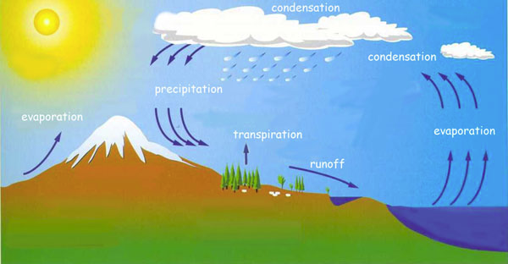

12. Complete the chart below about the 4 separation methods:

Method | Brief Description | Equipment needed
Sedimentation | letting an insoluble substance settle at the bottom of a solvent. | Beaker
Decantation | Pouring off the top layer of a heterogeneous mixture into the other container using a glass rod | Beakers, glass rod
Filtration | The mixture is poured through filter paper which allows small particles to pass through and larger particles to remain in the filter paper | Funnel, filtration paper, Beaker, Erlenmeyer flask,
Distillation | A mixture is heated until one of the substances reaches its boiling point and becomes a vapour. The vapour rises, is collected, and then is condensed (cooled) back into a liquid. | Rubber stopper with glass elbow, Stand, Boiling chips, test tube clamp, boiling (distillation) flask, glass tubing

13. What percentage of Earth is water? What percentage is potable? 75% and 0.02%

14. What is another term for potable water? Drinkable water

15. Is the salinity of water constant in different bodies of water? No

16. How have humans influenced the water cycle?
- Create pollution
- Remove the natural vegetation such as plants and trees
- Pave over the natural environment and build houses etc.
- Put in irrigation systems, build dams, change natural drainage systems, build wells

Technological World

1. Give 2 examples for each of the following simple machines: wedge, pulley, wheel and axle, inclined
plane, and lever Wedge: Door stop, axe Pulley: tow truck, clothesline
Wheel and axle: car tires, water well Inclined Plane: moving van ramp, park slide
Lever: wheelbarrow, seesaw, hockey stick

2. Briefly outline the 8 steps of the design process.

- An Idea-- There is a need for...
- Analysis--Brainstorm possibilities and pick one
- Resources--What material and equipment will you need
- Design Plan--A representation (sketch) used to effectively explain the operation of a technical object.
- Drawing--Make a diagram of the structure, include measurements, andinfo to build
- Manufacturing Process Sheet--The needed tools, materials, and the order of the steps
- Building--The construction phase
- Review--Can be done at anytime, write down any changes

3. Use arrows to show each of the following types of motion: rectilinear, alternating, circular, and oscillatory.

Rectilinear:

Alternating:

Circular: Oscillatory:

4. Complete the chart below regarding forces:

Type of Force | Description | Diagram | Example
Flexion | Bending | 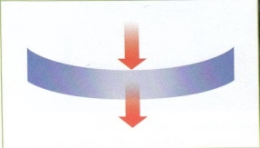 | Gymnast,  Hockey stick
Tension | Pulling |  | Climbing a rope,  Tug of war
Compression | Squeezing | 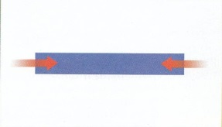 | Sitting on a chair, Beams and pillars in a house
Torsion | Twisting | 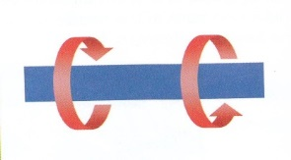 | Unscrew a lid, wringing a towel
Shearing | Cutting | 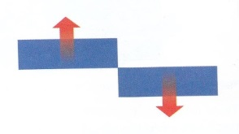 | Tearing a paper, scissors

