Review Sec I Term 2
The Material World
1. List the steps of the scientific method and briefly describe each.
2. Define mass and give 2 examples of objects with the units mg, g, and kg. How would you find the mass of a solid and of a liquid?
3. Define volume and describe how to find the volume of a regular object and irregular object. What are the units associated with each?
4. Define temperature and state the boiling point and freezing point of water.
5. What instrument is used to measure temperature?
6. Define thermal expansion.
7. State 3 units of temperature.
8. State the pH levels for an acid, a base, and a neutral substance.
9. How is litmus paper used to determine if a substance is an acid, a base or is neutral?

The Technological World

1. Define simple machine.

2. List the types of basic machines and give two example of each.

3. List the three classes of levers and give two examples of each.

4. How is the class of lever determined?

5. State whether each statement is true or false: a) machines allow humans to use less force
b) machines allow human to do less work
c) the closer to the fulcrum the load is, the more
effort force must be applied.

6. Define fulcrum, load, and effort force, and indicate them on a diagram below:

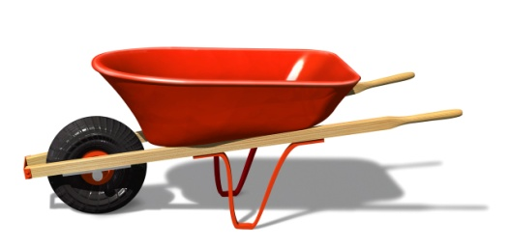

7. What three things are required to make a technical drawing?

8. What three things do we find on a technical drawing?

9. How is the front view determined?

10. Be able to create a technical drawing of a given object.

The Living World
1. Be able to distinguish a plant cell from an animal cell.

2. List the organelles in a cell and their role or function. Which two are found only in plant cells?

3. Label a flower diagram.

4. Describe the characteristics of sexual and asexual reproduction in plants.

5. List the 3 types of asexual reproduction and 3 types of sexual reproduction in plants.

6. Know the 15 definitions associated with plant reproduction (cotyledon, seed, seed coat, asexual reproduction, sexual reproduction, ova, spermatozoon, fertilization, pollination, cross-pollination, self-pollination, angiosperm, gymnosperm, spores, and embryo)

7. Define the following: population, taxonomy. Give two examples of a population.

8. What are the criteria used to determine whether something is a living organism?

9. What are the criteria used to determine if organisms are of the same species?

10. Describe physical and behavioral adaptations and give two examples of each.

11. Given a species name, ex Homo sapiens, state the genus name. What is the common name of Homo sapiens?

12. What are the components of an animal’s habitat? 13. What are the components of an animal’s ecological niche?

14. Describe the type of bird beak that is appropriate for a bird that eats: a) meat b) berries
c) nuts and seeds d) fish e) insects

