Phosphorus Cycle notes Enriched
- Phosphorus is the basic composition of DNA and one of the main components of bones.
- Phosphate PO₄ acts as a fertilizer.

Vocabulary
Erosion
Proliferation
Leaching

Steps
1
2
3
4
5
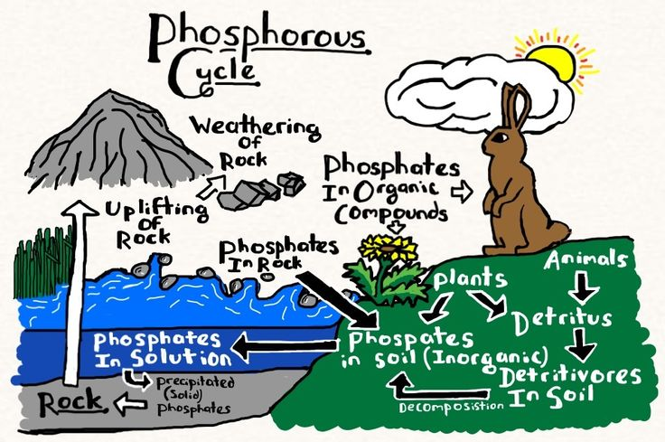

Negative from phosphates

Eutrophication: _________________________________________________________________
______________________________________________________________________________
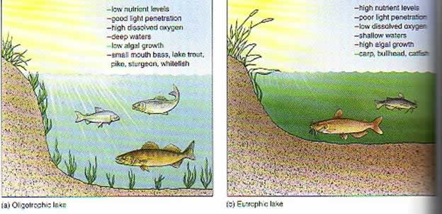
- Nitrates from fertilizers can be converted N₂O which is a factor in climate change and reduces the ozone layer.
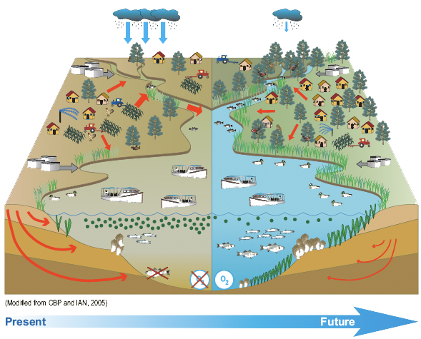

Past exam questions

1. Fertilizers are widely used in agriculture. Farm 1 only uses potassium chloride, KCl, to fertilize the land. Farm 2 applies only potassium dihydrogen phosphate, KH₂PO₄, as a fertilizer. Both farms are located on the opposite side of a large lake. Since farming can have an effect on the lake ecosystem, measurements have been taken over the past several years to record the changes in the depth of the lakeshore.
a- Explain which farm will not contribute to the effect of eutrophication.
b- Explain which side of the lake will become shallower more quickly after several years of fertilizer usage.

2. The accelerated eutrophication of lakes is a concern in several regions of Québec. One town in Québec passed by-laws requiring lakefront property owners to:
a) Plant more shrubs and trees along the shoreline.
b) Stop using chemical fertilizers on their lawns and gardens.

Explain how the requirements of the by-law listed above could help prevent accelerated eutrophication.

