Phosphorus cycle and living world worksheet

1. Eutrophication is a widespread environmental problem. Most scientists agree that eutrophication is caused by increasing inputs of phosphorus and nitrogen, which are abundant in human sewage, in the excrement of the livestock and in fertilizers applied to agricultural land. How do increases in nitrogen and or phosphorus lead to eutrophication in Quebec lakes? Give 4 statements.
2. Jennifer visits her grandparents who operate a small farm by a lake. Her grandparents had cleared a path to the lake to have access to a small beach. In doing so, many trees and shrubs were removed. Recently, her grandparents noticed an increase in algae bloom in the lake and a decrease in the quantity of fish. Jennifer explains to her grandparents the causes and effects of this ecological phenomenon by referring to the diagram below.

Diagram 1 refers to the current state of the lake and Diagram 2 refers to the future state of the lake.

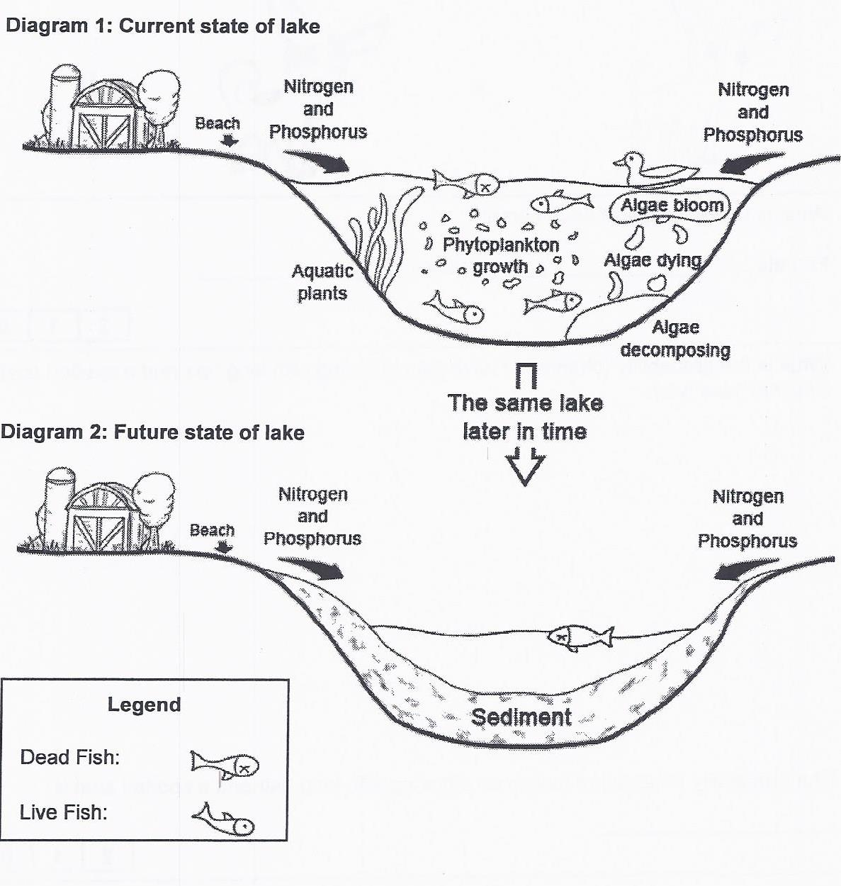

a) What is the name of the ecological phenomenon Jennifer is referring to?

b) What are the causes of this phenomenon?

1. In 2009 Hydro-Québec measured mercury levels in fish from the Eastmain and Opinaca reservoirs and found that they were significantly higher than in 2004. Using the data published by Hydro-Québec, the Cree Health Board made the following recommendations for three groups of fish in this area:

● for one species of fish they recommend 2 or more servings weekly.

● for the other two species of fish they recommend only 1 serving or less per month.



|  |
| --- |
| Use the food web in Figure 4 to determine which species of fish can be eaten more often than the others. |

1. In the summer of 2008, a toxic red algae bloom which lasted between 2 to 3 weeks caused the death of 10 belugas, 100 seals and over 1 000 birds and fish in the St. Lawrence Estuary. The red algae contain toxins that are harmful to the organisms in the estuary.

Food Web in the St. Lawrence Estuary



|  |
| --- |
| a) Why did the belugas and sea birds die as a result of the toxic algae bloom? Justify your answer.  b) Why did more harbour seals than belugas die as a result of the red tide? Justify your answer. |

1. The company “Cleanall” conducts tests in their laboratory to determine the toxicity threshold of their cleaning products. Every 10 minutes, a technician adds a drop of a detergent to an aquarium containing a population of Daphnia (small crustaceans). She must determine the toxicity threshold of the detergent.

**Daphnia**

|  |  |
| --- | --- |
|  | |
| Which of the following statements indicates that the toxicity threshold for the detergent has been reached? | |

1. The Daphnia are behaving normally, 10 minutes after the detergent has been added
2. The mobility of a few of the Daphnia is reduced, 20 minutes after the detergent has been added
3. Half of the Daphnia are dead, 30 minutes after the detergent has been added
4. All of the Daphnia are dead, 40 minutes after the detergent has been added
5. A toxicologist must assess the danger related to the human consumption of some rice which may be contaminated with arsenic.

Listed below are 4 possible factors which may affect the toxicity of this rice to humans.

1. Frequency of consumption 3- Concentration of arsenic in rice
2. Volume of container 4- Mass of consumer

Which factors listed above should be assessed?

1. 1 and 2 B) 1, 2 and 3 C) 1, 3 and 4 D) 2, 3 and 4
2. An industry that employs 1 000 workers is looking to reduce its ecological footprint. Here are some proposed measures.

1. Salary bonuses for all employees that carpool on a regular basis.

2. Changing the cafeteria menu to include international foods.

3. Installing air conditioning in all offices.

4. Hiring an outside company to do all the necessary printing.

Which of the above measures would reduce the industry’s ecological footprint.

1. 1 B) 2 C) 3 D) 4
2. Every year, thousands of Canadians participate in a shoreline clean-up. The goal of this country wide activity is for volunteers to gather at different shorelines and pick up every piece of garbage in sight. This has been going on since 1994 and has helped promote an understanding about shoreline litter issues by educating and encouraging Canadians to rehabilitate shoreline areas. Name 2 soil water pollutants (contaminants) that may be found on Canadian shorelines and explain their effect on the environment.
3. Match the steps of the phosphorous cycle in the diagram with the terms below. 1 term is used twice. Absorption, Decomposition, Erosion, Proliferation of algae,

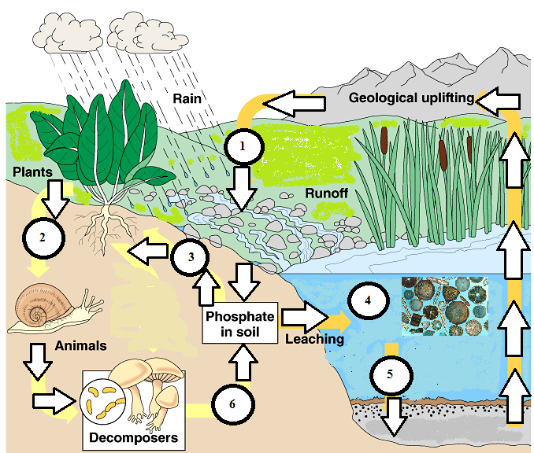Sedimentation

1. Phosphorus, a basic component of DNA, is an element essential to life. Phosphorus is exchanged continually between the lithosphere, hydrosphere and biosphere (plants and animals) through a series of transformations called the phosphorus cycle. Which of the following transformations allows phosphorus from fish to return to the lithosphere?
2. Absorption B) Sedimentation C) Decomposition D) Erosion
3. The world population has now reached 7 billion people. This has led to a greater demand for food. Agriculture must find ways to increase food production. Several farmers have started using fertilizers that cause plants to grow faster, resulting in larger harvests. The fertilizers contain elements such as nitrogen, potassium and phosphorous.These fertilizers have a positive effect on the plant crops; however they also have an impact on the surrounding environment.A corn crop fertilized with the new fertilizer is situated near several streams which flow into a lake.

|  |
| --- |
| Describe **two** consequences of the widespread use of the new fertilizer on this lake. |

1. What is true about the phosphorus cycle?

A) It enters out atmosphere.

B) Weathering of sedimentary rocks makes phosphates available.

C) Animals get the phosphates they need by eliminating wastes.

D) All of the above.