Organization of Matter
What is matter?
Matter is anything that has __________ or _________.
Made up of __________and __________.
_______________: smallest particle of matter and the simplest form of an element. Ex:
_______________a pure substance made up of only one type of atom. (Ex: __________________)
______________________________________
- Elements are arranged in the Periodic Table by their _____________________ (the number of electrons OR protons inside the atom)
Combining atoms to make molecules
- _____________________ a group of __________________ atoms that are chemically bonded Ex: A molecule of water (H₂O) is made from a __________________ between ___________ of hydrogen and ___________of oxygen

Chemical Formulas
- Molecules are represented by their ______________________________________.
- This shows the __________________ and the __________________ of each atom that composes the molecule.
- Each _______________________________________________________________ from the periodic table.
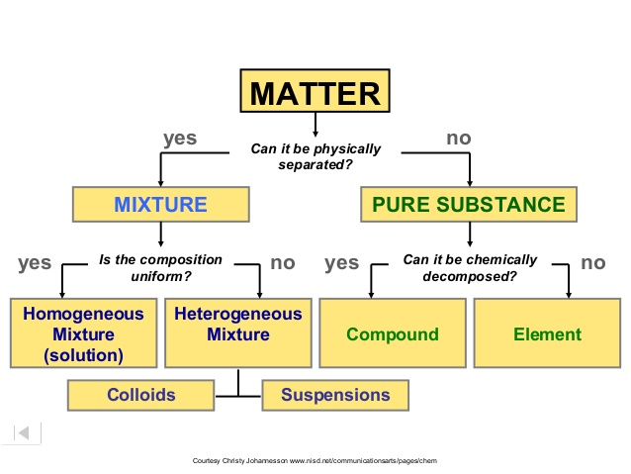
- The number of each atom is written directly after the symbol. (the number 1 is not written)
Matter is divided into two broad categories:___________________________________.

Pure Substances:
Pure Substances: Made up of only ONE ______________of particle regardless of whether they are ____________________________________. **Made up of elements and compounds.
Compound is a _______________________ made up of one type of molecule containing _________________ different atoms bonded together Ex. Table salt (NaCl) is sodium and chlorine.
- Compounds __________________________ into their individual ______________________.
E.g. Water (H₂O) can be broken down into hydrogen and oxygen using a process called electrolysis
Atoms | Elements | Molecules | Compounds
Building blocks of life  Simplest form of the element  Examples  - 2 nitrogen atoms (2 N)  - 3 Oxygen atoms (3 O)  - 4 hydrogen atoms (4 H) | Is a substance that cannot be broken down.  Made up of identical atoms  Examples  - Element nitrogen (N)  - Element oxygen (O)  - Element Hydrogen (H) | Two or more atoms bonded together chemically  Examples  - A molecule of water (H₂O)  - 2 molecules of carbon dioxide (2 CO₂)  - A molecule of oxygen (O₂) | Two or more different elements bonded together  Examples  - H₂O  - CO  - CO₂  - C₆H₁₂O₆  ***A molecule is NOT always a compound  ***A compound IS ALWAYS a molecule.

Mixtures
Mixtures: __________________________ substances that are ________________________________ with each other. (contains at least two types of particles)
They ________separated by ______________________________________ (ex. filtration).
Substances in a mixture keep their _______________________________.
Two Categories of Mixtures
*_________________________________________ – made up of at least ____________________________ that can be _______________ (can see layers)
Examples: oil and water, orange juice with pulp, fruit salad, salsa

**________________________________________ – made up of at least ___________________________________ which CANNOT be distinguished ***
Examples: tap water, salt water, air, orange juice without pulp, and skim milk.

Types of Homogeneous Mixtures
___________________: a homogeneous mixture in which it is _______________________ to distinguish the parts Ex:
- Solute: a substance that dissolves in another substance Ex: __________
- Solvent: a substance that dissolves a solute Ex: ________________

___________________ a homogeneous mixture with at least two different substances that __________________________________________ under magnification Ex:__________________

Properties of Matter

Properties: ___________________ used to identify _____________________________ or ___________
_____________________________.
Properties help us tell substances apart even though they may look the same.
- _________________________________: properties we can simply _______________________
_____________________ without modifying the nature of the substance.
Ex: color, smell, physical state, melting point, boiling point, mass, texture, taste, ductility, malleability, volume, density, electrical conductivity, solubility.
- _________________________________: describe how the substance ________________ with _________________________________.
Ex: combustible, reacts to water or acid, corrosion, reacts to contact with flame, reacts to lime water.

Physical and Chemical Properties can be either ______________________________________________
____________________________________________.

Characteristic Property | Non-Characteristic Property
A ____________________ or _________________ property that is __________________ to a particular substance.  Helps identify a substance. | A _____________________ or ________________ property that is _________________________ to one particular substance.  ________________ help us identify a specific substance.
Density, _____________________, DNA, Boiling point, ____________________________ | Mass, ____________________, _____________,  _____________________.

Changes of Matter
- Matter around us goes through many changes. Ex. Water evaporates, bread is toasted for your breakfast.
- Changes are divided into two categories:
___________________________ ___________________________
Physical Change
- __________________________________ is when the ______________________ of a substance is changed but not the ________________________ of the substance.
- Does not affect the characteristic properties
  - Ex. _____________________________________ all are water in a different state.
  - Ex: ________________________________________________________________.
Chemical Change
- ______________________________ happens when ___________________________________ ___________________react with each other to produce a _______________________________
- The nature of the substance is modified as are the _____________________________________
  - E.g. Iron + Oxygen = Iron oxide (__________________)
Signs a Chemical Change (reaction) has occured
1. change in _________________- indicates presence of a new substance
2. Formation of _______________________- ______________________________ in a liquid, or the presence of _________________________ e.g. Baking soda and vinegar
3. Formation of a ____________________- New substance formed (when two liquids are mixed and a solid forms and settles at bottom).
4. Change in ________________- gets warmer or cooler
5. Light is produced
Chemical Transformations
- A chemical transformation occurs when ____________________________called “reactants” interact _____________________________________ called “products” having _________________________________ characteristic properties.
- To represent a chemical transformation we use ________________________
_________________________________________
(Reactants ) (Product(s))
- 2H₂ + O₂ → 2H2O

Four types of chemical reactions:
- Synthesis Reaction: ________________________________________ combine to produce __________________________
The resulting product has a greater mass than either of the _________________________________.
Examples: 2H₂ + O₂ ---> 2H₂O Hydrogen + Oxygen ---> Water
Cl₂ + 2Na ---> 2NaCl Chlorine + Sodium ---> Sodium Chloride (table salt)

- Decomposition Reaction: A compound is ________________________ into _______________________ substances.
The resulting products have a ______________________________ (individually) than the initial reactant.
Ex. 2H₂O --> 2H₂ + O₂ Water --> Hydrogen + Oxygen

- Oxidation Reaction: occurs when a substance combines with one or more ___________________________________
The resulting substance is an _______________________________.
Oxidation reactions are ______________________________________ that involve oxygen.
Ex: Iron oxide (rusts) 4Fe + 3O₂ → Fe₂O₃
C₆H₁₂O₆ + 6O₂ ---> 6CO₂ + 6H₂O + Energy
Glucose (sugar) + Oxygen ---> Carbon Dioxide + Water

- Precipitation Reaction: occurs when __________________ in solution combine to form a new substance that is __________________________ in the solution
Insoluble: _________________________ of being _______________________.
This insoluble substance is called the_________________________________.
Ex: Pb (NO₃)2 + 2KI → PbI₂ + 2KNO₃

Identifying Substances in the Lab
- Often we are asked to identify various substances in the lab based on their __________________________________________________

- Specifically, we are able to identify them by testing for the ____________________________________________________________
Tests for Identification
Substance | Test | Reaction
Electroconductivity | Conductivity Meter | If the substance can conduct electricity, the conductivity meter will light up when the prongs are placed on the substance.
Presence of H2O | Cobalt Chloride Paper (CCP) | Will turn from dark blue to light pink if water is present in the solution.
pH level | Red Litmus Paper (RLP) Blue Litmus Paper (BLP) | An acid will turn the BLP red (BRA)  A base will turn RLP blue  A neutral substance will not cause either to change colour
Presence of Glucose | Glucose Test Paper | If the substance contains carbohydrates (glucose), the glucose test paper will turn from yellow to green when placed in the substance
Presence of Protein | Protein Test Solution | The solution will begin to turn violet around the edges if protein is present
Presence of Fat | Alcohol Test | When alcohol is added to the solution, it will turn cloudy and white if fat is present
Presence of H₂ Gas | Lit Split Test | When a lit splint (burning) is placed in the presence of H₂ gas, a "popping" sound will be heard
Presence of O₂ Gas | Glowing Splint Test | When a glowing splint (glowing embers) is placed in the presence of O₂ gas the splint will re-ignite
Presence of CO₂ Gas | Lime water Test | When lime water, Ca(OH)₂ is added to CO₂ gas, the liquid becomes cloudy/milky and a precipitate is formed

