Nutrition Fill-In Notes

- _______________________ is any substance that is ingested (“__________”) and sustains ___________
- Food is usually grouped into the following categories:
-_____________________________________
-_____________________________________
-_____________________________________
-_____________________________________
-_____________________________________

- Food contains __________________________ known as ________________that perform several different _______________________within the body

Nutrient | Function | Food
Carbohydrate
Protein
Fat
Vitamins, Minerals, Fiber and Water

Carbohydrates
- Main source of energy
- _____________________________
  - 1-2 sugar molecules connected together. (Digested quickly)
  - Pop, candy, honey, sweets, fruit
- _____________________________
  - 3+ sugar molecules connected together. (Longer to digest)
  - Legumes, Grains, Vegetables

Protein
- Composed of chains of ________________________
- Used in growth and repair of tissues.

Fats
- Second source of energy (energy storage)
- _____________________________
  - Animal sources (solid at room temperature)
  - Linked to increased cholesterol levels
- ______________________________
  - Vegetable sources (Liquid at room temperature)
  - Linked to reduced cholesterol levels

Vitamins
- Nutrients that are essential to all bodily functions
- Regulate metabolism (chemical reactions that take place in the body, needed to live

Minerals
- _______________________________ found in food that are essential to life processes.
  - e.g. Calcium, Potassium, Sodium, Phosphorus, Iron

Water
- approximately 60% of body-weight
- __________________________________

Energy Needs
- Every individual has his or her energy ______________________________
  - ________________________- energy needed by the body to when ___________ (heart, respiration, cellular activity).
  - _______________________ – walking, running, moving
  - ______________________________________ - breaking down food
- Determined by:
  - Age
  - Sex
  - Weight
  - Level of _______________________
  - Overall state of ___________

Energy Units
- SI unit = ______________________
- More common = dietary calorie (_________________)
- __________________ = 4000 J OR 4 kilojoules (kJ)

Average Teenager Energy Needs
- Avg teen girl requires between ________________ Cal / ___________________ per day
- Avg teen boy requires between ________________ Cal / ___________________ per day

Energy Value of Foods:
Carbohydrates ______ cal/g ______ KJ/g
Protein ______ cal/g ______ KJ/g
Alcohol ______ cal/g ______ KJ/g
Fats ______ cal/g ______ KJ/g

Reading Nutrition Labels:

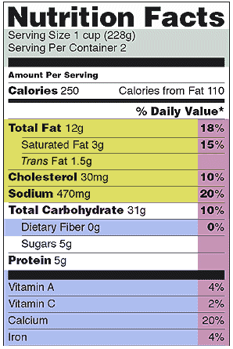

How much energy will I get from the food above?

