**Enriched Magnetism Notes**

**Ferromagnets and non-magnets**

**Def: Ferromagnets:** Act as _________________ magnets, they have _______________,

but their domains are ___________ ________________ when they come in contact with a magnet. Fe and Co are examples.

**Def: Non-magnets:** Can _______________ have any ___________________ properties because they do not have domains.

Reactions:

magnet to magnet= FM to FM=

magnet to FM= FM to NM=

magnet to NM= NM to NM=

1. Object A and B attract A is___________

Object A and C attract B is___________

Object B and C have no reaction C is___________

Object A and D have no reaction D is___________

1. Object A and B attract A is___________

Object A and C have no reaction B is___________

Object B and C have no reaction C is___________

Object A and D attract D is___________

Object B and D have no reaction

1. Object A and B repel A is___________

Object A and C attract B is___________

Object B and C attract C is___________

Object A and D attract D is___________

Object C and D have no reaction E is ___________

Object A and E have no reaction

1. Object A and B have no reaction A is___________

Object A and C have no reaction B is___________

Object B and C have no reaction C is___________

Object B and D attract D is___________

Object C and D attract

Object A and D have no reaction

**Solenoids**

Def: __________________________________________________________________________

Shape of the magnetic field like that of a bar magnet.

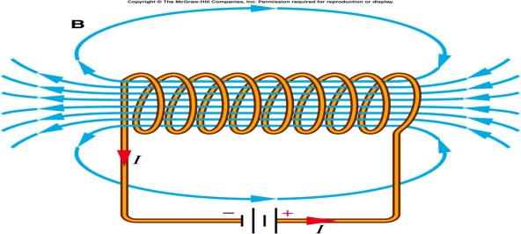

* Long line =
* Short line =

**Right hand rule:**

Thumb: Fingers:

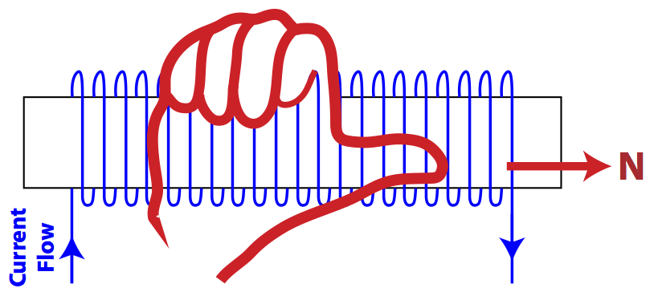

**Practice**

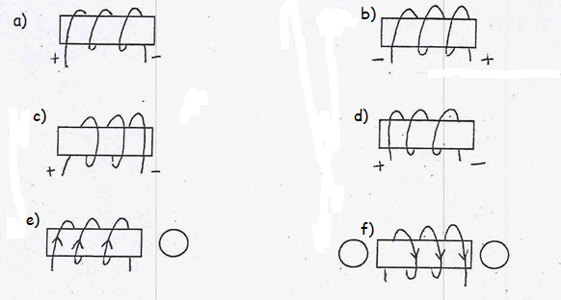

**Past Exam questions**

1. The four diagrams below represent electromagnets connected to the terminals of a battery. In which of the diagrams are the magnetic poles correctly indicated?

|  |  |  |  |
| --- | --- | --- | --- |
| 1. 1. |  |  | |
| 1. 2. |  |  | |
| 1. The magnet in the diagram is constructed from an iron core and a coil of wire connected to a battery. When the switch is turned off, an electric current circulates through the wire. | | |  | |

Which of the following diagrams correctly shows the magnetic field of this electromagnet?



1. Which pictures below have the correct compass direction?
2. 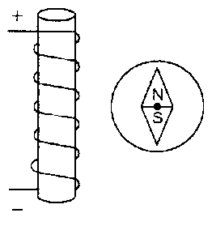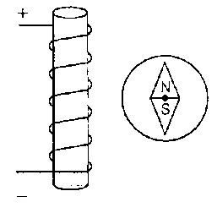 2. 3. 4.



1. 1 and 2 B) 1 and 3 C) 2 and 4 D) only 3

**Electromagnets**

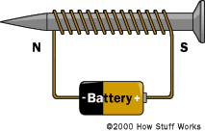Def: _________________________________________________________________________

Factors which influence the strength of an electromagnet

|  |  |
| --- | --- |
| Factor | Increase strength |
| Number of turns |  |
| Current intensity |  |
| Core of solenoid |  |
| Temperature |  |

Determining the force of an electromagnet **F=I x N**

**Past Electromagnet Practice Question**

1. Which one of the following electromagnets will produce the strongest magnetic field?

A) Copper Core B) Iron Core



C) Copper Core D) Iron Core

