**Enriched Statics and magnetism worksheet**

1. Which of the situations illustrated below would represent a force of attraction between the two objects?

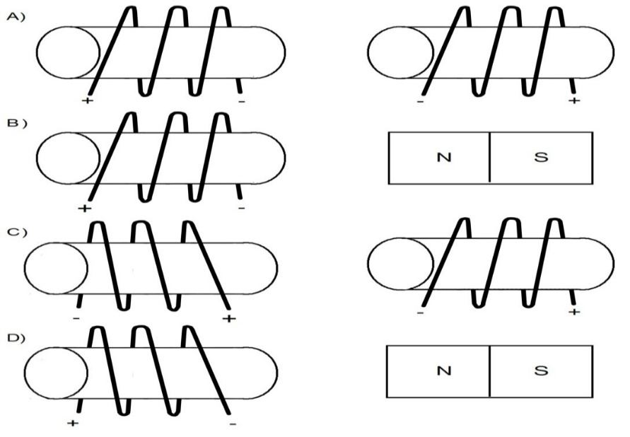

1. The electromagnets illustrated below produce magnetic fields of different intensities.

The electromagnets are to be arranged in increasing order of their magnetic field.

|  |  |
| --- | --- |
|  |  |
|  |  |

In what order should the electromagnets be arranged?

1. 1, 2, 4 and 3 C) 4, 3, 1 and 2
2. 4, 3, 2 and 1 D) 3, 4, 2 and 1
3. Consider the electric force between a pair of charged particles a certain distance apart. According to Coulomb’s law if the charge of one of the particles is doubled, the force will be

A) Unchanged B) Halved C) Doubled D) Quadrupled

1. Refer to the illustration of the compass and electromagnet in Figure 1.
2. Identify the positively charged terminal (+).
3. Identify the poles as N and S.
4. Identify the current direction.

Figure 1

1. What is the distance between two spheres if the electrical force between them is 6.50x106 N and the charge of one object is 6.0x10-3 C while the other’s charge is 4.45x10-5 C.?
2. The charge of a sphere is 6.5 x 10-5C. The electrical force of the 2 spheres is

9.00 x 103 N. The distance between the 2 spheres is 3.5 m. What is the charge of the other sphere?