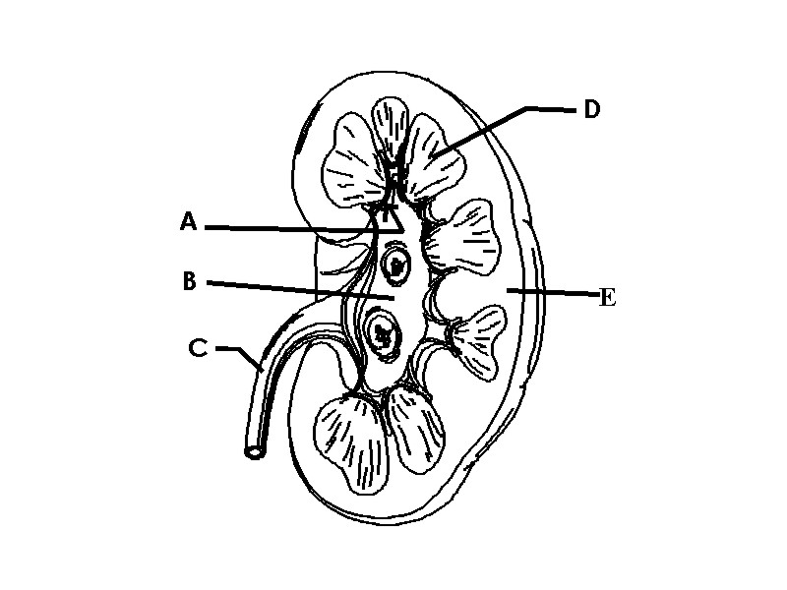

Fill in the blanks of the letters according to the diagram above:

A: ______________________________

B: ______________________________

C: ______________________________

D: ______________________________

E: ______________________________

