Hydrosphere
- Formed by all ______________ _____ _______________ on the Earth’s surface
- Includes ____________, _____________, ____________, ____________ and other ______________
- Covers ________% of Earth’s surface
- Without water there would be ________ ____________
- Water can either be ____________ or ______________

Why are the seas and Oceans salty?
- Seas and Oceans are salty because there are a ________________ quantity of _____________ _____________ dissolved in it
- Mineral salts come from _____________
- When it __________________, some minerals (which form the rocks) ______________
- Minerals run into ___________ ____________ where they _________________

Are some Seas saltier than others?
- The amount of salt in seas vary depending on the __________________ in the _______________

Which type of water can humans drink?
- Humans can only drink _________________ water because they can’t __________________ the large quantity of __________________ ____________ contained in salt water
- When water is ___________ to drink it is called ______________.
- Potable water = ________________ water
But how much water is available for humans to drink?
Works out to be about ____________% available fresh water

The Water Cycle
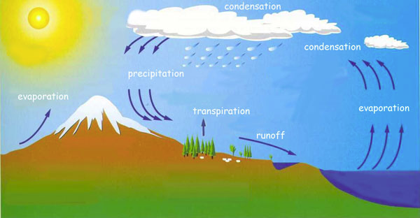

The Water Cycle
- a) Evaporation - water from lakes, rivers and oceans changes to water _______________ by the _______________ of the ___________.
- b) Transpiration - water vapour is released from _______________ by the ______________ of the ____________.
- c) Condensation - water vapour changes to _________________ of _________ as it cools, leading to the formation of ___________.
- d) Precipitation - water from clouds is released back into lakes, rivers and oceans, as ______________, ______________ or_____________, or onto land where it seeps through the soil and ____________ as ground water back to the _______________.
- e) Melting - ice and snow change to _______________ water by the addition of ____________, and __________________ into lakes, rivers and oceans.

