Energy Transformations and Heat Energy

Heat Energy
Def : _________________________________________________________________________
______________________________________________________________________________
Heat has 2 variables:
1- # of particles (how much ex: mass). Less mass allows substance to get hot faster.

2- Degree of agitation (movement) of the particles.

- High agitation = substance has high temperature
- Low agitation = substance has low temperature

Temperature
Def : _________________________________________________________________________
Mass is irrelevant for temperature, big or small 37℃is 37℃.

Heat transfer
- ________________________________________________________________________
- ________________________________________________________________________
ex: All buckets below have 7 L of water, but each bucket has a different temperature of water.
Bucket A Bucket B Bucket C Bucket D
80 °C 50 °C 25 °C 10 °C
You mix bucket A and C together and B and D together.
Explain what the temperature of the buckets will when you first mix them?
Why does this change in temperature occur?
Which buckets lost heat? Which buckets gained heat?

Recap:
Heat depends on: ____________________________________________________________
Temperature depends on: ______________________________________________________
You transfer ________________________, but you measure __________________________. You cannot transfer ________________________.

Energy Types
Type of energy | Definition | Examples
Chemical |  | candle wax, energy stored in food
Electric |  | Power plants and generators
Sound |  | Sound and music
Kinetic |  | Kicking ball
Potential |  | A rock on a hill
Mechanic |  | Swing starting to move
Thermal |  | Sun, fire and heating element
Radiation |  | Sun, microwave and light bulb
Wind |  | Wind turbines
Elastic |  | Spring and stretched elastic
Hydraulic |  | Waterfall and river
Nuclear |  | Sun and nuclear power plant

Energy transfer and transformation

Energy transfer: ________________________________________________________________
Energy transformation: _________________________________________________________
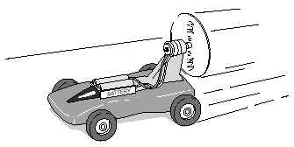
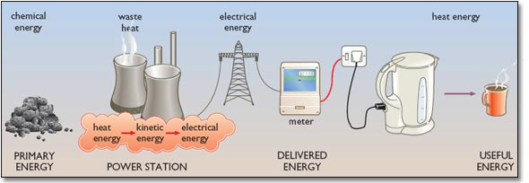
Give three examples that cause this race car to accelerate

