Earth and Space Enriched
- Soil pH
Soil that is too acidic or too basic can prevent or slow down plant growth due to its inability to properly absorb nutrients. Ideally, soil should be slightly acidic with a pH between 6 and 7.

Buffering capacity: The ability for soil to resist changes in pH when substances which are too acidic or too basic are added to it.

- Winds

Prevailing winds: Major wind currents that blow in a particular direction according to global patterns of movement.

Polar easterlies | polar regions | east to west | Poles to 60th parallel
Trade winds | near equator | east to west | 30th parallel to equator
Westerlies | middle latitudes | west to east | Between 60th and 30th parallels
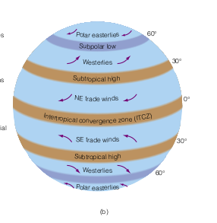

Prevailing winds pose a problem when there are contaminants and pollution in the air. They current spreads the pollutant over a large area.

