Digestive System Worksheet Name _________ANS___________

Part 1: Match the name of each organ with the letter that represents it on the diagram below.
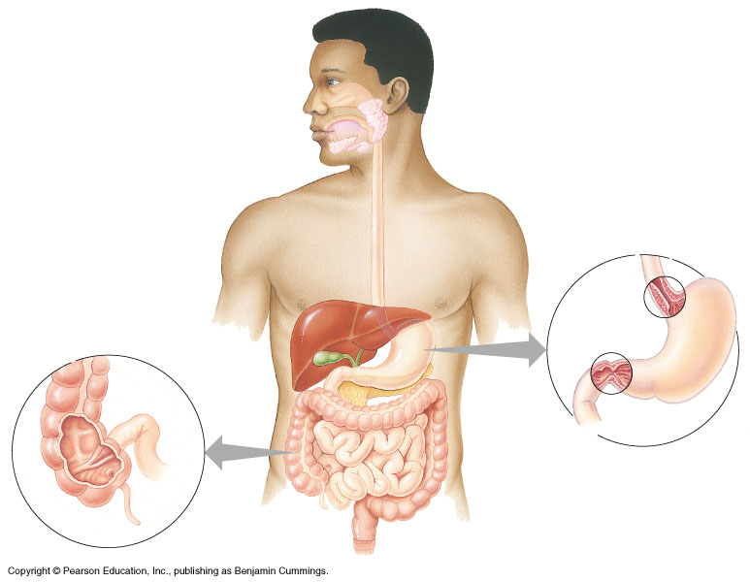
A
B
C
D
E
F
G
H
I
J
K
L
M

__K__ 1. Stomach __L_ 9. Esophagus
__E__ 2. Gall bladder __B_10. Tongue
__A__ 3. Oral cavity (mouth) __I_ 11. Small intestine
__D__ 4. Liver _M_ 12. Pharynx
__F__ 5. Large intestine __H_13. Anus
__G__ 6. Rectum
__C__ 7. Salivary glands
__J__ 8. Pancreas
Part 2: Using the key choices below, match the description given with the structure in the alimentary canal that it describes. Choices may be used more than once.
A. Anus | F. Liver | K. Salivary Glands
B. Villi | G. Mouth (Oral cavity) | L. Small intestines
C. Esophagus | H. Pancreas | M. Stomach
D. Gallbladder | I. Pharynx | N. Tongue
E. Large Intestines (Colon) | J. Rectum | O. Teeth  P. Peristalsis
__D__ 1. Stores bile, which physically breaks down fat into droplets, until it is secreted.
__B__ 2. Fingerlike extensions in intestinal wall that increase surface area and absorb nutrients
__O__3. used to cut, tear, and grind food; adult has 32
___N___ 4. Organ that mixes food in the mouth.
___I___ 5. Common passage for food and air.
___C__ 6. Literally a food chute; it has no digestive or absorptive role.
___M__ 7. Produces a juice that neutralizes stomach acid and contains digestive enzymes.
___L__ 8. Organ responsible for absorption of most nutrients.
__E__ 9. Organ primarily involved in water absorption and feces formation.
___M__ 10. Organ in which protein digestion begins.
___L__ 11. Organ into which the stomach empties.
___L__ 12. Organ that receives pancreatic juice and bile.
___A__ 13. Opening through which feces are expelled from the body.
___F__ 14. Produces bile.
___K_ 15. Produce enzymes that begin carbohydrate digestion.
___J__ 16. Stores feces until they are excreted.
___G__ 17. Digestion begins when salivary gland secretions enter this
___P__ 18. Muscular movement involving the walls of the digestive tract that serve to mix materials and move them along the tract
Part 3: Answer the following questions.

- What is the end product starch digestion?
Glucose
- What is the end product protein digestion?
Amino Acids
- What is the end product fat digestion?
- Where does starch digestion begin?
Mouth
- Where is starch digestion completed?
Small intestine
6. Where does protein digestion begin? Stomach
1 Glycerol and 3 fatty acids
- Where is protein digestion completed?
Small intestine
- Where does fat digestion begin?
Small intestine
- Where is fat digestion completed? Small intestine

