**Carbon Cycle, Hydrosphere and Energy Types**

**Carbon Cycle Questions**

1. Which of the following is a consequence of the increase in greenhouse gas emissions?

A) The permafrost will become thicker.

B) The surface area of the pack ice (ice floes) will decrease.

C) The proportion of oxygen in the atmosphere will increase.

D) The number of extreme weather events on Earth will decrease.

1. In nature, carbon follows a cycle and moves through the Earth’s different spheres, namely the atmosphere, the biosphere, the hydrosphere and the lithosphere. Which of the following human activities has the least influence on the carbon cycle?

A) Intensive tree cutting C) Burning fossil fuels

B) Raising dairy cows D) Operating a nuclear power plant

1. It is said that using wood to build houses helps in the fight against climate change because trees store some of the atmospheric carbon. Through what carbon cycle process do trees store atmospheric carbon?

A) Photosynthesis C) Plant decomposition

B) Cellular respiration D) Fossil fuel combustion

1. Which of the following does not contribute to the formation of greenhouse gases?

A) Decomposition of waste in landfills C) Melting of the permafrost

B) Burning of fossil fuels D) Photosynthesis in plants

1. In general, permafrost is ground that…

A) Is always frozen C) Only freezes during winter

B) Rarely freezes D) Is located mainly in high altitude

1. Which of the following is not a consequence of the warming of the permafrost?

A) Landslides

B) Unstable infrastructure (buildings and roads)

C) A decrease in the amount of vegetation

D) The release of greenhouse gases

1. In the last 100 years, the average temperature of our planet has increased. The intensification of the greenhouse effect can explain this increase in temperature.

a) What two human disturbances lead to an increase in greenhouse gases?

b) What are two consequences of the intensification of the greenhouse effect?

1. Global temperatures have been increasing at a steady rate. Ecologists have been hired to study the impact of increasing temperature s on a region in Northern Quebec. Which graph below correctly shows the consequence of a rise of temperature in the region? Explain your answer.

**Graph A Graph B**

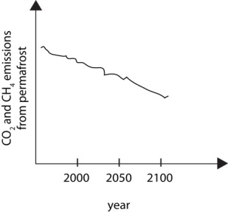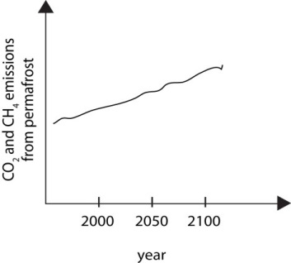

**Hydrosphere Questions**

1. The diagram below shows a house (H) and four nearby farms (1, 2, 3amd 4). A well is located very close to the house.

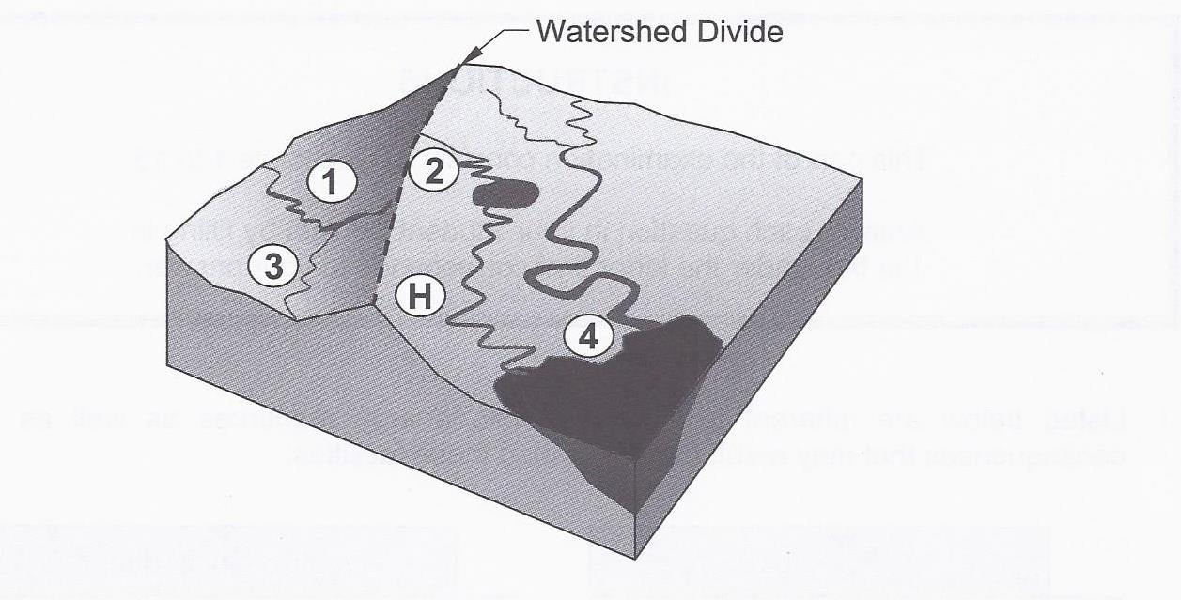

When the well water was tested, the results showed that it was contaminated with pesticides. Which of the four farms shown (1, 2, 3 or 4) is responsible for contaminating the well water?

A) Farm 1, because it is located upstream.

B) Farm 2, because it is located in the same catchment area.

C) Farm 3, because it is located near the house.

D) Farm 4, because it is located downstream.

1. What is the role of thermohaline circulation?

A) It keeps the pH of oceans uniform.

B) It transports heat from the equator toward the poles.

C) It captures atmospheric CO2

D) It controls the tidal cycle

1. Which of the statements below correctly identifies the effect of the increase in the melting of pack ice due to climate change?

A) Loss of habitat for arctic species C) Flooding of low lying areas

B) Rise in the sea level D) Increase in the number of icebergs

1. Which of the following activities has the greatest impact on the flow of water in a catchment area?

A) Filling up a child’s swimming pool with 40 L of water.

B) Treating drinking water for a city in a municipal water treatment plant.

C) Rerouting rivers for the construction of a hydroelectric dam.

D) Repairing a bridge connecting Montreal’s South Shore to the Island of Montreal.

1. Which of the following does not affect the flow of water into a catchment area?

A) Depth and latitude of the water reservoir C) Shape and slope of the terrain

B) Industrial and urban development D) Density and diversity of the vegetation

1. In which situation will water sink most rapidly to the ocean floor?

A) When it is cold and very salty C) When it is cold and not very salty

B) When it is warm and very salty D) When it is warm and not very salty

1. Different factors can affect the circulation of surface currents and deep currents in the ocean.

1. Temperature differences in the water 4. The rotation of the Earth

2. Air pressure differences in the atmosphere 5. The depth of the water

3. Differences in the waters’ salinity

Which of the factors above only effect surface currents?

A) 1 and 3 only B) 2 and 4 only C) 1, 3 and 5 D) 2, 4 and 5

1. In Ungava Bay in northern Québec, the tidal range can reach more than 17 m. The diagram below shows the Earth along with a dotted circle representing the moon’s orbit around the planet.

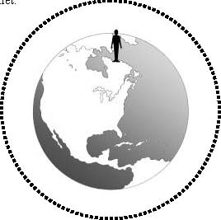

• Draw the symbol ☾ on the dotted circle to indicate the two (2) points in its orbit where the moon causes high tides in Ungava Bay. The position of this bay is denoted by the symbol: .

• Write the letter L on the Earth to indicate the two (2) points where the tides are low at the same time as the tide is high in Ungava Bay ().

1. For each statement state whether it is an example of a surface current or a subsurface current.

a- these currents are altered by density and salinity

b- these currents are mostly controlled by wind

c- these currents will allow cause you to swim off course in the ocean

1. The take below lists three human activities that can have an impact on the quality of the water in a drainage basin.

Human activities

|  |  |
| --- | --- |
| 1 | Fertilizing farmland |
| 2 | Using jet skis and motor boats |
| 3 | Planting vegetation along the bank of a river or stream |

Choose 2 of the 3 human activities and explain their positive or negative impact on the rivers and streams of a drainage basin.

1. Using the following diagram, complete the table below by writing YES or NO to indicate whether points Y and Z would be affected by a spill at point X and whether points X and Z would be affected by a spill at point Y.

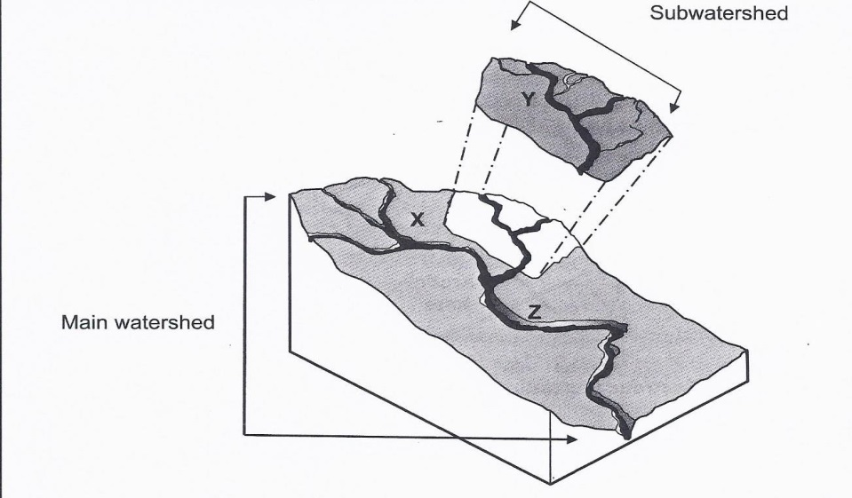

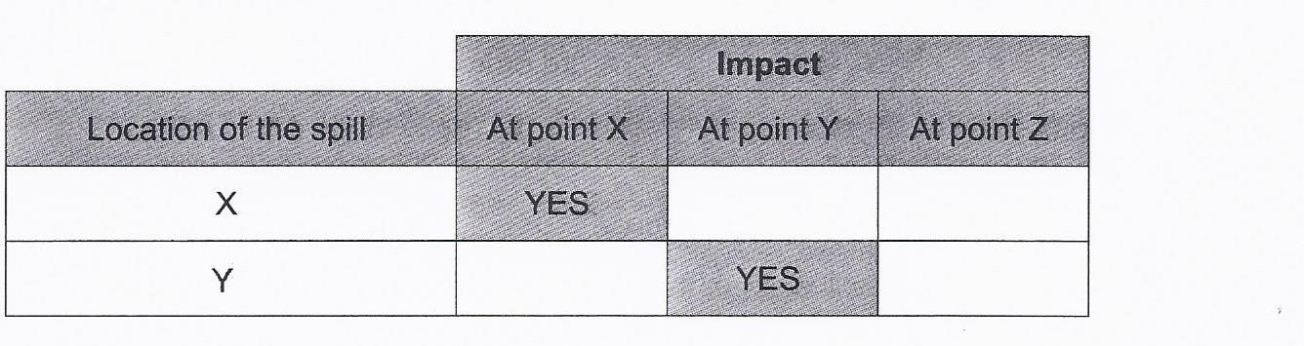

Explain your reasoning.

**Energy Types Questions**

1. 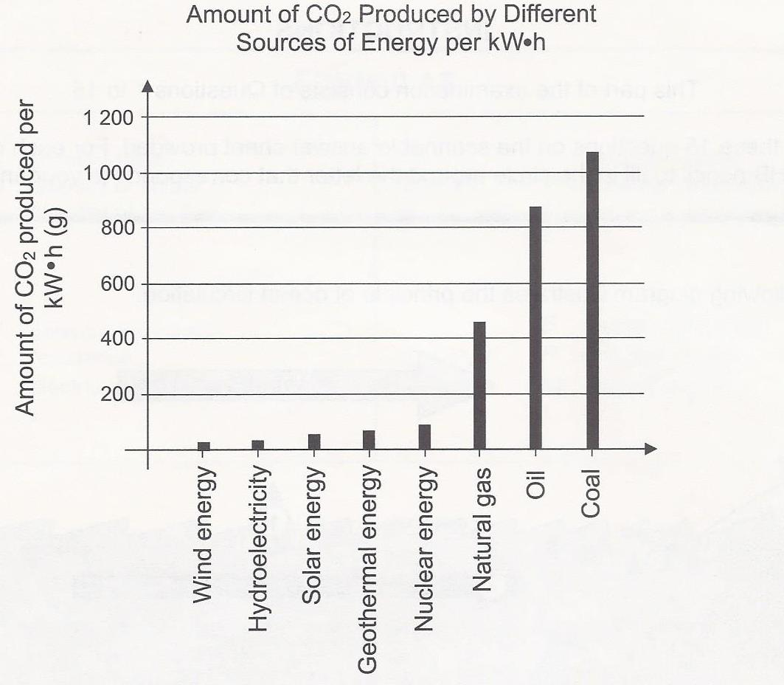The use of energy sources generates greenhouse gas emissions. The graph below shows the amount of greenhouse gas, CO2, produced by different sources of energy per kilowatt-hour.

According to this graph, which of the following statements is true?

A) Coal produces less greenhouse gas than all the other fossil fuels combined.

B) Only renewable energy sources produce less than 200 g of CO2 per kilowatt-hour.

C) Each energy source from the lithosphere produces more than 400 g of CO2 per kilowatt-hour.

D) Solar energy produces less greenhouse gas than the main energy source from the atmosphere.

1. Which of the following choices provides accurate information about one of the types of power plants listed?

|  |  |  |  |
| --- | --- | --- | --- |
|  | Type pf power plant | Renewable or non-renewable energy | Quantity of greenhouse gases produced |
| A | Geothermal | Non-renewable | Large amounts |
| B | Hydroelectric | Renewable | Little or none at all |
| C | Nuclear | Renewable | Large amounts |
| D | Tidal | Non-renewable | Little or none at all |

1. Different types of electric power plants are listed in the table below.

|  |
| --- |
| **Types of Power Plants** |
| Wind, Geothermal, Hydroelectric and Tidal |

Which statement is true about all these types of power plants?

A) They produce few air pollutants.

B) They can be set up anywhere in Canada.

C) They all use water as the primary source of energy.

D) They use non-renewable resources.

1. Listed below are different facilities that use energy resources as well as negative consequences that may result from operating these facilities. Which choice correctly matches each facility with its consequence?

|  |  |  |
| --- | --- | --- |
|  | Facilities | Negative consequences |
| A) | Coal-fired power plant | Noise produced |
| B) | Nuclear power plant | Greenhouse gas emissions |
| C) | Wind turbines | Greenhouse gas emissions |
| D) | Water turbines | Can negatively affect the migration patterns of aquatic species |

1. The following graph shows different sources of electricity in three major regions in Canada.

Graph 1 -Proportion of Electricity Produced From Different Sources in Three Major Regions in

Canada.



Given the information in this graph and your knowledge of energy resources, which conclusion is TRUE?

A) Electricity production has little impact on the environment in these three regions, since they all mainly use hydro power

B) Air pollution caused by electricity production is greater in Ontario than in Quebec, since Ontario has more thermal power plants.

C) Greenhouse gas emissions related to electricity production are greater in Ontario than in the Atlantic Provinces, since Ontario has more nuclear power plants.

D) Electricity production has a major impact on the environment in the three regions, since they use no renewable energy.

1. There are plans to put underwater turbines in the Gulf of the St. Lawrence. This technology uses the energy of deep currents to produce electricity.

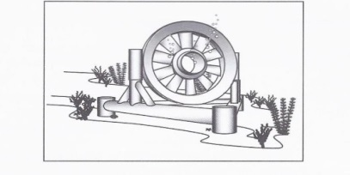

a) Is the source located in the lithosphere, hydrosphere or atmosphere?

b) Give two advantages of producing electricity with underwater turbines rather than wind turbines.

c) Indicate a possible negative consequence of using the underwater turbines.

1. The inhabitants of a remote island would like to replace gasoline-powered generators with devices that use renewable energy. The table below indicates certain characteristics of the island.

|  |  |
| --- | --- |
| Population | 583 inhabitants |
| Area | 250 km2 |
| Climate | Summer: humid and sunny Winter: cold and sunny |
| Environment | Wildlife: seals, fish, aquatic birds Vegetation: diversified |
| Topography | Coasts: sandy beaches and small waves  Igneous rock and volcanic activity constantly monitored |
| Economic activities | Tourism, sailing, deep sea fishing, excursions |

Fill in the table below. 