Coulomb’s Law Enriched Notes

Def: _________________________________________________________________________________
_____________________________________________________________________________________

Coulomb found the attraction between 2 objects depends on 2 things:

- ___________________________________________________________________
- ___________________________________________________________________

The stronger the charge the stronger the attraction will be, the greater the distance the weaker the attraction is.
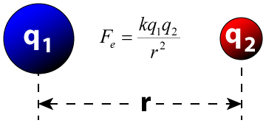
Symbol | Stands for | Unit
k
q₁
q₂
r²
Fe

- q₁ and q₂ will be the same number unless specified in the problem.
- r often given in cm, must convert to m. ÷ 100

ex- 1- q₁ = 4x10⁻⁷ C and r = 3 cm

ex- 2- Two positively charged objects each have a charge of 5.0x10⁻⁸ C and are placed 1.0 cm apart. What is the electrical force between the 2 objects?

ex- 3
Two positively charged particles at rest exert a force of 5.6 x 10³ N on one another. The charge of the first particle is 6.0 x 10⁻⁵ C and the charge of the second particle is 2.0 x 10⁻⁴ C. What is the distance between the two charged particles?

ex- 4
Two positively charged particles at rest exert a force of 4.65 x 10⁴ N on one another. The charge of the first particle is 7 x 10⁻⁵ C and the charge of the second particle is 5.55 x 10⁻⁶ C. What is the distance between the two charged particles?

ex- 5
What is the charge of sphere 2, if sphere 1 has a charge of 5x10⁻⁴ C the distance between both is 0.004 m and the electrical force acting between both spheres is 4x10⁴ N?

ex- 6
What is the charge of a sphere , if one of the spheres has a charge of 9.99x10⁻³ C the distance between both is 1.75 cm and the electrical force acting between both spheres is 4.855x10⁷ N?

