Enriched Circuit notes

Coloured Resistors
Resistors may have various coloured strips around them. These colours give the strength of the resistor.
- 1st colour = 1st digit of the resistor value.
- 2nd colour= 2nd digit of the resistor value.
- 3rd colour= multiplier (10?)
- 4th colour = tolerance (the amount the answer can be off by).
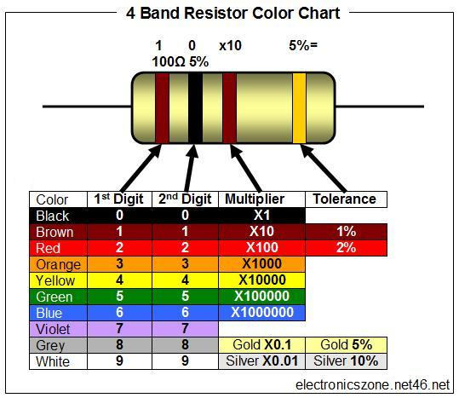

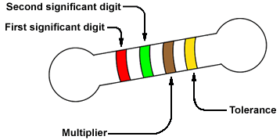

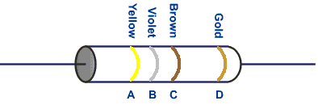

Various types of switches
Switches | Other Term | Possible paths | # of switches | Diagram
Single pole  Single throw | Unipolar  Unidirectional |  |  | 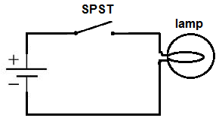
Single pole  Double throw | Unipolar  Bidirectional |  |  | 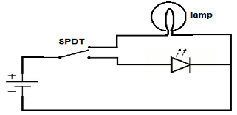
Double pole  Single throw | Bipolar  Unidirectional |  |  | 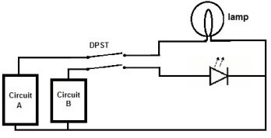
Double pole  double throw | Bipolar  Bidirectional |  |  | 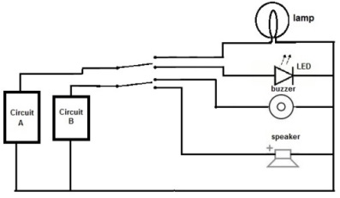

Equivalent resistance

Def: _________________________________________________________________________________
_____________________________________________________________________________________
symbol:

Series rule: Parallel rule:
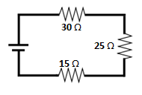
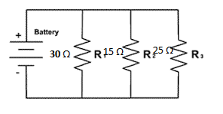

Solving circuits
- Kirchoff’s Law
 | Series | Parallel
Current intensity
Potential difference
Resistance
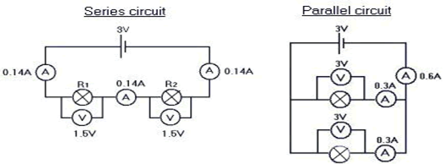
- Ohm’s law
R= V/I

Circuit practice
1.
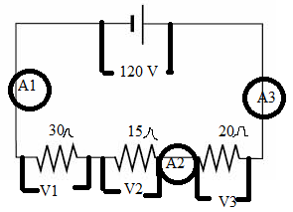
 | I’s | R’s | V’s
1
2
3
T
2. What is the current intensity coming from the power source?
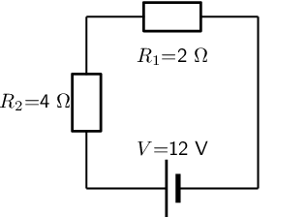

3. What is the current coming from the power source?
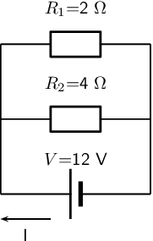

4. What is the current intensity of resistor 1 and 2?
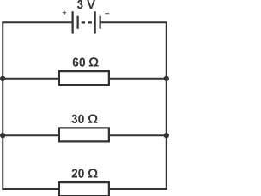

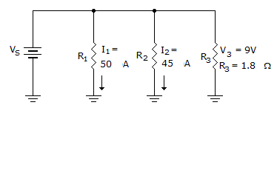
5. What is the resistance of resistor 2?

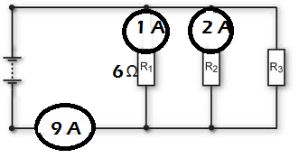
6. What is the resistance of resistor 3?

7. What is the current intensity of resistor 1?
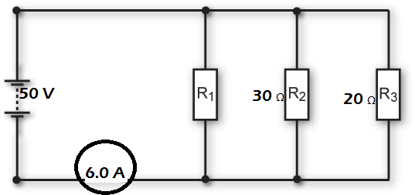

8. What is the total voltage?
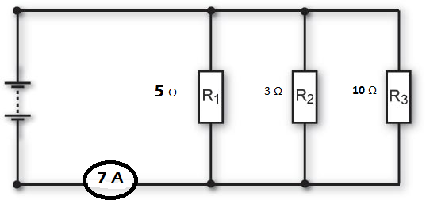
9. What is the voltage of resistor 2?
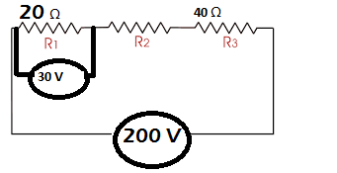
10. What is the resistance of resistor 1?
